Mean Recurrence Interval and Joint Density of

Measured Environmental Loads for Malaysian Water

Idzwan Mohamad Selamat

Civil Engineering Department

Universti Teknologi PETRONAS

Tronoh, Perak, MALAYSIA

idzwan.selamat@gmail.com

Assoc. Prof. Ir. Dr. Mohd Shahir Liew

Civil Engineering Department

Universti Teknologi PETRONAS

Tronoh, Perak, MALAYSIA

shahir_liew@petronas.com.my

Abstract-A key design element in coastal structure is the environmental load which consists of wind speed, wave height, and current. In order to avoid platforms from being subjected to extreme loadings, the design should be above the extreme conditions, which is usually composed of tides and storm surges but could also include tsunami, el Niño, and other climate and geological effects. The extreme loads may be determined with the annual maxima and joint density distribution. Based on the study conducted, it is proposed that for a wind mean return interval of 100 years, the associated wave design is 10 years for all 6 platforms that are currently under study. These studies were conducted through all Malaysian water including Peninsular Malaysia Operation, Sabah Operation and Sarawak Operation. This paper help to provide the correlation of wind and wave as wave and current. In addition, the benchmark can be set up for the operational region of the operation. The interim guidelines will be useful to expect the joint densities in this area and it will benefits operation on optimization of current design cost and time completion with lighter platform design.

Keywords-component; Environmental Load, Joint Densities, Wave Height, Wind Speed, Return Period, and Extreme Values

# Introduction

Wind speeds, wave heights and current speeds are the dominants factor in the design of offshore structures and have been traditionally considered as a combination of environmental loads during the design phase. For example, current knowledge of the climate offshore West Africa suggests that wind, wave and current are generated by different directions and un-correlated sources and therefore may have different directions and intensities[1]. This means that a 100 year current is not likely to be observed at the same time as the 100 year wave and wind as well and vice versa. Design periods have varied between 50 and 100 years but however they are not considered for their joint effects, but more so as a combination or addition of factors[1]. However, joint considerations have now been made for West African waters whereby 100 year conditions for a given element is associated to perhaps a 1-10 year return period for other elements.

Sea waves are caused by wind blowing for a sufficiently long time, the state of the sea is related to wind parameters and the possibility of correlating wind and wave loading conditions on structure exist[2]. However, according to Joan C. Liu 2010 [3], estimating extreme sea conditions requires an understanding of oceanographic science and coastal engineering. By determining the local oceanographic environment and employing coastal engineering knowledge, the process of predicting extreme sea value conditions can be determined. Thus as such, a separate joint density study has to be conducted for local application in South China Sea waters for operation in this region

To study the data, the author have used the Weibull distribution in order to analyse the data. The primary advantage of Weibull analysis is the ability to provide reasonably accurate exceedance analysis and forecasting[4]. This will help the author to have a better view on analysing the raw data. Furthermore, the author have also includes the extreme value method whereby the prediction of extreme loads associated with a target return period requires statistical extrapolation from available loads data[5]. This will forecast the extreme loads from the data given of any targeted return period.

This report summarizes the results of the joint densities study as to assess the joint effects of different environmental loads and its' associated return periods for 6 different platforms located throughout Peninsular Malaysia, Sabah and Sarawak. The analysis uses joint probabilities to assess the effects of 50 year and 100 year wind mean return intervals on the associated wave return periods. Due to unavailability of ocean current data, the joint density conducted is valid for the wind and its associated wave return periods. This methodology sets itself apart from existing forecasting methods that utilizes combined effects of various environmental loadings which may result in overdesign of structures.

This study is expected to provide the valuable insight into the optimization of current practices which will ultimately result in major structural cost savings for the client. The objective of this study is to obtain joint densities characteristics of the measured metocean data related to wind and wave in Malaysian water using Weibull distribution and probability density function. This method help to provide the correlation of wind and wave. In addition, the benchmark can be set up for the operational region of the operation. The interim guidelines will be useful to expect the joint densities in this area and it will benefits operation on optimization of current design cost and time completion with lighter platforms design. In completion, forecasting the return period design of correlated wind, wave and current based on measured data will be performed.

# Data Description and Analysis

Data were analyzed for 6 platforms; Platform A, Plaform B, Platform C, Platform D, Platform E and Platform F. The data consist of wind speed (knots), and wave height (m). Then, the data will be filtered for the wind speed and the wave height. The data will be compiled and corrected through the SPSS PASW and Easyfit software. This is to ensure that there is no error in the data collection that consist of 5 years consecutive raw data. The data will then be use for the joint density and forecasting. There are two steps needed in order to find the correlation and forecast of the mean return interval (MRI). The first step is by using the Weibull distribution using the probability theory. During this step, the total of 250,000 data will be filtered and calculated through the probability of exceedance. Then, this data will be using the probability density function which will give a better view on the data correlation.

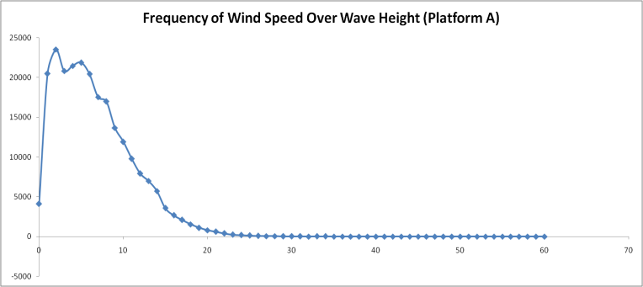

Figure 1 : Frequency of wind speed over wave height

TABLE 1

TABLE OF PROBABILITY FOR 0.99 PROBABILITY CORRELATION



Figure 1 is a typical plot of probability of wind speed over wave height and Figure 2 is a typical plot of probability density function of wind speed over wave height.

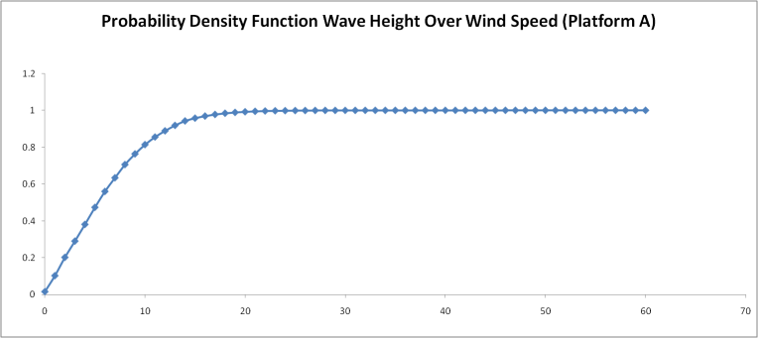

Figure 2 : Probability density function of wave height over wind speed

Next, all the data is used to the Gumbel method for the forecasting which is based on extreme value. Gumbel method will sort the extreme value monthly from the lowest to the highest value with a set of rank. Then there will be a graph that is based on the ranked probability to the wind speed or wave height value. The graph will provide the value of R square, intercept and slope. This will further help the calculation of the predicted mean return interval. This will be presented through the logarithmic scale graph of monthly return period to predicted max wind speed or wave height.

# Results and Discussions

## The Correlation of Wind Speed and Wave Height

Table 1 shows the joint density by using the probability density function that provides the correlation between the wind speed and the wave height. The highlight shows the correlation for the 0.99 probability of exceedance. The horizontal value is the wind speed while the vertical value is the wave height. For example, the forecast value of 50 years wind speed will give the result of 64.6 knots (refer Table 1), based on 0.99 probability of exceedance. The table will then display the correlated value of the wave height of 4m (max

horizontal value) based on the 64.6 knots wind speed (vertical value).

## Forecasting using the Gumbel Distribution

Table 2 is the summary of the Gumbel method result. From the Gumbel method, which is based on ranking probability, the slope and the intercept of the forecasting graph (Figure 3) can be obtained. Also provided will be the wind speed, Vr values and its’ associated return period. For example, if a 50 years (600 months) return period for wind is required, the forecast wind speed, Vr is at 64.6 knots. The calculation of the forecasting and the orrelation will use the same steps in order to to find 100 year MRI or even 10 year MRI.

TABLE 2

TABLE OF FORECASTING (GUMBEL DISTRIBUTION)

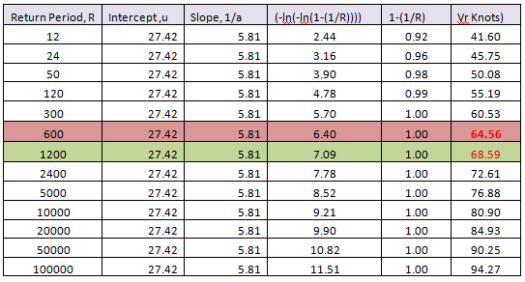

Figure 3 is an excerpt from the Platform A to show the forecasted return period of the wind speed. The X axis will show the month of the return period in logarithmic terms and the Y axis will show the forecast wind speed value. The result can be based on the return period for the predicted wind speed, or the wind speed for the predicted return period.

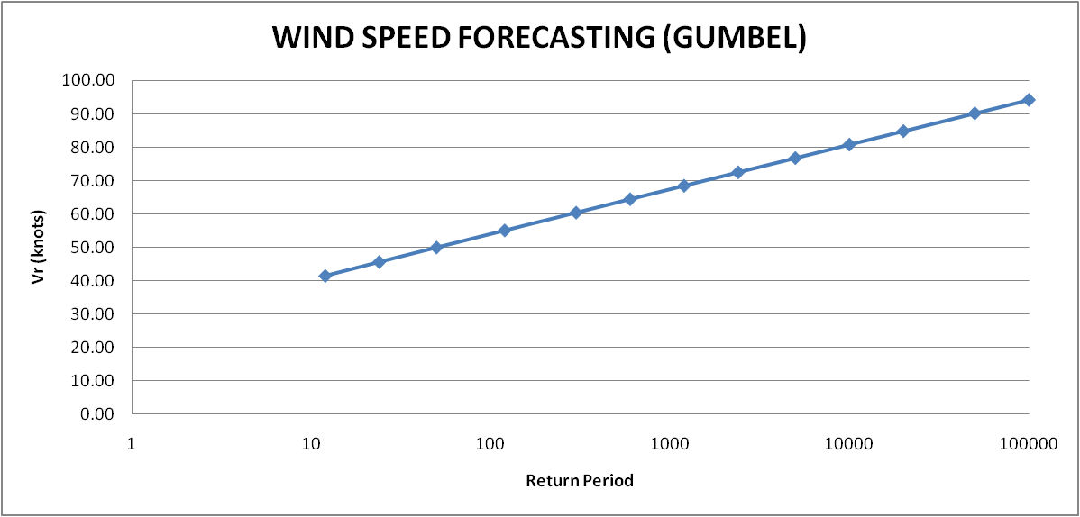

Figure 3 : Wind speed forecasting on logarithmic scale graph

*C. Correlation of wind and wave for 100 years and 50 years*

Table 3 and 4 shows the summary of correlation values between wind and wave for all 6 platforms of concern. Table 3 shows the associated wave return periods based on a 50 or 100 year wind MRI. Table 4 shows the inverse of the process whereby the associated return period of wind is forecasted based on a 50/100 year wave MRI.

TABLE 3

Forecasting of Wave Height and Its' Associated Wind Speed

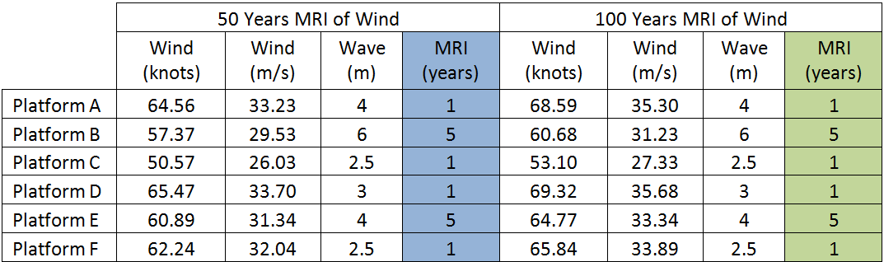

TABLE 4

Forecasting of Wind Speed and Its' Associated Wave Height

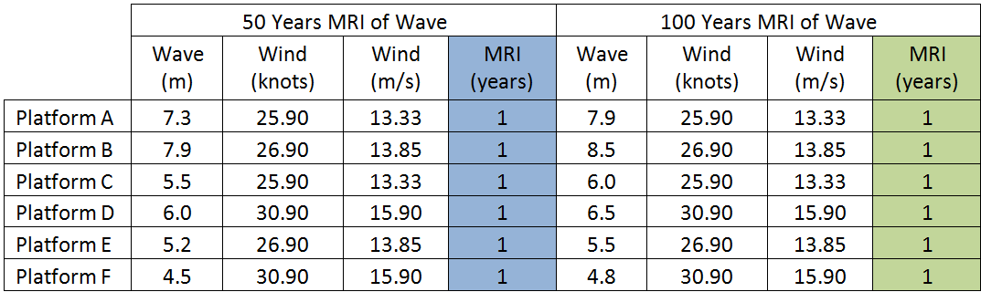

The results indicate that for both 50 and 100 year wave MRI, the resultant wind MRI is only 1year. A comparative study is made for both Figure 5 and Figure 6 against PTS values.

*D. Percentage differences between 50 and 100 years*

TABLE 5

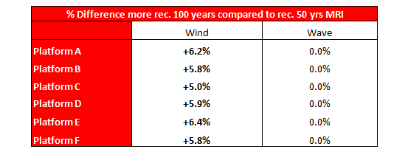Percentage Differences Between 50 and 50 Years MRI

From the percentage difference, we can conclude that there is a marginal increase in design parameters between 50 and 100 year MRI and therefore suggests that 100 year wave MRI and 10 year associated wind MRI is sufficient for design purposes.

Based on the comparison table 6 and 7, it is observed that while there is marginal increase of PTS values in terms of wave height for both cases (maximum at 49.97%), the difference of the associated wind speeds are very large with almost 261.01% increase in the Platform E compared to our joint density analysis results. This indicates a possibility that PTS values for wind speeds may have been overestimated and that the joint density analysis has provided a method to optimize these results.

TABLE 6

Wind Speed Percentage Difference Against PTS

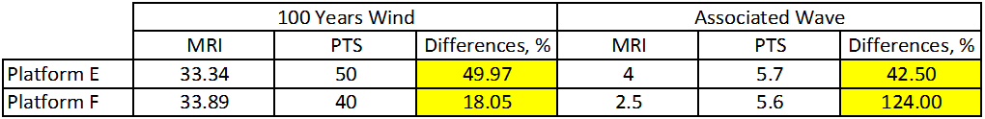

TABLE 7

Wave Height Percentage Difference Against PTS

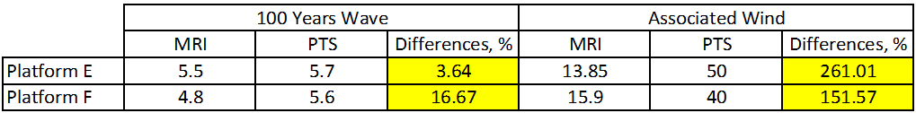

To back these recommended associated wind speed values, a background study is made based on the regional wind speeds for Sabah and Sarawak regions.

Figure 4 indicates that the average wind speed values of the Sarawak and Sabah region vary around 30m/s and thus as such, it closely follows the values of the 50 year wind MRI based on joint density analysis. The PTS values of 40m/s and 50m/s for Platform E and F can be rated as to have been slightly overestimated compared to actual measure values.

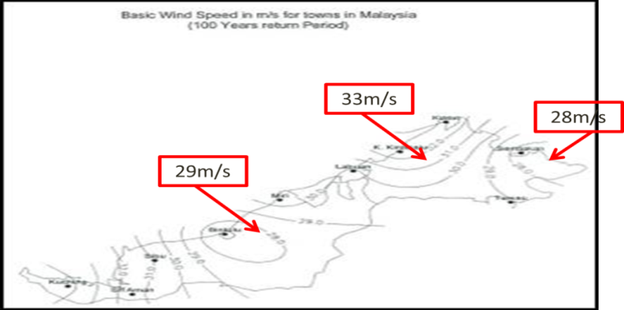

Figure 4 : Wind speed value of the Sarawak and Sabah region

There is however concern of effects of typhoons that pass through the region. Figure 5 to 8 shows the history of category 5 typhoons that have passed through the region from 1995 to present day.

Looking into regional extreme values (typhoon incidents), values although surpass design values, has never breached Malaysian waters due to the combined effects of buffering effect by Philippines as well as the coreolis effect of typhoons during their travel path.

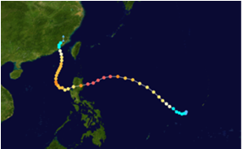

Figure 5 : Megi (2010), 64 m/s

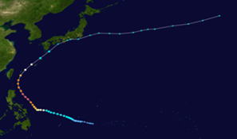

Figure 6 : Songda (2011), 52 m/s

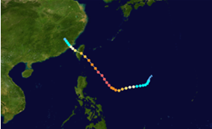

Figure 7 : Sepat (2007), 57 m/s

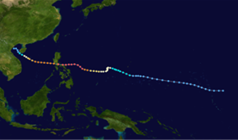

Figure 8 : Angela (1995), 60 m/s

There have however been cases whereby typhoons on a smaller scale have breached into Sabah waters such as Tropical Storm Greg. While it has crossed over into Sabah waters, it has only been at a sustained 1-min wind speed of 21m/s which is far lower than ordinary wind speed values as prescribed by MMS.

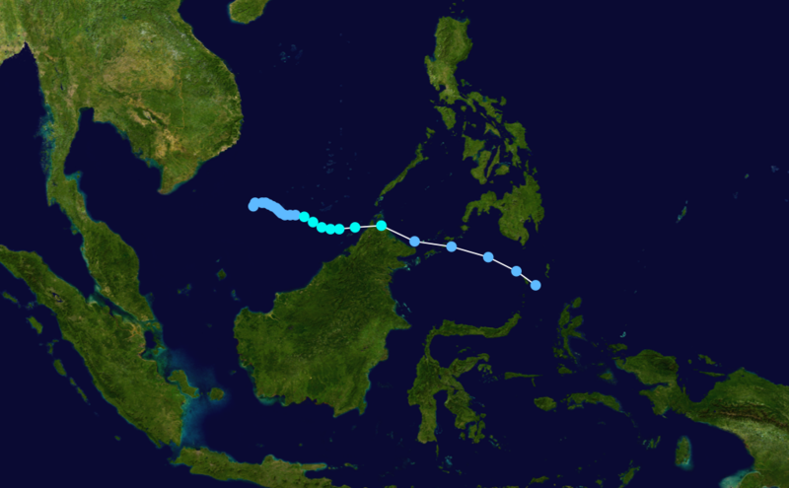

Figure 9 : Path of tropical storm Greg in 1996

# Conclusion

In conclusion, this study has indicated that joint density analysis has provided a key contribution in optimizing current practices and design values. The correlation has clearly demonstrated the relation of the wind speed and the wave height in producing results that vary significantly from combination of environmental loads (traditional practice). The current data analysed is based on 5 years of past data. The forecast can be more accurate if a longer period of data can be provided by the client.

Based on the forecast of associated wind MRI based on 100 year wave MRI and vice versa, we can recommend the following parameters.

TABLE 8

Design MRI for Wind and Wave and its' Associated

|  |  |
| --- | --- |
| **Design MRI** | **Associated MRI** |
| Wind: 100 years | Wave: 10 years |
| Wave: 100 years | Wind: 10 years |

Future research will include the joint densities with ocean current data as provided by the client in the near future. Furthermore, the research will extend by using the hindcast data.

# References

1. Nerzic, R., Frelin, C., Prevosto, M., and Ramus, V. Q. (July 2006). Joint Distribution of Wind/Waves/Current in West Africa and derivation of multivariate extreme I-FORM contours. *The international Offshore and Polar Engineering Conference* , 36-42.
2. Colwell, S., and Basil, B. (2006). Simulation of joint wind and wave loading time histories. ISSC 2006, Dublin Institute of Technology , 117-132.
3. Liu, J. C., Lence, B. J., ASCE, A., Isaacson, M., and ASCE, F. (February 2010). Direct Joint Probability Method for Estimating Extreme Sea Levels. *Journal of Waterway, Port, Coastal, and Ocean Engineering* , 66-76.
4. B., A., and Rober, D. (2006). Weibull. Bryan Donson.
5. Agarwal, P., and Manuel, L. (November 2009). On the Modelling of Nonlinear Waves for Predictiion of Long-Term Offshore Wind Turbine Loads. *Journal of Offshore Mechanics and Arctic Engineering* , 1-8.
6. Pascoal, R., Soares, C. G., and Sorensen, A. J. (May 2007). Ocean Wave Spectral Estimation Using Vessel Wave Frequency Motions. *ASME* , 90-96.
7. Rusu, E. (December 2009). Modelling of Wave-Current Interactions at the Mouths. *JASNOE 2009* , 143-159.
8. Rusu, E. (April 2009). Wave Energy Assessments in the Black Sea. *JASNOE 2009* , 359-372.
9. Soares, C. G., and Arena, F. (November 2009). Nonlinear Crest, Trough, and Wave Height Distribution in Sea States with Double Peaked Spectra. *Journal of Offshore Mechanics and Arctic Engineering* , 1-8.