Bankruptcy Profile of Foreign vs. Domestic Islamic Banks of Malaysia: A Post Crisis period Analysis
Amin Jan¹
Maran Marimuthu²
Mohammad Zahid³
Mohammad Kashif Shad⁴
^{1, 2, 3, 4} Universti Teknologi PETRONAS Malaysia
Correspondence: Amin Jan (E-mail): Amin_jan_khan@yahoo.com

Abstract
After the (2007-2008) subprime financial crisis considering bankruptcy evaluation for the banking industry becomes a paramount. In line of that, this study aims to analyze the bankruptcy profile of foreign vs. domestic Islamic banks in Malaysia. This study predicted 40 percent and 75 percent bankruptcy in the subjected samples of foreign and domestic Islamic banks of Malaysia respectively. However, the specific reason behind this variation in their bankruptcy rates is tagged with the significant difference in their liquidity ratio i.e. (1.59) by foreign and (0.41) by the domestic Islamic banks sample. The ANOVA results revealed that, the sample of foreign and domestic Islamic banks of Malaysia do differ significantly on bankruptcy rates as well as on the top bankruptcy’s predictors namely liquidity, profitability, and insolvency. However, the sample does not vary on productivity with regards to bankruptcy exposure. Furthermore, the regression results revealed that, liquidity, profitability, and insolvency ratios in the sample of domestic Islamic banks, while only insolvency ratio in the sample of foreign Islamic banks have a significant positive relationship with bankruptcy in Islamic banking industry of Malaysia. Moreover, in the context of identified bankruptcy rates, the analysis here is viable to witness the sustainability ratings possessed by the sample of foreign and domestic Islamic banks of Malaysia.

Key words: Bankruptcy, Sustainability, Foreign Islamic Banks, Domestic Islamic Banks, Financial Characteristics
JEL classification: A10, C01, C12, C33, C50, C53
- Introduction
After the subprime crisis, bankruptcy evaluation for the banking industry becomes a paramount (Laurent Clerc, 2015; Nair, Purohit, & Choudhary, 2014), this is because the banking industry holds a pivotal position in a country’s economy. And due to the central role of the banking industry, it accounts for the sustainable economic growth and development of the country (Brown, 2003; Hanif, Tariq, Tahir, & Momeneen, 2012; Jeucken & Bouma, 1999; Olson & Zoubi, 2011; Safiullah, 2010). As a result of this intermediate and delicate role associated with the banking industry in the world financial system, if on one hand it is responsible for the achievement of sustainable economic growth and stability of the country. Similarly on the other hand, it is also culpable for any threat or deterioration cause to the country’s financial system as a result of inefficient banking performance (Cecchetti, 2015; Iman van Lelyveld, 2006).
The importance of banking industry in the global financial world can also be vestige to the recent past subprime crisis of (2007-2008). When the topple of gigantic world banks like the, Citigroup New York, Anglo Irish bank and Lehman Brother’s investment bank etc. swayed the momentum of the global financial system. Considering this nicety of banking industry, its regular bankruptcy appraisement seems as good as mandatory (Jan & Marimuthu, 2015b; Rashid & Nishat, 2009). In the views of (Jan & Marimuthu, 2015a; Swamy, 2014) the urge for adopting an efficient sustainable banking model becomes more vital where the domination of banking industry in the economy has reached up to 80 percent, because the collapse in such case may lead towards an economic crisis inside the area of its reach.
However, instead of an utmost importance for the banking industry to use an efficient bankruptcy evaluation model in order to stay sustainable, yet the bungling of business seems as a common anomaly, with a few organizations coming up short while the others are supplanting them, known as enter and exit phenomena (Chieng, 2013). But the more important thing is to analyze and pinpoint the coming financial distress if any, and take remedial measures for minimizing its effects on the financial health of businesses (Helmut Elsinger, 2006). In business terms, this process is known as the early warning systems (EWS) or systematic risk identification (Elsinger, Lehar, & Summer, 2005). Cihak and Hesse (2010) argued that, instead of being the sheer importance for bankruptcy and sustainability prediction, unfortunately in the case of Islamic banking industry (EWS) has been widely over sighted. Moreover, the literature on Islamic banking with regard to bankruptcy and sustainability is found to be scarce (Jan & Marimuthu, 2015b).
The focus of this study is to address the highly important, but rather neglected area in Islamic banking industry i.e. bankruptcy and sustainability evaluation. However, to bring it a level up, instead of just computing the overall country’s bankruptcy evaluation, this study pioneered the concept of comparing the sustainability strategies adopted by foreign and the domestic Islamic banks as well. For that purpose, we choose Malaysian Islamic banking Industry. The reasons for choosing Malaysia Islamic banking industry is because, it is composed of sufficient foreign and domestic Islamic banks. Secondly, in line of its higher bankruptcy rate identified by researchers like (Jan & Marimuthu, 2015b), this study will helps the researchers to understand the share of foreign and domestic Islamic banks in the overall bankruptcy rate.
  - Problem Statement
In line with the absolute importance of banking industry in the global financial system (Jan & Marimuthu, 2015b) carried out a study on the sustainability profile of the top five Islamic banking countries ranked by global banking assets. However, according to the results of the study, Malaysian Islamic banking industry cataloged the highest bankruptcy rate of 89 percent. The point of discussion here is that, the Malaysian Islamic banking industry is composed of foreign and domestic Islamic banks, and in the context of the higher bankruptcy rate identified by researchers, we do not know whether or not the foreign and domestic Islamic banks of Malaysia are contributing uniformly to overall bankruptcy rate, or they are contributing with different proportion.?
  - Significance of the Study
Firstly, the testimony of bankruptcy rates for foreign and domestic Islamic banks in Malaysia will lead us towards the illumination of bankruptcy rates of both the sample, on the basis of which we can predict that what is the proportion of foreign and the domestic Islamic banks in the overall bankruptcy rate of Malaysian Islamic banking industry. Secondly, the bankruptcy rates identification may prove help full for the sample with higher bankruptcy rate to inspect the reasons for its failure, and also to consider and ratify the sustainability strategies adopted by the sample with lower bankruptcy rate in order to stay viable.
- Literature Review
  - Islamic Banking Industry in Malaysia
According to Kaleem (2000) domestically in Malaysia the notion of Islamic banking and finance can be vestige to 1969 with the establishment of an Islamic investment and saving institution, known as the Pilgrims Management and Fund Board (Lembaga Tabung Haji). The enacting of any Islamic financial institutions, and banking services in Malaysia is confined to the Shariah Advisory Council (SAC) administered by the national bank of Malaysia i.e. Bank Negara Malaysia. According to Bank Negara Malaysia, collectively 20 Islamic banks are operating in Malaysia out of which 9 are international and foreign owned banks, while the others are domestic. The details of the banks are shown in the table below.
Table 1. Islamic Banks Operating in Malaysia (Bank Negara Malaysia)
 | Domestic Islamic Banks | International and Foreign Owned Islamic banks
01 | Al Rajhi Banking & Investment Co Bhd | 12 | PT. Bank Shariah Muamalat Indonesia, Tbk
02 | Public Islamic Bank Berhad | 13 | Al-khair International Islamic Bank Berhad
03 | Bank Islam Malaysia Berhad | 14 | Al Rajhi Banking & Investment Corporation
04 | Am Islamic Bank Berhad | 15 | Deutsche Bank Aktiengesellschaft
05 | RHB Islamic Bank Berhad | 16 | Asian Finance Bank Berhad
06 | May Bank Islamic Berhad | 17 | HSBC Ammnah Malaysia Berhad
07 | Bank Muamalat Malaysia Berhad | 18 | Kuwait Finance House (Malaysia) Berhad
08 | Hong Leong Islamic Bank Berhad | 19 | OCBC Al-Amin Bank Berhad
09 | Alliance Islamic Bank Berhad | 20 | Standard Chartered Saadiq Berhad
10 | CIMB Islamic Bank Berhad
11 | Affin Islamic Bank Berhad
Source: http://www.bnm.gov.my/?ch=li&cat=islamic&type=IB&lang=en
http://www.bnm.gov.my/index.php?ch=li&cat=iib&type=IIB&fund=0&cu

  - Shariah Supervisory Model in Malaysia
The Shariah governance authority of Malaysia has adopted a pro-active approach, because the proponents have strong faith in a centralised regulatory framework. Therefore, the Bank Negara Malaysia (BNM) in 2009 enacted the Shariah Advisory Council (SAC) and it is considered the sole authority to look after all matters in the Islamic banking industry. However, the SAC is enacted to work under the country’s central bank (BNM). Therefore, the Shariah supervisory approach adopted by the Islamic banking industry in Malaysia is centralised (NuHtay & Salman, 2013).
  - Opportunities for Islamic banking in Malaysia
Other than the difficulties confronted by Malaysian Islamic banking industry, there lies some opportunities for Islamic banking industry as well. With the possession of third highest Islamic banking assets share worldwide Malaysia is set third on the rundown of worldwide Islamic banking assets (The banker, KFHR, Bloomberg, Islamic financial service industry stability report, 2013 page.26). Moreover, according to statistics of (Horizon, 2008) Malaysia got the second highest global Sukuk share of 31 percent.
Table 2. Compound annual growth rate (Assets) of Islamic banking industry in percentage
S.N | Country | CAGR  (2006-2010) | CAGR  (2008-2012) | Decline
01 | Bahrain | 22.0 | 02.0 | 20.0
02 | Kuwait | 22.0 | 06.0 | 16.0
03 | Saudi Arabia | 19.0 | 11.0 | 08.0
04 | Qatar | 39.0 | 31.0 | 08.0
05 | UAE | 16.0 | 14.0 | 02.0
05 | Malaysia | 19.3 | 20.0 | 0.07  0.7

Increase in CAGR (2006-2012)

Source: World Islamic bank competitiveness report year 2011/2012 and 2013/2014.
Jan, A., & Marimuthu, M. (2015). Sustainability Profile of Islamic Banking Industry: Evidence from World Top Five Islamic Banking Countries. International Journal of Economics and Finance, 7(5), p125.
The above Table 2 demonstrates that out of the top Islamic banking countries, Malaysia is the main nation which Compound Annual Growth Rate of (Assets) expanded for the time of (2006-2010), notwithstanding, the increment is exceptionally minor. Other than Malaysia, an obvious decrease in the Compound Annual Growth Rates for the major Islamic banking countries can be seen. The majority of the above focuses demonstrates the quality and predominance of Malaysian Islamic banking industry. On the other hand, the significant opportunity for the advancement of Islamic banking industry of Malaysia exists within these qualities.
  - Challenges for Islamic banking in Malaysia
The significant difficulties in regards to Islamic banking in Malaysia are profoundly connected with the un-legality of Islamic principles in some of the offered Islamic banking products in Malaysia. Sudin Haron (2004) speculated that due to the discrepancy of Shariah board guidelines in offered products, the Islamic banking industry is not fully embraced by the Muslims. However, Samad and Hassan (1999) distinguished the inadequacy of skilled and educated workers appointed by Islamic banks as the real explanation behind not grasping Islamic products in Malaysia. In addition, Islamic banking experts in Malaysia are utilizing a few ideas which are considered lawful as per the Malaysia Shariah board, however are seen in contrast with the Sharia standards in the other Islamic banking nations, such as the concepts of, Bay-al-Dayn and Dawa-to-Ajjal etc. and numerous Middle Eastern Islamic scholars are contradicting with the researchers in Malaysia about the ramifications of these standards (SNA Haron, 2000).
As indicated by Chong and Liu (2009) Islamic banking is considered as a profit and loss sharing business in principle. However, in all actuality there is no distinctions between the profit and loss sharing criteria in the Islamic banking industry with the profit and loss sharing criteria set by conventional banks in Malaysia. Also, the development of Islamic banking in Malaysia did not happen because of its ostensible criteria of profit and loss sharing (PLS), but the development happened because of the Islamic banking resurgence around the world (Chong & Liu, 2009).
The significant challenges lies for Islamic banking industry in Malaysia is its most astounding bankruptcy rate. As indicated by the study completed by (Jan & Marimuthu, 2015b) in line with the sustainability profile of the main five Islamic banking countries ranked by global banking assets concluded that, bankruptcy rate of Malaysian Islamic banking industry discovered to be most noteworthy in the tested sample i.e. with 89 percent bankruptcy rate. Considering such a high bankruptcy rate, it is a major challenge for the Malaysian Islamic banking industry to come back to the track.
  - Performance Indicators used for Measuring Foreign vs. Domestic Islamic banks performance
Different performance indicators are utilized as a part of measuring the financial performance of foreign versus local Islamic banks. Inline to that (Muda, Shaharuddin, & Embaya, 2013) analyzed the performance of local versus foreign Islamic banks in Malaysia utilizing different performance indicators. The study found that foreign Islamic banks were more profitable, and a reasonable distinction between domestic and foreign Islamic bank profitability determinants was noticed. However, the study additionally inferred that the profitability of the local Islamic banks was influenced by the worldwide financial crisis. In contrast, the profitability of foreign Islamic banks did not influenced by the financial crisis.
Sufian (2007) measured the proficiency of the foreign and domestic Islamic banks in Malaysia utilizing DEA procedures. The study recommended that the performance of Islamic banking in Malaysia declined in the year 2002. However, a slight increase was seen in the years 2003 and 2004. Besides, the study reported that local Islamic banks were more effective contrasted with foreign Islamic banks.
Bashir (2003) concentrated on the profit and productivity of 14 Islamic banks from eight Middle Eastern nations by utilizing distinctive performance indicators. The specimen involved foreign and domestic Islamic banks. On the other hand, the performance indicators utilized as a part of the study contained banks specific variables, macro-economic variables, and structural variables. Additionally, the study recommended that the high loan to asset ratio and high leverage ratios lead to higher profitability. Moreover, the study reported that the foreign Islamic banks were more profitable than those of the domestic Islamic banks in the selected sample.
- Objectives of the Study
- To examine the bankruptcy rates of foreign and domestic Islamic banks operating in Malaysia.
- To perform a comparative analysis among foreign and domestic Islamic banks of Malaysia on the top bankruptcy predictors.
- To examine the impact of an individual performance indicator with bankruptcy in the Islamic banking industry of Malaysia.
- Methodology
  - Selection of Bankruptcy Model
According to Kumar and Ravi (2007) the area of bankruptcy forecasting has been widely considered and turned into the area of pursuit for many researchers since 1960's. In line with that Beaver (1966) completed the most punctual work done in the field of bankruptcy by building up a univariate bankruptcy model with the assistance of distinctive financial ratios. However, on the premise of its univariate nature i.e. forecast of only one variable at time, the model faced a lot of criticism. Altman (1968) postmarked the criticism made on earlier Beaver's model by establishing a new Z-score bankruptcy model utilizing multivariate procedure surprisingly. Altman's model opened new aspects in the field of bankruptcy and in this manner the Z-score model turned out to be exceptionally well known in bankruptcy literature because of its most noteworthy precision level i.e. 94 percent accuracy level. Deakin (1972) additionally criticized the univariate nature of prior Beaver's model and revamp his model in multivariate perspective for accomplishing higher accuracy. Altman, Haldeman, and Narayanan (1977) established new bankruptcy model called the Zeta-model, in that new Zeta-model the study presented some new variables for discovering financial distress. Ohlson (1980) presented another idea in bankruptcy literature by pioneering logistic regression and built up another bankruptcy model, however the model experienced a lot of criticism on the premise of its complication. Mossman, Bell, Swartz, and Turtle (1998) compared the top accessible bankruptcy models and appraised Altman model as the best indicator for bankruptcy because of its highest accuracy and ratio built nature, as the ratios are the best indicators in discovering bankruptcy (Altman, 1968; Chieng, 2013; Mossman et al., 1998; Pompe & Bilderbeek, 2005). Also, because of the precision and prevalence of Altman bankruptcy model (Altman, 2000) tended to all the criticism made on earlier bankruptcy models particularly on (Altman, 1968) and (Altman et al., 1977) and reexamined both the earliest models as per need of time, the new models are talked about as under.
Table 3. Available Formulas in Altman Models
If public firm | Z = 1.2x1 + 1.4x2 + 3.3x3 + 0.6x4 + .999x5
If private firm | Z = 0.717x1 + 0.847x2 + 3.107x3 + 0.420x4 + 0.998x5
If service firm | Z = 6.56x1 + 3.26x2 + 6.72x3 + 1.05x4
Source: Altman, E. I. (2000). Predicting financial distress of companies: Revisiting the Z-score and Zeta Models. Journal of Banking & Finance.
Total of three equations are utilized as a part of Altman's bankruptcy model as demonstrated in the above Table 3. For manufacturing firms the formula is partitioned into two sets i.e. public and private. While foreseeing the bankruptcy of service industry like the banking industry, Altman presented a separate service firm model (Altman, 2000).
  - Altman Model for Service Firms
Altman model is a linear model accredited out with distinctive weights. The model is being utilized by different researchers over the duration of time. Georgios (2012) utilized Altman model on Greek banking industry and discovered the model extremely exact in discovering bankruptcy. (Chieng, 2013) tested Altman model on Euro zone banks and reported the model 100 percent precise in discovering bankruptcy. Sharma (2013) utilized Altman model on Indian banking industry and reported the exactness of the model with 70 percent. Mamo (2011) exercised Altman model on Kenyan banking industry and reported the model 90 percent precise in general.
  - Areas of Discrimination for Altman Service Firm model
Z = 6.56X1 + 3.26X2 + 6.72X3 + 1.05X4

As indicated by Altman (2000) if the estimation of Z-score discovered more than 2.90 the firm will be evaluated in the (Safe) zone, if the estimation of Z-score discovered under 1.21 the firm will be placed in (Bankruptcy zone). However, if the estimation of Z-score lied in the middle of 1.21 < Z < 2.9 the firm is said to be in the (Grey) zone, in fact (Grey) zone is technically called the safe zone but with high alert.
  - Explanatory Variables
Z-score = Z-score is the dependent variable which is utilized to indicate bankruptcy. Higher the Z-score more secure is the bank and the other way around.
There are four independent variables in Altman model of service firm’s i.e.
X1 =Working Capital / Total Assets.
This proportion measures the liquidity of the organizations. As liquidity is the most essential viewpoint in discovering bankruptcy.
X2 =Retained Earnings / Total Assets.
This proportion measures the aggregate profitability of the organizations.
X3 =Earnings before Interest and Taxes / Total Assets.
This proportion measures the aggregate productivity of the organizations that how gainful the association's assets are.
X4 =book value of Equity / Book Value of Total Liabilities.
This proportion is in charge of measuring the indebtedness of the firm. Higher the proportion most secure is the firm and vice versa.
Independent Variables
X1
Liquidity
X2
Profitability
X3
Productivity
X4
Insolvency
Avg Score
Distress zone Z < 1.21

Grey zone
1.21 < Z <2.9
Safe zone Z > 2.9
Bankrupt
Non-Bankrupt
Dependent Variable

Figure 4. Conceptual Frame work of Altman’s model for service firm
Jan, A., & Marimuthu, M. (2015). Bankruptcy and Sustainability: A Conceptual Review on Islamic Banking Industry. Global Business and Management Research: An International Journal, 7(1), 109-138.

In line with evaluating the bankruptcy profile of foreign and domestic Islamic banks of Malaysia, the above Figure 4 shows the conceptual frame work of this study. We applied Altman’s bankruptcy model on the sample of foreign and domestic Islamic banks, and if the bank is found bankrupt, it means that it has weak economic sustainability. On the other hand, if the bank is to found non-bankrupt, it means that it has strong economic sustainability.
  - Hypotheses Development
- Hypothesis One
The first objective of the study is to look at the bankruptcy rates of foreign and domestic Islamic banks working in Malaysia. Then again, inline of the studies like (Jan & Marimuthu, 2015), which recognized the most elevated bankruptcy rate in Malaysian Islamic banking industry, this study will permit us to comprehend the truth that, regardless of whether the foreign and domestic Islamic banks of Malaysia are just as equally bankrupt, or they vary on bankruptcy rates. So, we can anticipate the share of domestic and foreign Islamic banks in the general bankruptcy rate of Malaysian Islamic banking separately. Therefore, the accompanying hypothesis is created.
- H_{0:} Foreign and domestic Islamic banks of Malaysia do not differ on bankruptcy rates.
- H₁: Foreign and domestic Islamic banks of Malaysia do differ on bankruptcy rates.
- Hypothesis Two
The second objective of the study is to perform a comparative analysis among foreign and domestic Islamic banks of Malaysia on the top bankruptcy predictors. Altman (2000) contended that liquidity, profitability, productivity, and insolvency are the top performance indicators for measuring bankruptcy of the service firms. Consequently, this study will lead us to comprehend the way that, regardless of whether the foreign and domestic Islamic banks of Malaysia vary on the top bankruptcy indicators with respect to bankruptcy exposures. And accordingly, the accompanying hypotheses are proposed.
H₀: Foreign and domestic Islamic banks of Malaysia do not differ on performance indicators with regards to bankruptcy exposures.
H₁: Foreign and domestic Islamic banks of Malaysia do differ on performance indicators with regards to bankruptcy exposures
H_{1a}: Foreign Islamic banks of Malaysia do differ on liquidity with regards to bankruptcy exposures.
H_{1b}: Foreign Islamic banks of Malaysia do differ on profitability with regards to bankruptcy exposures.
H_{1c}: Foreign Islamic banks of Malaysia do differ on productivity with regards to bankruptcy exposures.
H_{1d}: Foreign Islamic banks of Malaysia do differ on insolvency with regards to bankruptcy exposures.
H_{1e}: Domestic Islamic banks of Malaysia do differ on liquidity with regards to bankruptcy exposures
H_{1f}: Domestic Islamic banks of Malaysia do differ on profitability with regards to bankruptcy exposures
H_{1g}: Domestic Islamic banks of Malaysia do differ on productivity with regards to bankruptcy exposures
H_{1h}: Domestic Islamic banks of Malaysia do differ on insolvency with regards to bankruptcy exposure
- Hypothesis Three
The third objective is to examine the impact of an individual performance indicator with bankruptcy in Islamic banking industry. Altman (2000) model argues that the four performance indicators namely liquidity, profitability, productivity, and insolvency are the four top variables that measures bankruptcy. Hence, it would be interesting to see the effect of these four variables in Islamic banking context. Therefore, the following hypothesis are developed.
H_{0:} Performance indicators do not have a positive significant impact on bankruptcy profile of the Islamic banking industry.
H_{1:} Performance indicators do have a significant positive impact on bankruptcy profile of the Islamic banking industry.
H_{1a}: liquidity does have a significant positive impact on bankruptcy profile of the Islamic banking industry.
H1_{b}: Profitability does have a significant positive impact on bankruptcy profile of the Islamic banking industry.
H1_{c:} Productivity does have a significant positive impact on bankruptcy profile of the Islamic banking industry.
H1_{d}: Insolvency does have a significant positive impact on bankruptcy profile of the Islamic banking industry.
  - Data Collection
This study is based on secondary data, all the obliged information is taken from the yearly report of delegate banks. The official websites for downloading the obliged yearly reports (2009-2013) is followed by means of http://wiki.islamicfinance.de/index.php/Islamic_financial_institutions.
S.N | Sample of Banks | Starting Date
 | Domestic Islamic Banks
01 | Alliance Islamic bank | 2008
02 | CIMB Bank | 2008
03 | Hong Leong Islamic | 2008
04 | Public Islamic Bank | 2007
 | Foreign Islamic banks
05 | HSBC Ammnah | 2007
06 | KFH Malaysia Berhad | 2005
07 | OCBC Al-Amin | 2003
08 | Asian Finance Bank | 1994
Table 4. Selected Islamic Banks from Malaysia

The above Table 4 demonstrates the list of foreign and domestic Islamic banks of Malaysia chosen for this study. For instance, four foreign and four domestic Islamic banks are taken on the premise of convenient sampling, and considering accessibility of annual reports.

  - Conceptual Frame Work of the Study
Bankruptcy
Yes
Altman’s
Model
Weak Economic Sustainability
Strong Economic Sustainability
Foreign and Domestic Islamic banks of Malaysia
No

Figure 2. Conceptual Frame Work of the Study
- Results and Discussion.
  - Data Normality Tests
The results of data normality tests in particular Shapiro-Wilk and Kolmogorov-Smirnov for the chosen sample of foreign and domestic Islamic banks of Malaysia demonstrated that our data is normally distributed. As the significance values of all the banks in both the samples are found greater than 0.05, which implies that our chosen data is normally distributed.
# | Bank Name | 2009 | 2010 | 2011 | 2012 | 2013 | Avg | Zone | Ranking
 | Sample of Foreign Islamic Banks
01 | HSBC Ammnah | 0.82 | 0.96 | 0.53 | 0.80 | 0.82 | 0.79 | Distress | 06th
02 | KFH Malaysia Berhad | 1.83 | 1.24 | 1.03 | 0.67 | 1.26 | 1.21 | Grey | 04th
03 | OCBC Al-Amin | 1.58 | 2.23 | 1.36 | 2.29 | 2.25 | 1.94 | Grey | 03rd
04 | Asian Finance Bank | 3.16 | 3.21 | 3.74 | 2.84 | 3.23 | 3.24 | Safe | 02nd
05 | Yearly Average | 1.84 | 1.91 | 1.66 | 1.65 | 1.89 | 1.79 | Grey | 00
 | Sample of Domestic Islamic banks
06 | Alliance Islamic bank | 0.93 | 0.87 | 0.76 | 0.69 | 0.65 | 0.78 | Distress | 07th
07 | CIMB Bank | 4.91 | 4.64 | 3.59 | 3.19 | 3.53 | 3.97 | Safe | 01st
08 | Hong Leong Islamic | 0.95 | 1.04 | 0.70 | 0.66 | 0.65 | 0.80 | Distress | 05th
09 | Public Islamic Bank | 0.61 | 0.72 | 0.55 | 0.62 | 0.53 | 0.61 | Distress | 08th
10 | Yearly Average | 1.85 | 1.81 | 1.44 | 1.29 | 1.34 | 1.54 | Grey | 00
Table 5. Z-score Results of all the Selected Banks

The above Table 5 demonstrates the Z-score results (2009-2013) for all the selected foreign and domestic Islamic banks of Malaysia. Firstly, yearly Z-scores is calculated i.e. (2009 to 2013), and afterward a five year Z-score is taken. The zones i.e. (Safe), (Grey), and (bankrupt) are figured on five year average Z-score values. However, as indicated by Altman's (2000) service firms model zone of discrimination which contends that, if the estimation of Z-score is discovered higher than 2.90 the banks is in the (safe zone), if the Z-score value discovered under 1.21 the bank is in the (bankruptcy zone). Then again, if the estimation of Z-score found in the middle of 1.21 and 2.90 the bank is said to be in the (grey zone). In addition, the (grey zone) is in fact considered in the (safe zone) but with higher alert.
In the above Table 5 two foreign Islamic banks of Malaysia are found in the (grey zone), one in the (bankruptcy zone) and only one in the (safe zone) namely Asian Finance Bank. On the other hand, three domestic Islamic banks of Malaysia are found in the (bankruptcy zone) one in the (safe zone) to be specific CIMB Bank. However, from the sample no domestic Islamic bank of Malaysia found in the (grey zone). Later on, the positioning to an individual banks is allotted on the premise of most noteworthy Z-score. CIMB Islamic banks beat the sustainability profile list with the most noteworthy normal Z-score i.e. 3.97, opposite, Public Islamic Bank from domestic Islamic banks catalogued last position on the sustainability list. Be however, considering the sustainability profile, the sample of foreign Islamic banks of Malaysia performed superior than the sample of domestic Islamic banks as it recorded the 2nd, 3rd, and 4th, place separately.
Table 6. Performance Zone of Foreign vs. Domestic Islamic banks of Malaysia
Bankruptcy Rates | 2009 | 2010 | 2011 | 2012 | 2013 | AVG
Foreign Islamic Banks
Bankruptcy zone | 25 | 25 | 50 | 50 | 50 | 40
Grey zone | 50 | 50 | 25 | 50 | 25 | 40
Safe Zone | 25 | 25 | 25 | 00 | 25 | 20
Domestic Islamic banks
Bankruptcy zone | 75 | 75 | 75 | 75 | 75 | 75
Grey zone | 00 | 00 | 00 | 00 | 00 | 00
Safe Zone | 25 | 25 | 25 | 25 | 25 | 25
Overall Bankruptcy
Bankruptcy zone | 50 | 50 | 63 | 63 | 63 | 58
Grey zone | 25 | 25 | 12 | 25 | 12 | 20
Safe Zone | 25 | 25 | 25 | 12 | 25 | 22

The above Table 6 demonstrates bankruptcy rates (2009-2013) for the sample of foreign, domestic and the combine sample of Islamic banks. The yearly bankruptcy rate for representative sample is calculated considering the yearly values of each zone i.e. (safe zone), (bankruptcy zone) and the (grey zone). For instance, if we examine the Z-scores value of foreign Islamic banks for the year 2009 in the previous Table 5 which demonstrates diverse Z-scores for foreign Islamic banks in year 2009 i.e. (0.82), (1.83), (1.58), (3.16) . However, In light of Altman's model zone of discrimination the Z-score value for one bank in the above mentioned values is discovered less than 1.21 i.e. (0.82) therefore, it is set in the bankruptcy zone. In this manner, the proportion of foreign Islamic banks in bankruptcy zone for the year 2009 turned into 25 percent i.e. 1/4*100. Likewise, considering the above information two banks are found in the grey zone i.e. (1.83) and (1.58), hence, the proportion of foreign Islamic banks in (Grey zone) for the year 2009 turned into 50 percent i.e. 2/4*100. In view of one bank found in the (Safe zone) with its Z-score more than 2.90 i.e. (3.16), the proportion of foreign Islamic banks in the (Safe zone) for the year 2009 turned into 25 percent i.e. 1/4*100. Following the same system the bankruptcy rate (2009-2013) is ascertained for every individual zone inside the sample of foreign and domestic Islamic banks of Malaysia.
Considering results of the above Table 6, the rate of the foreign Islamic banking found at 40 percent in the (Bankruptcy zone), 40 percent in the (Grey zone) and just 20 percent in the (Safe zone). On the other hand, the rate of the domestic Islamic bankis found at 75 in (Bankrupt zone), 00 percent in the (Grey zone) and just 25 percent in the (Safe zone). In fact, the Grey zone fall inside the safe zone, yet with high alarm. However, in line of the outcomes it is anticipated that, the sample of foreign Islamic banks of Malaysia is not so much bankrupt but rather more sustainable, on the other hand, the chosen sample of domestic Islamic banks of Malaysia is observed to be more bankrupt and less sustainable. Also, the general bankruptcy rate for the chosen sample of Malaysia Islamic banks is discovered high i.e. 58 percent.
ANOVA | Bankruptcy  Zone | Grey  zone | Safe  Zone
P-Value | 0.000*** | 0.000*** | .569
F-Value | 19.28 | 25.19 | .569
Post Hoc Scheffe Test
Foreign - Domestic | 0.000*** | 0.000*** | 0.569
Foreign - Overall | 0.027** | 0.013*** | 0.874
Domestic - Overall | 0.032** | 0.014** | 0.854
Table 7. ANOVA Results

*significant at 10%, **significant at 5%, and *** significant at 1%.
The first objective of the study was to examine the bankruptcy rates of foreign and domestic Islamic banks working in Malaysia. For this reason different bankruptcy rates were first computed as shown in the previous Table 6. However, the above Table 7 is demonstrating the result of ANOVA Post Hoc Scheffe test in accordance with the hypothesis number one which expresses that,
- H_{0:} Foreign and domestic Islamic banks of Malaysia do not differ on bankruptcy rates.
- H₁: Foreign and domestic Islamic banks of Malaysia do differ on bankruptcy rates.
In the above Table 7, the P-value of bankruptcy zone is exceptionally noteworthy at 1 percent i.e. 0.000. Therefore, the alternative hypothesis of the study is supported, and it implies that, the foreign and domestic Islamic banks of Malaysia do differ on bankruptcy rates. Also, the results of Post Hoc Scheffe test is demonstrating that, which sample is differentiating to which sample, on which zone and on what significance rate. For instance, the results of Post Hoc Scheffe test concerning bankruptcy zone demonstrates that, the foreign and domestic Islamic banks of Malaysia differ at 1 percent, foreign and overall sample differ at 5 percent, while, domestic and the overall sample additionally differ at 5 percent on bankruptcy zone. On grey zone the sample of foreign and domestic Islamic banks differs at 1 percent, foreign and the overall sample additionally differ at 5 percent, however domestic and the overall sample differs at 5 percent on the grey zone. Besides, the relationship of foreign and domestic Islamic banks of Malaysia discovered insignificant on the safe zone, due to its insignificant P-value.
Banks | Average  Liquidity | Average  Profitability | Average  Productivity | Average  Insolvency | Z-Score
Domestic Islamic banks
Alliance Islamic bank | 0.54 | 0.04 | 0.10 | 0.10 | 0.78
CIMB Bank | 0.14 | 0.28 | 0.59 | 2.97 | 3.98
Hong Leong Islamic | 0.61 | 0.04 | 0.07 | 0.08 | 0.81
Public Islamic Bank | 0.37 | 0.03 | 0.13 | 0.08 | 0.61
Average Ratio | 0.41 | 0.09 | 0.22 | 0.80 | 1.54
Foreign Islamic banks
HSBC Ammnah | 0.53 | 0.06 | 0.08 | 0.12 | 0.79
KFH Malaysia Berhad | 0.96 | -0.12 | 0.11 | 0.22 | 1.17
OCBC Al-Amin | 1.79 | 0.03 | 0.05 | 0.07 | 1.94
Asian Finance Bank | 3.10 | -0.06 | -0.02 | 0.22 | 3.24
Average Ratio | 1.59 | -0.02 | 0.05 | 0.15 | 1.79
Table 8. Specific Reasons for Difference in Bankruptcy Rates

The above Table 8 demonstrates the five year (2009-2013) average values of all the performance indicators which are used in Altman model for evaluating bankruptcy. In short, the results of Altman bankruptcy model are dependent on the values of all the performance indictors namely liquidity, profitability, productivity, and Insolvency. The main reason for the difference between the bankruptcy rates of domestic Islamic banks i.e. 75 percent and that of foreign Islamic banks with 40 percent is because of the difference in both countries liquidity. As the above Table 8 clearly demonstrates that the foreign Islamic banks of Malaysia are more liquid than that of domestic Islamic banks. This high liquidity factor ultimately became the reason for low bankruptcy, and high sustainability for foreign Islamic banks as compared to the sample of domestic Islamic banks of Malaysia in the overall calculation process of Altman’s model. Furthermore, the results also revealed that, domestic Islamic banks are more productive and more profitable, but its impact has been surpass by the higher liquidity by foreign Islamic banks in the overall calculation process of the model.

Table 9. Comparative Analysis on top Bankruptcy Predictors
Particular | Foreign Islamic Banks |  | Domestic Islamic Banks
ANOVA Test | P-Value | F-Value | P-Value | F-Value
Liquidity | 0.000*** | 59.36 | 0.000*** | 14.34
Profitability | 0.010*** | 5.269 | 0.000*** | 26.56
Productivity | 0.32 | 1.264 | 0.000*** | 45.44
Insolvency | 0.000*** | 34.53 | 0.000*** | 92.66
*significant at 10%, **significant at 5%, and *** significant at 1%.
The above Table 9 demonstrates the comparative Analysis of foreign and domestic Islamic banks with regards to bankruptcy exposures. For saturating the second objective of the study i.e. to perform a comparative analysis among foreign and domestic Islamic banks of Malaysia on the top bankruptcy predictors, this study applied ANOVA test. On the other hand, Altman (2000) contended that liquidity, profitability, productivity, and insolvency are the top performance indicators for measuring bankruptcy of the service firms. Subsequently, this comparative investigation for foreign Islamic banks sample on the top bankruptcy indicators demonstrates that, the P-value for liquidity, profitability, and insolvency is exceptionally noteworthy at 1 percent. However, the value of productivity is found to be insignificant in foreign Islamic banks sample. This implies that the sample of foreign Islamic banks do differ on these bankruptcy pointers. Therefore, the alternative hypotheses of the study are supported i.e..
H_{1a}: Foreign Islamic banks of Malaysia do differ on liquidity with regards to bankruptcy exposures.
H_{1b}: Foreign Islamic banks of Malaysia do differ on profitability with regards to bankruptcy exposures.
H_{1d}: Foreign Islamic banks of Malaysia do differ on insolvency with regards to bankruptcy exposures.
On the other hand, the comparative investigation of domestic Islamic banks on the top bankruptcy indicators demonstrates that, all the performance indicators in particular, liquidity, profitability, productivity, and insolvency do differ on these indicators with regards to exposures. And hence the alternative hypotheses are supported with argued that
H_{1e}: Domestic Islamic banks of Malaysia do differ on liquidity with regards to bankruptcy exposures
H_{1f}: Domestic Islamic banks of Malaysia do differ on profitability with regards to bankruptcy exposures
H_{1g}: Domestic Islamic banks of Malaysia do differ on productivity with regards to bankruptcy exposures
H_{1h}: Domestic Islamic banks of Malaysia do differ on insolvency with regards to bankruptcy exposures

Table 10. Correlation Matrix
Particulars | Domestic Islamic Bank |  |  |  |  | Foreign Islamic Banks
Variables | Z-Score | Liquidity | Profitability | Productivity | Insolvency | Z-Score | Liquidity | Profitability | Productivity | Insolvency
Z-score (Bankruptcy) | (1) |  |  |  |  | (1) | .960*** | -.158 | -.528* | .007
Liquidity | -.054 | (1) |  |  |  |  | (1) | -.284 | -.610** | .081
Profitability | .501** | -.556* | (1) |  |  |  |  | (1) | .450* | -.619**
Productivity | .358 | -.709*** | .309 | (1) |  |  |  |  | (1) | -.385*
Insolvency | .699*** | -.367 | .490** | .624*** | (1) |  |  |  |  | (1)
***significant at 1%, **significant at 5%, *significant at 10%
r= ± 0.5—0.8 in between (Medium correlation)
r= ± 0.8 or higher (Strong correlation)
r= ± 0.4 or lower (Weak correlation)
The above Table 10 shows correlation results for the sample of foreign and domestic Islamic banks of Malaysia. From the sample of domestic Islamic banks the p-values of variables profitability and insolvency ratio are found significant with 5% and 1% respectively. Moreover, the values of their coefficients are also positive with .501 and .699 respectively. This means that these variables have a medium positive correlation with Z-score which represents bankruptcy. On the other hand, from the sample of foreign Islamic banks the p-values of variables liquidity and productively ratios are found significant with 1% and 10% respectively. However, considering their coefficient values, the profitability ratio got a positive significant, while productivity ratio got a weak negative correlation with dependent variable Z-score.
Variables | Domestic Islamic Banks |  |  |  | Foreign Islamic Banks
Z-Score | Coef. | T-value | Prob. | VIF | Coef. | T-value | Prob. | VIF
Constant | -2.26 | -1.984* | .066 | 3.298 | 0.458 | 1.033 | .318 | 1.708
Liquidity | 4.633 | 2.774*** | .014 | 2.117 | 0.957 | 7.191*** | .000 | 1.814
Profitability | 7.280 | 2.707*** | .016 | 3.664 | 0.863 | .732 | .475 | 1.983
Productivity | 2.785 | 1.593 | .132 | 2.385 | 0.224 | .181 | .859 | 1.777
Insolvency | 0.469 | 1.871* | .081 | 3.298 | -1.72 | -.922 | .371 | 1.708
R-Squared |  |  | 0.69 |  |  |  | 0.40
Table 11. Regression Results
***significant at 1%, **significant at 5%, *significant at 10%
- Overall statistics
The third objective of the study was to examine the impact of an individual performance indicator on bankruptcy profile of the Islamic banking industry. In line of that, the above Table 11 shows the regression results for the sample of foreign and domestic Islamic banks. The overall statistic shows that the R² for the sample of domestic Islamic banks is 0.69, while for foreign Islamic banks of Malaysia is 0.40 respectively. In consonant to R-squares the error term for the sample of foreign Islamic banks is 0.31, and that of domestic Islamic banks is 0.60 respectively. The dependent variables in this study is Z-score which represents bankruptcy, however, according to Altman Z-score interpretation higher is the Z-score lower will be the chances of bankruptcy and vice versa. For explaining the expected change in the dependent variable (Z-score) this study used the unstandardized coefficient, because the data scale used in this study i.e. ratio is well known in daily use. While on the other hand, the standardised coefficients are used when a study sets a unique scale for data which is not commonly used. The T-values shows the confidence level and the significance of an individual variable in the model. Furthermore, the results of VIF confirms no signs of multicollinearity in the model, as the VIF values for all the independent variables in foreign as well as domestic Islamic banks samples are found less than the default thresh hold for multicollinearity i.e. 10.
- Regression Results for Domestic Islamic banks
- Regression Model
Z = -2.263 + 4.633 _{Liquidity} + 7.280 _{Profitability} + 2.785 _{Productivity} +0 .469 _{Insolvency}+0.31_{ƩT}

From the sample of domestic Islamic banks of Malaysia the p-value of variables liquidity, profitability, and insolvency ratio are found significant with 10%, 1% and 1% respectively, moreover, the values of their unstandardized coefficient beta are also found positive i.e. 4.633, 7.280 and 2.785 respectively. This means that these variables have a significant positive relation with (Z-score) which represents bankruptcy. As higher Z-score represents lower, while lower Z-score represents higher bankruptcy. In line of that, a unit increase in liquidity, profitability, and insolvency ratios will increase the values of Z-score with 4.633, 7.280, and 2.785 units respectively. Hence, in this case the alternative hypotheses of the study are supported. Which argued that, liquidity, profitability, and insolvency ratios have a significant positive relationship with bankruptcy in Islamic banking industry of Malaysia. While the performance indicator productivity got insignificant relation, therefore, the null hypothesis in this case is supported.
- Regression Results for Foreign Islamic banks
- Regression Model
Z = 0.458 + 0.957 _{Liquidity} +0 .863 _{Profitability} + 0.224 _{Productivity} - 1.721 _{Insolvency}+0.60 _{ƩT}
From the sample of foreign Islamic banks of Malaysia the p-value of only one variables i.e. liquidity is found significant with 1%, and moreover, the value of its unstandardized coefficient beta is also found positive with 0.975. This means that liquidity has a significant positive relation with (Z-score) which represents bankruptcy. In line of that, a unit increase in liquidity ratio will increase the values of Z-score with 0.975 units respectively. However, the higher Z-score represents lower, while lower Z-score represents higher bankruptcy hence, in this case the alternative hypothesis of the study is supported. Which argued that, liquidity ratio has a significant positive relationship with bankruptcy in Islamic banking industry of Malaysia. Moreover, the performance indicator profitability, productivity, and insolvency have insignificant relation, therefore, the null hypothesis in their case are supported.
- Conclusion
For saturating the first objective of the study i.e. is to examine the bankruptcy rate of foreign and domestic Islamic banks of Malaysia, this study categorised the financial performance of Islamic banks into three zones i.e. the (Safe zone), the (Grey zone) and the (Bankruptcy zone) using Altman Model. The sample of foreign Islamic banks found 40 percent in the (Bankruptcy zone), 40 percent in the (Grey zone) and just 20 percent in the (Safe zone).On the other hand, the sample of domestic Islamic banking found 75 percent in the (Bankruptcy zone), 00 percent in the (Grey zone) and just 25 percent in the (Safe zone). The ANOVA results uncovered that, the foreign and domestic Islamic banks of Malaysia do differ on (Bankruptcy zone) and (Grey zones). However, the sample of foreign and domestic Islamic banks of Malaysia do not differ on the financial characteristics of the (safe zone). In the line of identified bankruptcy rates i.e. 75 percent by domestic and 40 percent by the sample of foreign Islamic bank, it is anticipated that the sample of foreign Islamic banks of Malaysia is more sustainable. While the sample of domestic Islamic banks is accounted for to be more bankrupt and less sustainable. This study found out that, the higher five year average liquidity by foreign Islamic banks i.e. (1.59), compared to the lower average liquidity ratio i.e. (0.41) by domestic Islamic banks to be the specific factor behind the lower bankruptcy rates i.e. 40 percent by foreign Islamic banks, and the highest bankruptcy ratei.e. 75 percent by domestic Islamic banks sample respectively. These findings are consistent with the findings of (Marin, 2013; Nance, Smith Jr, & Smithson, 1993) which argued that more liquid firms have low changes of default as compared to less liquid firms.
The above findings are in contrast with the finding of (Sufian, 2007) which contended that domestic Islamic banks of Malaysia are efficient than foreign Islamic banks, however the findings are inline and supporting the past finding by (Muda et al., 2013) which said that the performnace of foreign Islamic banks of Malaysia are better than domestic Islamic banks. In addition, the findings of this study may be help full for the practitioners of domestic Islamic banks in Malaysia to take remedial measures for minimising its higher bankruptcy rate of 75 percent. Whatsoever, the foreign and domestic Islamic banks of Malaysia needs to eliminate or reduce this mismatch between the cross-border banks performnace, because the financial performance mismatch between the cross-border banking is detrimental for smooth running of the country’s financial system (Degryse & Nguyen, 2007).
According to the second objective of the study i.e. to perform a comparative analysis among foreign and domestic Islamic banks of Malaysia on the top bankruptcy predictors, the results uncovered that, the sample of foreign and domestic Islamic banks do differ on bankruptcy predictors namely liquidity, profitability, and insolvency. While on productivity the sample of foreign Islamic banks does not vary. On the other hand, the sample of domestic Islamic banks do vary on all the main four bankruptcy indicators recognized by (Altman, 2000) namely liquidity, profitability, productivity, and insolvency. These discovering may help the researchers and professionals to comprehend the impact and result of all the main four bankruptcy indicators in term of foreign and domestic Islamic banks in point of interest, however, this process may also leads into the development of a separate bankruptcy and sustainability diagnosing model for domestic as well as the foreign Islamic banks of Malaysia.
In consonant with the third objective which is to examine the impact of an individual performance indicators in Islamic banking industry of Malaysia the regression results demonstrated that, liquidity, profitability, and insolvency have a significant positive relationship with bankruptcy of domestic Islamic banks of Malaysia. While productivity ratio is found to have an insignificant relation with bankruptcy in domestic Islamic banks of Malaysia. On the other hand, the regression result for the sample of foreign Islamic banks of Malaysia revealed that, only liquidity ratios have a significant positive relationship with bankruptcy profile of foreign Islamic banks of Malaysia, while performance indicators profitability, productivity, and insolvency ratios are found to have an insignificant relationship with bankruptcy profile of the sample of foreign Islamic banks of Malaysia.
  - Suggestion for further study
As this study analysed the bankruptcy profile of foreign and domestic Islamic banks in Malaysia for the period (2009-2013). However, the tested period is considered as the post subprime crisis period, and according to the practitioners of Islamic banking industry, the post subprime crisis period is considered to the transformational or recovery period from the crisis effects. However, to testify that claim it would be rather interesting to compare the bankruptcy profile of foreign and domestic Islamic banks of Malaysia for the pre and post subprime crisis period i.e. (2003-2008) and (2009-2013).
- References:
Altman, E. I. (1968). Financial ratios, discriminant analysis and the prediction of corporate bankruptcy. The journal of finance, 23(4), 589-609.
Altman, E. I. (2000). Predicting financial distress of companies: Revisiting the z-score and zeta models. Stern School of Business, New York University, 9-12.
Altman, E. I., Haldeman, R. G., & Narayanan, P. (1977). Zeta tm analysis a new model to identify bankruptcy risk of corporations. Journal of Banking & Finance, 1(1), 29-54.
Beaver, W. H. (1966). Financial ratios as predictors of failure. Journal of accounting research, 71-111.
Brown, K. (2003). Islamic banking comparative analysis. The Arab Bank Review, 5(2), 43-50.
Cecchetti, S. G. (2015). The road to financial stability: Capital regulation, liquidity regulation, and resolution. International Journal of Central Banking, 11(3), 127-139.
Chieng, J. R. (2013). Verifying the validity of altman’s z” score as a predictor of bank failures in the case of the eurozone. Submitted to the National College of Ireland.
Chong, B. S., & Liu, M.-H. (2009). Islamic banking: Interest-free or interest-based? Pacific-Basin Finance Journal, 17(1), 125-144.
Cihak, M., & Hesse, H. (2010). Islamic banks and financial stability: An empirical analysis. Journal of Financial Services Research, 38(2-3), 95-113.
Deakin, E. B. (1972). A discriminant analysis of predictors of business failure. Journal of accounting research, Vol. 10, (No. 1), 167-179.
Elsinger, H., Lehar, A., & Summer, M. (2005). Using market information for banking system risk assessment. Available at SSRN 787929.
Georgios, K. (2012). The edward i. Altman’s model of bankruptcy and the implementation of it on the greek cooperative banks. MIBES,, pp 423-436.
Hanif, M., Tariq, M., Tahir, A., & Momeneen, W. U. (2012). Comparative performance study of conventional and islamic banking in pakistan. International Research Journal of Finance & Economics(83).
Haron, S. (2000). Islamic banking system in malaysia center for middle eastern studies (pp. 155-163). Harvard University.
Haron, S. (2004). Determinants of islamic bank profitability. Global Journal of Finance and Economics, 1(1), 11-33.
Helmut Elsinger, A. L., Martin Summer. (2006). Using market information for banking system risk assessment. International Journal of Central Banking, 02(01), 138-165.
Horizon, N. (2008). Global perspective on islamic banking and insurance. July- September 2008, Rajab- Ramadan 1429(Issue No. 168).
Iman van Lelyveld, F. L. (2006). Interbank contagion in the dutch banking sector: A sensitivity analysis∗. International Journal of Central Banking, 2(2), 100-133.
Jan, A., & Marimuthu, M. Bankruptcy and sustainability: A conceptual review on islamic banking industry. Global Business and Management Research: An International Journal of Accounting and Finance, 7(1), 109-138.
Jan, A., & Marimuthu, M. (2015a). Altman model and bankruptcy profile of islamic banking industry: A comparative analysis on financial performance. International Journal of Business and Management, 10(7), p110.
Jan, A., & Marimuthu, M. (2015b). Sustainability profile of islamic banking industry: Evidence from world top five islamic banking countries. International Journal of Economics and Finance, 7(5), p125.
Jeucken, M. H., & Bouma, J. J. (1999). The changing environment of banks. Greener Management International, 1999(27), 20-35.
Kaleem, A. (2000). Modeling monetary stability under dual banking system: The case of malaysia. International Journal of Islamic Financial Services, 2(1), 21-42.
Kumar, P. R., & Ravi, V. (2007). Bankruptcy prediction in banks and firms via statistical and intelligent techniques–a review. European journal of operational research, 180(1), 1-28.
Laurent Clerc, A. D., Caterina Mendicino,. (2015). Capital regulation in a macroeconomic model with three layers of default. International Journal of Central Banking, 11(03), 10-63.
Mamo, A. Q. (2011). Applicability of altman (1968) model in predicting financial distress of commercial banks in kenya. UNIVERSITY OF NAIROBI.
Marin, M. (2013). Can financial risk management help prevent bankruptcy? Journal of Finance and Accountancy, 12, 1.
Mossman, C. E., Bell, G. G., Swartz, L. M., & Turtle, H. (1998). An empirical comparison of bankruptcy models. Financial Review, 33(2), 35-54.
Muda, M., Shaharuddin, A., & Embaya, A. (2013). Comparative analysis of profitability determinants of domestic and foreign islamic banks in malaysia. International Journal of Economics and Financial Issues, 3(3), 559-569.
Nair, G. K., Purohit, H., & Choudhary, N. (2014). Influence of risk management on performance: An empirical study of international islamic bank. International Journal of Economics and Financial Issues, 4(3), 549-563.
Nance, D. R., Smith Jr, C. W., & Smithson, C. W. (1993). On the determinants of corporate hedging. Journal of finance, 267-284.
NuHtay, S. N., & Salman, S. A. (2013). Comparative analysis on aaoifi, ifsb and bnm shari’ah governance guidelines. International Journal of Business and Social Science, 4(15).
Ohlson, J. A. (1980). Financial ratios and the probabilistic prediction of bankruptcy. Journal of accounting research, 109-131.
Olson, D., & Zoubi, T. A. (2011). Efficiency and bank profitability in mena countries. Emerging markets review, 12(2), 94-110.
Pompe, P. P., & Bilderbeek, J. (2005). The prediction of bankruptcy of small-and medium-sized industrial firms. Journal of Business Venturing, 20(6), 847-868.
Rashid, M., & Nishat, A. (2009). Disparity of performance indicators of islamic banks: Study on bangladesh. International Journal of Business and Management, 4(8), p52.
Safiullah, M. (2010). Superiority of conventional banks & islamic banks of bangladesh: A comparative study. International Journal of Economics and Finance, 2(3), p199.
Samad, A., & Hassan, M. K. (1999). The performance of malaysian islamic bank during 1984-1997: An exploratory study. International Journal of Islamic Financial Services, 1(3), 1-14.
Sharma, N. (2013). Altman model and financial soundness of indian banks. International Journal of Accounting and Finance, 55-60.
Sufian, F. (2007). The efficiency of islamic banking industry in malaysia: Foreign vs domestic banks. Humanomics, 23(3), 174-192.
Swamy, V. (2014). Testing the interrelatedness of banking stability measures. Journal of Financial Economic Policy, 6(1), 25-45.
Appendix A (Calculation of Z-score)
Country | Malaysia
Bank | OCBC Al-Amin
Year |  | 2009 | 2010 | 2011 | 2012 | 2013 | Particular | Avg. Value
X1
Working Cap |  | 1110438 | 1339745 | 1090967 | 2255032 | 3168801
Total Assets |  | 4,872,208 | 4,305,378 | 5,710,136 | 6,959,277 | 10,125,684
6.5X1 |  | 1.50 | 2.04 | 1.25 | 2.13 | 2.05 | Avg. Liquidity | 1.79
X2
Retained earnings |  | 6897 | 81819 | 28833 | 64441 | 118188
Total Assets |  | 4,872,208 | 4,305,378 | 5,710,136 | 6,959,277 | 10125684
3.26X2 |  | 0.00 | 0.06 | 0.02 | 0.03 | 0.04 | Avg. Profitability | 0.03
X3
EBIT |  | 23850 | 31988 | 23771 | 58961 | 136297
Total Assets |  | 4,872,208 | 4,305,378 | 5,710,136 | 6,959,277 | 10125684
6.72X3 |  | 0.03 | 0.05 | 0.03 | 0.06 | 0.09 | Avg. Productivity | 0.05
X4
Book Value of Equity |  | 210,287 | 294,504 | 318,731 | 471,751 | 595167
Total Liability |  | 4,661,921 | 4,010,874 | 5,391,405 | 6,487,526 | 9530517
1.05X4 |  | 0.05 | 0.08 | 0.06 | 0.08 | 0.07 | Avg. Leverage | 0.07
Annual Z-score |  | 1.58 | 2.23 | 1.36 | 2.29 | 2.25 | Avg. z-score | 1.94
Country | Malaysia
Bank | Asian Finance Bank
Year |  | 2009 | 2010 | 2011 | 2012 | 2013 | Particular | Avg. Value
X1
Working Cap |  | 951680310 | 1088135832 | 1331578038 | 1174776866 | 1136542762
Total Assets |  | 2075153261 | 2242293896 | 2438275413 | 2810525086 | 2391561914
6.56X1 |  | 2.99 | 3.16 | 3.56 | 2.72 | 3.09 | Avg. Liquidity | 0.41
X2
Retained earnings |  | -21456744 | -55771729 | -55589970 | -61224255 | -48510674.5
Total Assets |  | 2075153261 | 2242293896 | 2438275413 | 2810525086 | 2391561914
3.26X2 |  | -0.03 | -0.08 | -0.07 | -0.07 | -0.07 | Avg. Profitability | -0.07
X3
EBIT |  | 4209830 | -27869406 | 181759 | -8340155 | -7954493
Total Assets |  | 2075153261 | 2242293896 | 2438275413 | 2810525086 | 2391561914
6.72X3 |  | 0.01 | -0.08 | 0.00 | -0.02 | -0.02 | Avg. Productivity | 0.10
X4
Book Value of Equity |  | 328383995 | 384466552 | 476562750 | 471734589 | 415286971.5
Total Liability |  | 1746769266 | 1857827344 | 1961712663 | 2338790497 | 1976274942.50
1.05X4 |  | 0.20 | 0.22 | 0.26 | 0.21 | 0.22 | Avg. Leverage | 0.09
Annual Z-score |  | 3.16 | 3.21 | 3.74 | 2.84 | 3.23 | Avg Z-score | 0.53
Country | Malaysia
Bank | Hong Leong Islamic Bank
Year |  | 2009 | 2010 | 2011 | 2012 | 2013 | Particular | Avg. Value
X1
Working Cap |  | 1041524 | 1252617 | 977555 | 1707920 | 1499959
Total Assets |  | 9141960 | 9962346 | 12178617 | 21902469 | 21728546
6.56X1 |  | 0.75 | 0.82 | 0.53 | 0.51 | 0.45 | Avg. Liquidity | 0.61
X2
Retained earnings |  | 119207 | 156726 | 172531 | 215308 | 274065
Total Assets |  | 9141960 | 9962346 | 12178617 | 21902469 | 21728546
3.26X2 |  | 0.04 | 0.05 | 0.05 | 0.03 | 0.04 | Avg. Profitability | 0.04
X3
EBIT |  | 100040 | 111423 | 90059 | 204248 | 300640
Total Assets |  | 9141960 | 9962346 | 12178617 | 21902469 | 21728546
6.72X3 |  | 0.07 | 0.08 | 0.05 | 0.06 | 0.09 | Avg. Productivity | 0.07
X4
Book Value of Equity |  | 740031 | 818810 | 865704 | 1185723 | 1352741
Total Liability |  | 8401929 | 9143536 | 11312913 | 20716746 | 20375805
1.05X4 |  | 0.09 | 0.09 | 0.08 | 0.06 | 0.07 | Avg. Leverage | 0.08
Annual Z-score |  | 0.96 | 1.05 | 0.70 | 0.67 | 0.66 | Avg. Z-Score | 0.81
Country | Malaysia
Bank | CIMB Bank
Year |  | 2009 | 2010 | 2011 | 2012 | 2013 | Particular | Avg. Value
X1
Working Cap |  | 719160 | 527286 | 331053 | 136990 | 73584
Total Assets |  | 14315200 | 16754508 | 18380429 | 19159301 | 20896369
6.56X1 |  | 0.33 | 0.21 | 0.12 | 0.05 | 0.02 | Avg. Liquidity | 0.14
X2
Retained earnings |  | 1995678 | 1263815 | 1281871 | 1521610 | 1306058
Total Assets |  | 14315200 | 16754508 | 18380429 | 19159301 | 20896369
3.26X2 |  | 0.45 | 0.25 | 0.23 | 0.26 | 0.20 | Avg. Profitability | 0.28
X3
EBIT |  | 703478 | 1552599 | 2005154 | 1613082 | 2132339
Total Assets |  | 14315200 | 16754508 | 18380429 | 19159301 | 20896369
6.72X3 |  | 0.33 | 0.62 | 0.73 | 0.57 | 0.69 | Avg. Productivity | 0.59
X4
Book Value of Equity |  | 11215234 | 12945147 | 12963194 | 13202931 | 14923865
Total Liability |  | 3099966 | 3809361 | 5417235 | 5956370 | 5972504
1.05X4 |  | 3.80 | 3.57 | 2.51 | 2.33 | 2.62 | Avg. Leverage | 2.97
Annual Z-score |  | 4.91 | 4.64 | 3.59 | 3.20 | 3.54 | Avg Z-Score | 3.98
Country | Malaysia
Bank | HSBC Ammnah
Year |  | 2009 | 2010 | 2011 | 2012 | 2013 | Particular | Avg. Value
X1
Working Cap |  | 377271 | 751279 | 497563 | 978965 | 1209422
Total Assets |  | 4792676 | 6753635 | 10197379 | 12146179 | 14564398
6.56X1 |  | 0.52 | 0.73 | 0.32 | 0.53 | 0.54 | Avg. Liquidity | 0.53
X2
Retained earnings |  | 11360 | 74652 | 153216 | 328085 | 472050
Total Assets |  | 4792676 | 6753635 | 10197379 | 12146179 | 14564398
3.26X2 |  | 0.01 | 0.04 | 0.05 | 0.09 | 0.11 | Avg. Profitability | 0.06
X3
EBIT |  | 77428 | 63278 | 97797 | 165171 | 187657
Total Assets |  | 4792676 | 6753635 | 10197379 | 12146179 | 14564398
6.72X3 |  | 0.11 | 0.06 | 0.06 | 0.09 | 0.09 | Avg. Productivity | 0.08
X4
Book Value of Equity |  | 740644 | 784516 | 864059 | 1039780 | 1177382
Total Liability |  | 4052032 | 5969119 | 9333320 | 11106399 | 13387016
1.05X4 |  | 0.19 | 0.14 | 0.10 | 0.10 | 0.09 | Avg. Leverage | 0.12
Annual Z-score |  | 0.82 | 0.97 | 0.53 | 0.81 | 0.83 | Avg Z-score | 0.79
Country | Malaysia
Bank | KFH Malaysia Berhad
Year |  | 2009 | 2010 | 2011 | 2012 | 2013 | Particular | Avg. Value
X1
Working Cap |  | 2808073 | 1817169 | 865121 | 944483 | 1214544
Total Assets |  | 11576324 | 10892777 | 10142319 | 8970840 | 9396136
6.56X1 |  | 1.591 | 1.094 | 0.560 | 0.691 | 0.848 | Avg. Liquidity | 0.96
X2
Retained earnings |  | 25775 | -224960 | -821168 | -808989 | 82406
Total Assets |  | 11576324 | 10892777 | 10142319 | 8970840 | 9396136
3.26X2 |  | 0.007 | -0.067 | -0.264 | -0.294 | 0.029 | Avg. Profitability | -0.12
X3
EBIT |  | -30163 | -139357 | 745171 | 93341 | 145223
Total Assets |  | 11576324 | 10892777 | 10142319 | 8970840 | 9396136
6.72X3 |  | -0.018 | -0.086 | 0.494 | 0.070 | 0.104 | Avg. Productivity | 0.11
X4
Book Value of Equity |  | 2275120 | 2021711 | 1456119 | 1507499 | 1575397
Total Liability |  | 9301204 | 8871066 | 8686200 | 7463341 | 7820739
1.05X4 |  | 0.257 | 0.239 | 0.176 | 0.212 | 0.212 | Avg. Leverage | 0.22
Annual Z-score |  | 1.838 | 1.180 | 0.965 | 0.679 | 1.192 | Avg Z-score | 1.17
Country | Malaysia
Bank | Public Islamic Bank
Year |  | 2009 | 2010 | 2011 | 2012 | 2013 | Particular | Avg. Value
X1
Working Cap |  | 1310633 | 1661878 | 1331722 | 1684330 | 1729192
Total Assets |  | 22730606 | 23660885 | 29420028 | 29299144 | 34472575
6.56X1 |  | 0.38 | 0.46 | 0.30 | 0.38 | 0.33 | Avg. Liquidity | 0.37
X2
Retained earnings |  | 157310 | 220380 | 438088 | 278074 | 317834
Total Assets |  | 22730606 | 23660885 | 29420028 | 29299144 | 34472575
3.26X2 |  | 0.02 | 0.03 | 0.05 | 0.03 | 0.03 | Avg. Profitability | 0.03
X3
EBIT |  | 459832 | 522002 | 581290 | 544748 | 473239
Total Assets |  | 22730606 | 23660885 | 29420028 | 29299144 | 34472575
6.72X3 |  | 0.14 | 0.15 | 0.13 | 0.12 | 0.09 | Avg. Productivity | 0.13
X4
Book Value of Equity |  | 1505887 | 1815388 | 2098332 | 2287279 | 2591446
Total Liability |  | 21224719 | 21845497 | 27321696 | 27011865 | 31881129
1.05X4 |  | 0.07 | 0.09 | 0.08 | 0.09 | 0.09 | Avg. Leverage | 0.08
Annual Z-score |  | 0.61 | 0.73 | 0.56 | 0.62 | 0.54 | Avg Z-score | 0.61
Country | Malaysia
Bank | Alliance Islamic bank
Year |  | 2009 | 2010 | 2011 | 2012 | 2013 | Particular | Avg. Value
X1
Working Cap |  | 341651 | 444531 | 521905 | 436016 | 429947
Total Assets |  | 3171853 | 4881779 | 6223100 | 6508221 | 6825115
6.5X1 |  | 0.71 | 0.60 | 0.55 | 0.44 | 0.41 | Avg. Liquidity | 0.54
X2
Retained earnings |  | 15861 | 31925 | 82222 | 118621 | 138853
Total Assets |  | 3171853 | 4881779 | 6223100 | 6508221 | 6825115
3.26X2 |  | 0.02 | 0.02 | 0.04 | 0.06 | 0.07 | Avg. Profitability | 0.04
X3
EBIT |  | 42434 | 113264 | 75523 | 97145 | 74765
Total Assets |  | 3171853 | 4881779 | 6223100 | 6508221 | 6825115
6.72X3 |  | 0.09 | 0.16 | 0.08 | 0.10 | 0.07 | Avg. Productivity | 0.10
X4
Book Value of Equity |  | 333794 | 416468 | 467942 | 547090 | 592554
Total Liability |  | 2838059 | 4465311 | 5755158 | 5961131 | 6232561
1.05X4 |  | 0.12 | 0.10 | 0.09 | 0.10 | 0.10 | Avg. Leverage | 0.10
Annual Z-score |  | 0.94 | 0.87 | 0.76 | 0.70 | 0.65 | Avg. z-score | 0.78

Appendix B Domestic Islamic Banks Sample (Data Normality Curves)
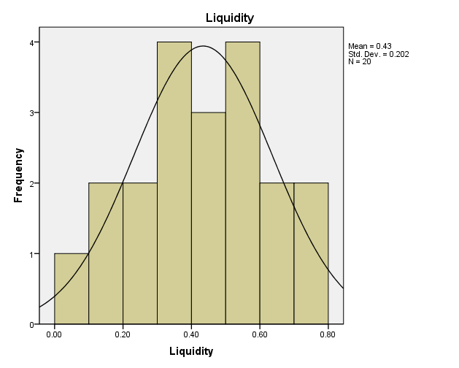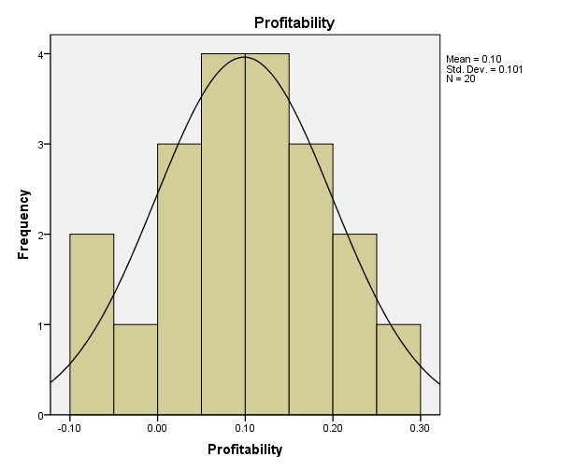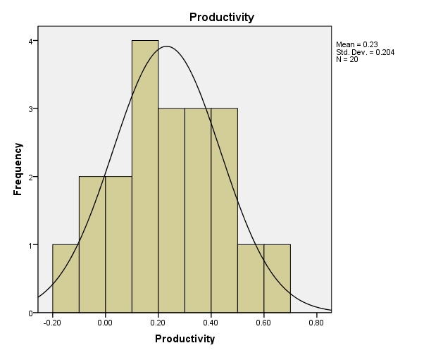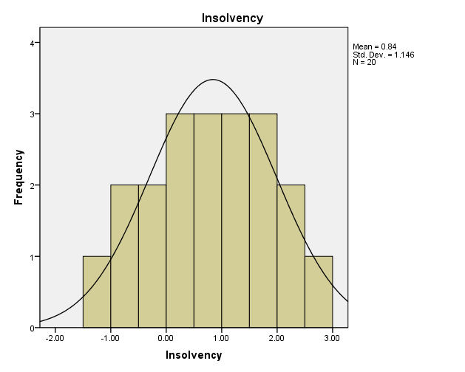

Appendix C Domestic Islamic Banks Sample (Data Normality Curves)
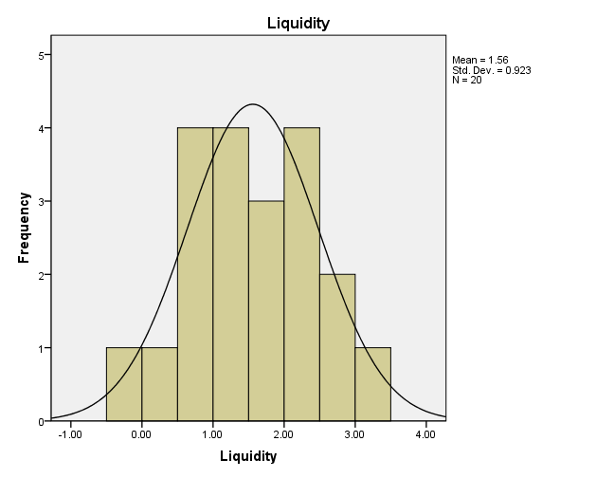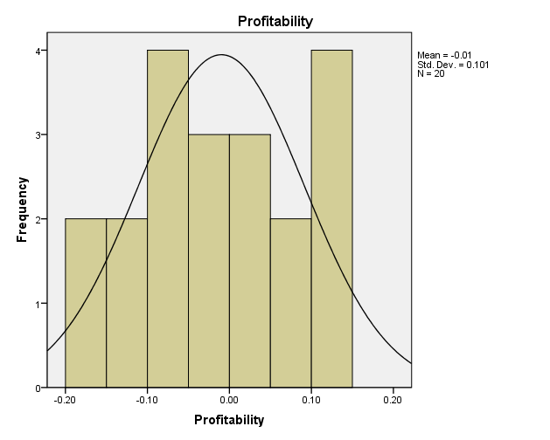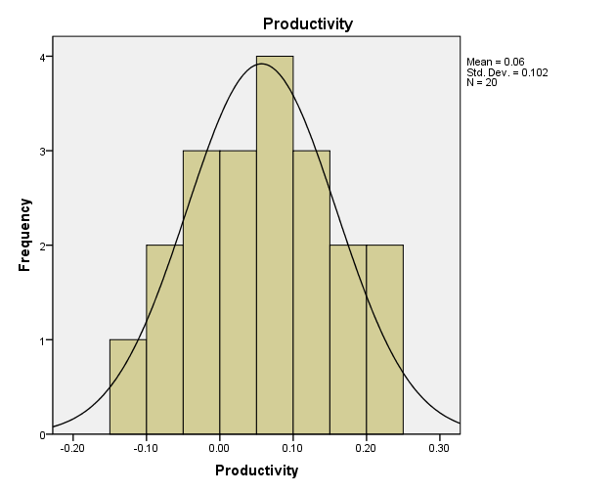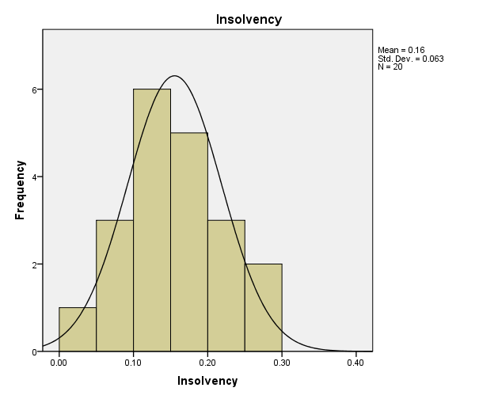
Appendix D Data Normality Tests
Domestic Islamic banks
 | Kolmogorov-Smirnova |  |  | Shapiro-Wilk
Variables | Statistic | df | Sig. | Statistic | df | Sig.
Liquidity | .058 | 19 | .200* | .987 | 19 | .991
Profitability | .066 | 19 | .200* | .990 | 19 | .999
Productivity | .040 | 19 | .200* | .993 | 19 | 1.000
Insolvency | .063 | 19 | .200* | .993 | 19 | 1.000
Zscore | .067 | 19 | .200* | .991 | 19 | .999
Foreign Islamic Banks
 | Kolmogorov-Smirnova |  |  | Shapiro-Wilk
Variables | Statistic | df | Sig. | Statistic | df | Sig.
Liquidity | .058 | 19 | .200* | .989 | 18 | .998
Profitability | .085 | 19 | .200* | .990 | 18 | .999
Productivity | .060 | 19 | .200* | .991 | 18 | .999
Insolvency | .054 | 19 | .200* | .988 | 18 | .995
Zscore | .058 | 19 | .200* | .989 | 18 | .998

