Structural Sensitivity of Tarpon Monopods in Intermediate Water Depths for Marginal Field Development

Lee Hsiu Eik ^{a,*} and Mohd Shahir Liew,ª
^{a)} Department of Civil Engineering, Universiti Teknologi PETRONAS ,Bandar Seri Iskandar, 31750 Tronoh, Perak, Malaysia

*Corresponding author: aaronlhe@gmail.com

Paper History

Received:
Received
Accepted:

ABSTRACT

The Tarpon Monopod is a minimal platform cable guyed caisson used to develop marginal fields. An in depth structural sensitivity study is performed on the Tarpon platform in 76 m water depth situated in Malaysian waters. An operating Tarpon platform offshore Peninsular Malaysia is modelled in the finite element structural analysis software, SACS v5.3 to reflect the as built condition and simulated to a combination of four different storm design criterion with two dominant approach directions to capture the monsoon seasons in the region. The guying system will be varied by simulating trivial loss of wire ropes from being intact, fully guyed to its damaged, freestanding mode. The results suggest that the Tarpon Monopod has relatively low structural redundancy and its integrity highly depends on its guying system condition. Structural weaknesses are identified alongside proposed key best practices and potential improvements to the platform..

KEY WORDS: Tarpon Monopod, guyed, caisson, SACS v5.3, finite element, storm design.

NOMENCLATURE
API American Petroleum Institute
Hmax Maximum wave height
Hs Significant wave height
RP Recommended Practice
NE North East
PTS PETRONAS Technical Standards
SACS Structural Analysis Computer System
SW South West

1.0 INTRODUCTION

More than often, smaller oil and gas fields would be deemed marginally economic, should it be developed with conventional offshore technologies like that of multi leg space frame platforms or floating systems. Such discoveries are usually left untapped until a good mix of high oil prices, innovative technologies and revamped company policies eventually justify their economic viability. The Tarpon Monopod, also known as the cable guyed caisson, is one of the many innovative minimal platform designs used in developing marginal fields.

The platform consists of a main caisson guyed with three sets of cables to anchor piles secured at the sea bed. There are currently more than 56 Tarpon platforms in use worldwide [5] with the bulk growing from a meagre 37 back in the late 90’s [6]. The platform consists of a minimum topside superstructure supported on a single main structural caisson element which is guyed with three symmetrical pre tensioned cables.

Inherent in its relatively simple design and fabrication as compared to conventional jacket platforms, the Tarpon is used in developing marginal fields or fields that require a relatively quick intervention and fast tracked date to first oil or gas.

In the academia, there is a pressing need for a better understanding of the Tarpon platform in terms of its in place structural response, characteristics and sensitivity to the natural environment. For this study, due to its inherent design standardization, a single Tarpon Monopod is chosen to represent the fleet of Tarpon Monopods situated in similar water depth with matching field-topside configuration and payload.

The platform is situated in a depth of approximately 76m, offshore Terengganu in Malaysian waters [4]. It was purposefully singled out due to complete availability of supporting documents and data.

  - Objective of Study

Of late, there has been a need for a better understanding on the structural response and sensitivity of Tarpon monopods in Malaysian waters. The lack of specific structural inspection and maintenance procedures has bolstered this need. In the open literature, structural design documentation and studies on Tarpon platforms are very scarce and scattered. Hence, the Tarpon in place structural responses are not understood as well as conventional jacket platforms that which would put its response characteristics and sensitivity in the grey area domain of many Oil and Gas operators.

With the proliferation of marginal field developments and increase of awareness for the natural environment with millions of dollars’ worth of investments at stake, this is something that should be actively avoided. Hence, this study intends to bridge the gap to shed light on the structural sensitivity of the Tarpon monopod to various design storm conditions alongside simulated damaged conditions.

  - Review of Tarpon Monopods

Subrata K. Chakrabarti, in the publication- Handbook of Offshore Engineering Vol.1 defined minimal platforms as fixed production platforms with a small deck used for the development of marginal fields in shallow water [3]. The minimum configurations for such platforms include typically less than ten wells, a small deck where it is possible to accommodate a coil tubing or wire line unit, a test separator and well header, a small crane, a boat landing and in some cases a minimum helideck.

Buacharoen published a study on the use of minimal platforms in the hostile waters of the Nova Scotian Offshore (NSO), eastern Canada [2]. The conclusion of this study revealed that the design of the single caisson and tripod type can be done in a way that would meet the minimal structural definitions whilst providing excellent production and structural capacity, all delivered with potential cost savings as compared to past conventional developments in the NSO region.

The tarpon monopod is a cable-guyed caisson minimal production platform. As of the year 1999, there were 37 of such platforms operating in the Gulf of Mexico, West Aftica and Indonesia. It was first used back in 1987 with Stolt Comex Seaway as the owner of the patents for the system. The major substructure of the Tarpon concept is made up of a central caisson, capable of housing multiple wells internally or even externally via conductor clamps. This caisson is stabilized by three cable guys at 120 degrees apart [6].

Each set of guy cables consist of two wire ropes with one end pinned to the anchor pile at or below the mud line and the other, pinned to the caisson below the water line. Generically, the anchor cables would be engineered to form a 35 degree angle from the mudline hence, giving the subsequent approximate horizontal distance of the anchor piles from the caisson to be 170 % of the water depth [6].

The major structural components of a Tarpon monopod can be listed to be: - anchor piles, structural caisson, guy cables, conductors and the topsides [8]. The life cycle cost advantages of a Tarpon system are reviewed to be; low capital expenditure, simple construction, ease of installation, early production capability, low abandonment cost, recoverable and reusable components [5].

  - The Finite Element Model

The generic platform data used for the modelling is as tabulated in Table 1 [8].

Table 1 Generic platform data
Platform details | Data
Platform type | Monopod
Water depth | 76.2m
Jacket height | 82.2m
Water Depth | 76.2m
Deck weight | 184.8 MT
Jacket weight | 800 MT
Location | Offshore Terengganu

Figure 1 is a snippet taken from the SACS Tarpon model on a 2 dimensional plane. Hence only two of the three guy cables are visible. It is obvious that the entire Topside is supported on a single main structural caisson, hence the term monopod, rather unlike the array of trusses used on a conventional fixed jacket platform.

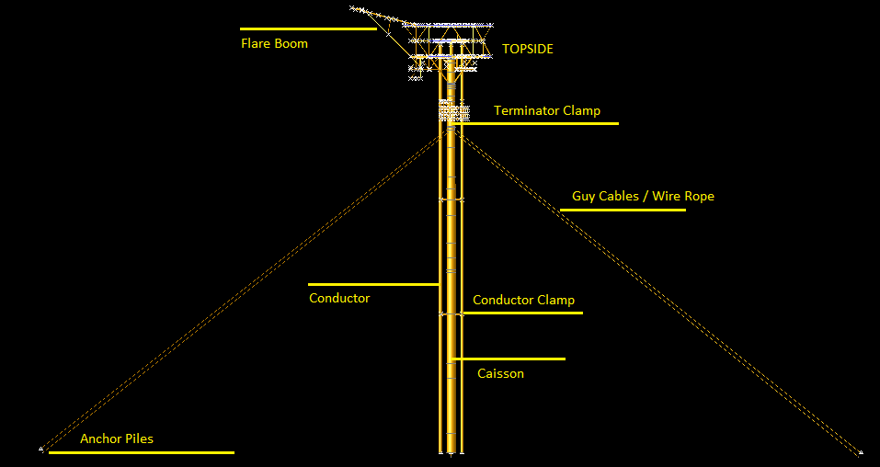
Figure 1 Tarpon Monopod Components

The main structural elements of the Tarpon Monopod are taken to be the structural caisson, wire ropes and the anchor piles. Figure 2 reports the detailed descriptions for the aforementioned structural caisson used in the model, which reflects the as built in-place condition of the platform.

Three pairs of EIPS-Independent Wire Rope Core class 6 × 61 were employed as post tensioned wire ropes. The wire ropes are attached symmetrically around the caisson to guy it to three anchor piles on the sea bed. The piling radius is approximated at 108 m from the caisson. Table 2 illustrates the key properties for the wire rope and anchor pile assembly. The structural caisson itself serves as the fourth pile with a penetration of approximately 35 m into the seabed. The in situ soil consists predominantly of clay, silt and several layers of sand.

Table 2 Wire rope - anchor pile assembly
Structural element | Description
Wire rope | Diameter | 10.16 cm
 | Breaking strength | 6992 kN
Anchor pile | Diameter | 182.88 cm
 | Wall Thickness | 3.175 cm

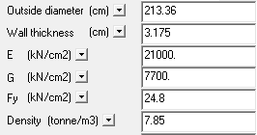
Figure 2 Structural caisson properties

A full 3-dimensional structural model showcased in Figure 3 was used for the analyses in the offshore structural analysis software, Structural Analysis Computer Software (SACS) Version 5.3. Table 3 provides a summary on the model elements and nodes.

Table 3 Finite Element Model Summary
Description | No.
Joints | 938
Members | 1591
Groups | 54
Sections | 14
Plates | 174
Shell elements | 0

2.0 ANALYSIS METHODOLOGY

This project is broken down into three major phases. The first phase is planned as a preparatory stage which gives great emphasis on data collection and platform familiarization, alongside extensive literature reviews. The second segment would cover modelling the structural components of the platform, in place sea state, soil foundation, guy cable conditions and followed by the revised model’s analysis, all performed via SACS v5.3 suite of programs.

The third phase on the interpretation of results from the latter, and presenting them in a meaningful and organized way. The supporting guidelines and codes used herein are the Petronas Technical Standard’s PTS 34.19.10.30 and American Petroleum Institute’s API RP 2A 21st Edition.
2.1 SACS v5.3 Analysis

SACS v5.3 Suite of Programs was used extensively for both modelling and simulation. Several SACS modules will be used herein. The first is the PRECEDE program, to be used as the graphical user modeler. The actual metocean data acquired from Offshore Engineering Centre UTP Joint Density research initiative, PETRONAS Technical Standards and the actual as designed seastate will be generated in the SACS SEASTATE module.

The Pile Soil Interaction module would be used to model the soil-pile interaction. The soil foundation data was keyed into the. The SACS IV module would be used to process and perform in place Linear static analysis coupled with nonlinear pile soil effects.

The results can then be viewed in SACS post processors such as POSTVUE which enables the results to be interpreted interactively and graphically. DYNPAC and Wave Response are employed to obtain the dynamicity of the Tarpon monopod and dynamic amplification factors to be used in the static load case analysis for incorporation of dynamic wave effects.

Tables 4~6 showcases the four different sets of storm metocean criteria, the design water depth and the Cd and Cm values respectively used in this study.

Table 4 Simulated metocean conditions
Analysis data | 100 year return period
 | PTS [7] | Joint Density | As Designed [4]
Wave Height (m) | 5.77 (H_{s}) | 5.7 (H_{s}) | 11.3 (H_{max)}
Wave Period (s) | 8.06 | Assume 6 and 8 seconds | 9.3
Current (m/s) | 1.67 at surface  1.33 @ mid  0.36 @ seabed | 0.69 at -3m | 1.3 at surface  0.7 at seabed

Table 5 Simulated drag and mass coefficients [7]
For tubular members | Clean Member | Fouled Members
Drag Coefficient, C_{d} | 0.65 | 1.05
Mass Coefficient, C_{m} | 1.6 | 1.20

Table 6 Design water level computation
Description | Min | Max
Mean Sea Level, MSL(m) | 76.3 | 76.3
Highest Astronomical Tide (m) | Not applicable | 1.06
Lowest Astronomical Tide (m) | -1.13 | Not applicable
Storm Surge (100 year) (m) | - | 0.6
Design Water Level (m) | 75.12 | 77.96
 | Use 78m for metocean loading water level

The storm approach is modeled from two directions to simulate the two major monsoons in Malaysian waters – The North East Monsoon and the South West Monsoon. Note that the North East monsoon has been modified at an angle to induce a certain amount of eccentricity to the storm loading on the platform. Figure 3 illustrates the directionality. Marine growth used for the submerged platform members are in accordance with PTS 34.19.10.30 for the PMO region [7]. The 100 year return period wind speed used is as per the latter standard, modified by the Durst curve to 1 hour mean interval. Wind loading is then modelled as joint loads on the topside of the platform in SACS as per the recommended formula from API RP 2A [1].

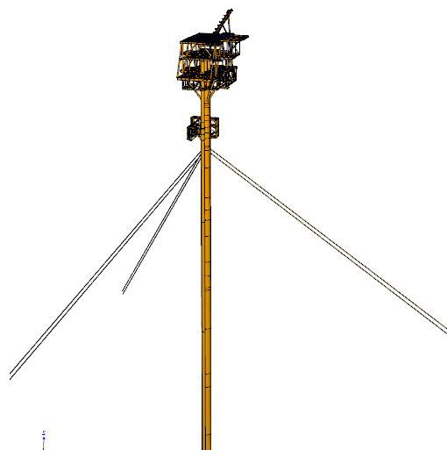
Figure 3 Three dimensional platform finite element model

The Tarpon Monopod SACS model was simulated to the array of combinations of metocean and guy system as shown in Table 7.

Table 7 Simulated scenario
No. | Metocean Data | Guyed by
1 | As Designed | 3 cables  (intact)
 | PTS
 | Joint Density(Wave T=8s)
 | Joint Density(Wave T=6s)
2 | As Designed | 2 cables
 | PTS
 | Joint Density(Wave T=8s)
 | Joint Density(Wave T=6s)
3 | As Designed | 1 cable
 | PTS
 | Joint Density(Wave T=8s)
 | Joint Density(Wave T=6s)
4 | As Designed | Free Standing
 | PTS
 | Joint Density(Wave T=8s)
 | Joint Density(Wave T=6s)
 | PTS
 | Joint Density(Wave T=8s)
 | Joint Density(Wave T=6s)

The pretension on each guy cable is simulated to 445 kN. The linear static wave loading was factored with pre-determined Dynamic Amplification Factors to be used within the in place static analysis frame in line with a quasi-static analysis methodology.

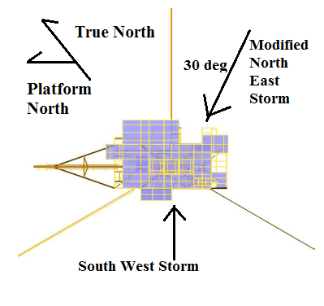
Figure 4 Storm approach direction

3.0 RESULTS

Since the Tarpon has only one main structural caisson, it is reasonable to assume that if the caisson is noted to have failed, then the Tarpon platform integrity as a whole will have been lost. Hence, a significant portion of the proceeding discussions are centered on the stiffness, dynamicity, deflections and unity check results of the single structural caisson.

It would be prudent to note here that the Tarpon model herein is located in approximately 76m water depth (MSL) and that the results published here may find application for similar Tarpon platforms situated in identical water depth and seabed condition rather than those located in shallower waters like that of the 30-50m range.

3.1 Sensitivity to loss of wire rope

As the guy cables are sequentially removed from fully guyed to freestanding a same trend can be observed for both storm approach directions. In a prevailing storm direction, the Tarpon’s structural caisson experiences increasing internal loading as the guy wires are reduced.

This is an expected observation as the guy cables is inferred to provide the bulk of the Tarpon’s lateral stiffness, without which the Tarpon will behave like that of a slender cylindrical cantilever beam. Table 8 shows the internal loadings at the mud line portion of the structural caisson when the platform is subjected to the worst (as designed) design storm. A comparison of stiffness values revealed dramatic loss of structural integrity from intact fully guyed to the freestanding condition. The Tarpon Monopod studied is hence unsuitable. The result summary for stiffness computation is summarized in Figures 5~6 and Table 9.
Table 8 Caisson mudline internal forces
Modified NE Storm Approach
 | Freestanding | x 1 wire | Fully guyed (x 3)
Axial (kN) | 4127.9 | 4653.7 | 5364.3
Shear (kN) | 1767.5 | 710.2 | 250.1
Bending (kN.m) | 106000 | 28518.2 | 5828.1
South West Storm Approach
Axial (kN) | 3330.9 | 6982.9 | 5872.3
Shear (kN) | 5589.8 | 1371.7 | 241.0
Bending (kN.m) | 65933.6 | 78831.7 | 6605.8

Table 9 Global lateral stiffness summary
Condition | Stiffness (kN/m)
Freestanding | 92.3
Intact | 2357.7

It is evident from Table 9 that the Tarpon Monopod experiences a dramatic loss of stiffness in the event of full guy wire failure. The platform’s dynamicity in terms of natural period also shows an obvious shift from the fixed regime to a more compliant regime, that which it is not designed for. The freestanding mode is hence, a non-real dynamic solution as the platform has failed.

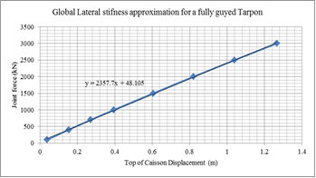
Figure 5 Global lateral stiffness for intact condition

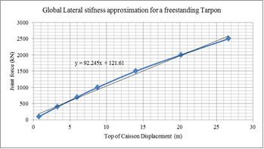
Figure 6 Global lateral stiffness for freestanding condition

3.2 Dynamic Analysis

The natural periods of the Tarpon structure were simulated via SACS DYNPAC module. In order to account for the nonlinear pile soil interaction, the foundation elements were linearized in the form of pile superelements. The dynamic mass system was selected as consistent and continuous mass. The first three modes of natural vibration are displayed in Table 10.

Table 10 First three platform natural periods
Modes | Freestanding | 1 wire | 2 wires | 3 wires
1 | 16.430 s | 11.224 s | 3.746 s | 2.418 s
2 | 11.847 s | 2.805 s | 2.403 s | 2.354 s
3 | 2.606 s | 2.377 s | 2.358 s | 2.344 s

3.3 Platform Deflection and Unity Check

The results from the unity checks are superimposed with the Tarpon’s in place deflection as tabulated in Tables 11~12. The deflection herein is defined not as the structural caisson’s displacement but as the maximum displacement experienced by a point on the Tarpon platform, usually at the topsides or flare boom.

Table 11 Caisson deflection-unity check for SW approach
Guy wire | Metocean for SW approach | Max Caisson Deflection (cm) | Max Caisson Unity Check
x 0 | As Designed | 13016.8 | 7.65
 | PTS | 684.6 | 2.79
 | Joint Density 8 sec | 284.1 | 1.28
 | Joint Density 6 sec | 348.3 | 1.51
x 1 | As Designed | 1135.4 | 4.4
 | PTS | 557.9 | 2.46
 | Joint Density 8 sec | 222.5 | 1.11
 | Joint Density 6 sec | 238.5 | 1.17
x 2 | As Designed | 62.1 | 0.55
 | PTS | 13.1 | 0.44
 | Joint Density 8 sec | 11.2 | 0.35
 | Joint Density 6 sec | 9.1 | 0.35
x 3 | As Designed | 62.1 | 0.55
 | PTS | 16.4 | 0.3
 | Joint Density 8 sec | 8.1 | 0.24
 | Joint Density 6 sec | 10.3 | 0.24

It is obvious here that the freestanding modes have all failed indefinitely. The singly guyed condition also fails under the extreme As Designed metocean criteria and marginally survives with its plastic reserve strength, when loaded with the PTS metocean criteria while it comfortably survives the joint densities.

It would be prudent to note that the guy cables will not fail in axial tension, given their high breaking strength. This is proven via a pushover analysis. At platform failure, the guy cables still possess relatively large reserve strength and do not initiate the failure sequence.

It is keenly noted that the approach of defining complete platform failure at the failure of the structural caisson is intrinsic in the nature of a caisson monotower.
Table 12 Caisson deflection-unity check for NE approach
Guy wire | Metocean for NE approach | Max Caisson Deflection (cm) | Max Caisson Unity Check
x 0 | As Designed | 1800.6 | 6
 | PTS | 578.3 | 2.46
 | Joint Density 8 sec | 232.9 | 1.12
 | Joint Density 6 sec | 291.8 | 1.34
x 1 | As Designed | 315.2 | 1.66
 | PTS | 179.8 | 1.04
 | Joint Density 8 sec | 82.2 | 0.54
 | Joint Density 6 sec | 91.5 | 0.59
x 2 | As Designed | 46.6 | 0.48
 | PTS | 11.0 | 0.29
 | Joint Density 8 sec | 14.2 | 0.23
 | Joint Density 6 sec | 12.9 | 0.23
x 3 | As Designed | 46.6 | 0.48
 | PTS | 15.5 | 0.31
 | Joint Density 8 sec | 7.1 | 0.24
 | Joint Density 6 sec | 9.2 | 0.24

3.4 Soil Sensitivity

A soil sensitivity study was performed under two foundation conditions. The intact soil condition was modelled in accordance to the soil investigation report. The degraded soil conditions were modelled to a one third reduction in shear strength for all soil strata with additional skin friction reduction for sand layers. The density for clay was reduced by one third whilst the density for sand and silt was reduced by half.

The soil sensitivity studies show that the platform’s in place response is relatively insensitive to the soil condition in its intact condition. Figure 7 illustrates this. However, in damaged scenario such as a combination of maximum storm loading coupled with loss of wire ropes, the platform exhibits greater dependency on the foundation condition.

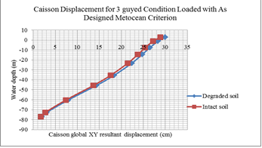
Figure 7 Intact Tarpon insensitivity to soi condition

3.5 Discussion

Like in the Modified NE direction, the SW storm approach induces failure in all freestanding Tarpons. The singly guyed Tarpon in the SW approach fails indefinitely for As designed and PTS metocean criterion The Tarpon banks on its reserve plastic strength to marginally survive the joint density storms on plastic reserve strength. For both storm directions, in intact condition, the Tarpon Monopod exhibited the largest unity check at the cable termination point on the main structural caisson. This is unlike the other conditions where the unity check was recorded maximum at the caisson mud line.

It can be well inferred here that the Tarpon monopod does not stand a storm survival chance in its freestanding mode. It is simply not designed to be unguyed. The Tarpon can also be seen to have increasing sensitivity to the direction of the storm attack as its guy cables are removed one set at a time. In its fully guyed mode, the Tarpon does not respond very differently for both monsoon storm approaches besides surviving through all simulated storm conditions.

However when the guy cables are removed sequentially, it becomes exceedingly clear on how the Tarpon’s sensitivity on storm direction and magnitude increases whilst putting huge uncertainties into the picture of its integrity and robustness. For example, it can be seen that the Tarpon monopod may comfortably survive with only 1 set of cables remaining in a storm of magnitude equal to the join densities metocean criterion during a prevailing North East monsoon.

This is not the case for the Southwest storm approach where the Tarpon’s structural state would have meant imminent failure for the same metocean loading. The deflections for both cases are also very different from each other. This is one of many instances where the Tarpon monopod becomes increasingly sensitive to the incoming storm direction and its integrity depends on the probability that favorable conditions would prevail, should the cable damage go unnoticed.

One of the interesting implications of these findings is that the event of a cable loss may go virtually unnoticed by topside maintenance personnel as reflected in the theoretically equal deflection magnitudes for the doubly guyed and fully guyed caisson, given that the wave, wind and current approach direction is conducive to utilize the tension capacities of the two remaining cables. This calls for an appropriate Tarpon specific inspection and maintenance regime that will be different than that of conventional jacket platforms.

3.6 Way Forward

It is obvious from this study that the Tarpon Monopod is not the most robust available option for 70-80m water depth offshore marginal field exploitations. Whilst competitive in the minimal platform market, below are some of the finer points for further improvements to the Tarpon structure that the engineer can incorporate for future developments.

•Increase in structural redundancy can be achieved by increasing the stiffness of the structural caisson, say by provision of grout to a certain length, the insertion of ring stiffeners or simply a caisson section with higher/tougher cross sectional properties.
•Improve pile capacity as to avoid plasticity. This involves considering different pile technologies such as steel hybrid –concrete grouted piles or suction piles, instead of conventional hollow steel piles.

•Form a dedicated inspection and maintenance system for the Tarpon platform.

•Consider the use of alternative marginal field platform designs. This may include but are not limited to the likes of minimal gravity based platforms where the seabed conditions permit, mini Tension leg platform and other types of monotowers.

•Place simple axial strain/stress monitoring gauges on each guy cables to effectively observe as to how the tension in each cables fair alongside its pre-tension of 100 kips.

4.0 CONCLUSION

This study delivers a comprehensive report detailing the structural response of the Tarpon Monopod when subjected to different metocean and guying system conditions. The topline summary of the findings is as summarized below.

•The Tarpon Monopod is a structure whose integrity is highly dependent on its guying system. The lateral restraint lies primarily on its wire ropes. The main caisson merely serves as a vertical column for the placement of the topside.

•Even one set of missing guy cable may initiate structural failure during unfavorable storm approach directions.

•Its damaged condition (removed guy wires) response is vastly sensitive to different storm directions as compared to its relatively insensitive intact condition.

•It may survive with only two or even one guy wire pair given that the storm approach is favorable for utilizing the full capabilities of the remaining cables.

•In its freestanding mode, the Tarpon structure fails in all simulated storm conditions in this study.

•Attention to be given at the cable terminators and cable-pile connections.

ACKNOWLEDGEMENTS

The authors would like to thank PETRONAS for their support throughout the course of this study. To the engineers at the Offshore Engineering Centre of Universiti Teknologi PETRONAS, thank you for such reliable technical input and advice where it was needed.

REFERENCES

- American Petroleum Institute API (2000). Recommended Practice for Planning, Designing and Constructing Fixed Offshore Platforms - Working Stress Design, 21st Edition. API

- Buachareon, J. (2010). Cost and Practical Based Concept for Innovative Design of Minimum Offshore Structures (Master's Thesis). Thailand: School of Engineering and Technology, Asian Institute of Technology.

- Chakrabarti, S. K. (2005). Handbook of Offshore Engineering Vol.1 . Offshore Structure Inc. Illinois, USA: Elsevier.

- ECL. (2008). Detailed Engineering Design of Substructure for LEDP-A Guyed Caisson (Substructure Design Manual).

- LLC, T. S. (2012). Tarpon Systems - Making Marginal Field Production More Profitable than Ever. Retrieved 2013, from http://tarponsystems.com/pdf/Tarpon2page2NoAdd.pdf

- Offshore (1999). Tarpon Monotower Develops further from 37 Field Applications. Retrieved 2013, from http://www.offshore-mag.com/articles/print/volume-59/issue-4/news/general-interest/tarpon-monotower-develops-further-from-37-field-applications.html

- PETRONAS. (2010). PETRONAS Technical Standards - PTS 34.19.10.30. Malaysia.

- Samsudin, M. S. (2012). Structural Sensitivty and Parameter of Tarpon Platform (unpublished dissertation). Perak, Malaysia: Universiti Teknologi PETRONAS.

