**Group-based Decision Support for Flood Hazard Forecasting: A Geospatial Technology-based Group Analytic Hierarchy Process Approach**

Dano Umar Lawal, Abdul-Nasir Matori, Khamaruzaman Wan Yusof , Ahmad Mustafa Hashim , Mansir Aminu5, Soheil Sabri 6, Abdul-Lateef Balogun7, Imtiaz Ahmed Chandio8, Munirah Radin Mohd Mokhtar9

1, 2, 3, 4, 5, 7, 8, 9 Civil Engineering Department, Universiti Teknologi PETRONAS

6 Urban and Regional Planning Department, Universiti Teknologi Malaysia

**Abstrac**t: A Geospatial Technology-based Group Analytic Hierarchy Process (GAHP) is carried out to forecast the likely flooded areas based on a total number of five set of criteria/factors believed to be influencing flood generation in the study area. The GAHP is based on the two categories of experts (hydrologists and geologists). Priority weights were assigned to each criterion/factor based on Saaty’s 9 point scale of preference by the experts and weights were further normalized through the AHP. The results of the two experts were further integrated into GIS environment to come up with the flood forecasting map for the area. These results were further validated using the known Flood Extent Extraction Model developed based on a Minimum Distance Algorithm embedded in ENVI 4.8 software and the Consistency Ratio (CR). Overlay was carried out in ArcGIS 9.3 software of the two results with the known Flood Extent Extraction Model developed based on a Minimum Distance Algorithm. The hydrologists’ preferences show a better correlation with what is on ground.

**Keyword**s: Flood susceptibility mapping, Geospatial Technology-based Group Analytic Hierarchy Process, Remote sensing

1. **Introduction**

Historically, floods have been part and parcel of the human encounter. They are regular phenomena that made a basic and persistent feature of all river basin and lowland coastal systems (Necsoiu, 2000). In the most developed nations, severe floods can be the prime cause of economic damages from natural catastrophes, and are likewise a key cause of hazard-related deaths in the less developed nations. Since ancient times, the natural catastrophes disrupted human civilization with devastating consequences. A group decision making is an essential feature of the modern emergency planning and management (Cosgrave, 1996). The opinions of one expert may vary from others, but this will often be to the benefit of the planning authorities since it offers a useful medium for all expectations to be questioned and reﬁned. The end result is therefore more realistic. Levy et al. (2007) described how the civil defense and emergency management group decisions shared numerous exclusive characteristics. First of all, the group must frequently make several sophisticated and multi-faceted decisions in a short period, thereby contributing to a great “decision load”. Secondly, these decisions may have possibly serious significances. Maier (1963) uses the terminology “decision quality” in describing the point to which a wrong decision could lead to disastrous outcomes. Thirdly, the group decision must frequently be prepared with incomplete information (equally in terms of quality and quantity), mainly in the initial phases of a disaster because of emergency management problems.

The Group Analytic Hierarchy Process (GAHP) (T. L. Saaty, 1980; T. L. Saaty, 1994; T. L. Saaty et al., 1998) has great potential for use in the group emergency decision making. The Analytic Hierarchy Process (AHP) is a mathematical modeling technique for multi-criteria decision making (T. L. Saaty, 1980; Cheng et al., 2001; Coyle, 2004; Modarres et al., 2010; and Chen, D. C. et al., 2011). It was developed by Saaty, a mathematician in early 70s. The AHP method helps to specify numerical weights representing the relative importance of factors, elements, criteria for flood susceptibility models (see also (Emmanouloudis et al., 2008; Sinha et al., 2008); Meyer et al., 2009; Chen, D. C. et al., 2011).

AHP allows both qualitative and quantitative approaches to solve complex decision problems. Therefore, vast majority of the work and literature available on the application of AHP in geo-engineering are dedicated to the generation of relative weights of influential factors based on a group decision making and integration of the weights into GIS environment for spatial modeling. Hence, AHP’s comprehensive literature collections could be found in http://www.expertchoice.com. For instance, Dai et al., (2001b) generated relative weights of influential factors affecting urban (Lanzhou city, China) geo-environment using AHP, where the suitability potentials of urban land use were evaluated using GIS.

Recently, Dano, et al., (2011) used AHP in finding the most suitable sites to propose a new recreational park for Universiti Teknologi Malaysia. Ayalew et al., (2004) similarly employed pairwise comparisons to come up with the relative weights of landslide controlling factors, where he further used GIS to develop landslide risk assessment map for Tsugawa area of Agano River, Niigata Prefecture, Japan. Moreover, Komac (2006) adopted the multivariate statistical analysis where he came to a conclusion that the use of the AHP method provides a way of defining the factors’ weights in the linear landslide susceptibility model. Its vast application is because of its simplicity, ease of use, and profound flexibility inherent in the approach (Laemlaksakul et al., 2008).

In this study, the principles of Multi-Criteria Decision Making (MCDM) in the context of group analytic hierarchy process (GAHP) have been integrated with GIS and remote sensing to forecast the flood susceptible zones. The objectives are to develop a flood susceptibility maps based on the preferences of two category of experts (hydrologists and geologists) using some hydrogeological indexes. The data preparation and integration would be carried out in GIS environment.

**2. Description of the Study Area**

*2.1. Location of the study area*

The State of Perlis is bounded by Thailand in the north, Kedah in the south, while its western coastline borders the Straits of Malacca as illustrated in Fig. 1. It is bounded by longitudes 100 º 07’ 02”E/ 100 º 22’ 33”E and latitudes 6 º 43’ 19”N/6 º 15’ 13”N.

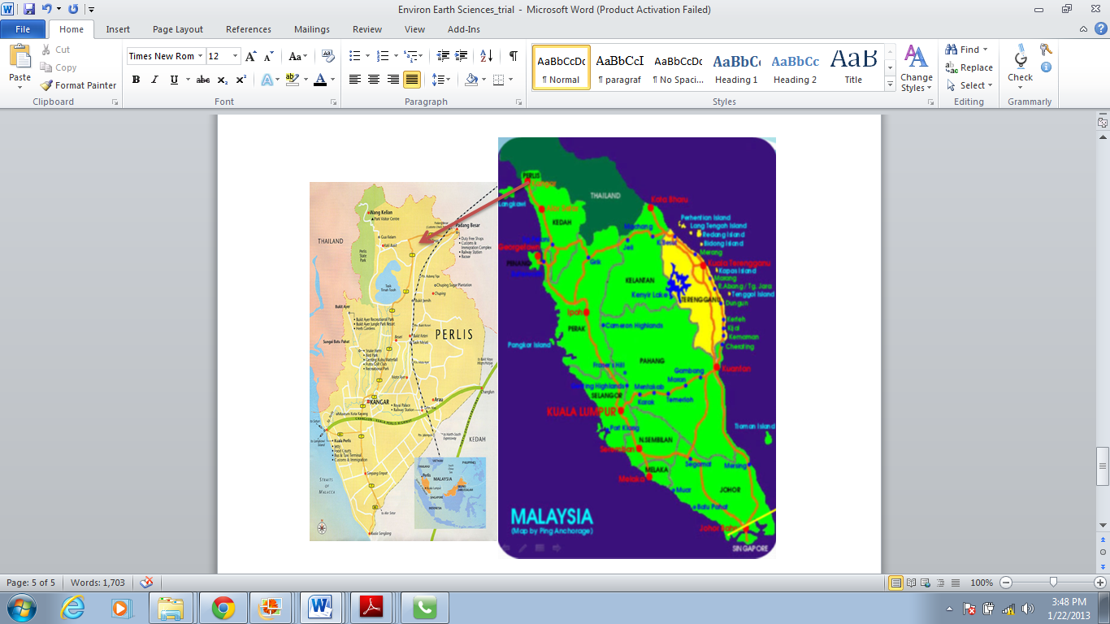

Fig. 1: Map of Peninsular Malaysia showing the study area

Source: http://www.royalpcg.com/sites

*2.2. Geology*

From the geology map of Perlis, alluvium covers a huge area of the central and southern regions of the state. This alluvium comprises unconsolidated sediments like sand as well as gravel. Paddy covers a significant part of the alluvium lying parts. Alluvium tends to be low-lying and can trigger flood during intense event; in fact, even the thinner alluvium tracts connected with smaller tributary valleys could be susceptible to flash-flood. The Kubang Pasu- Singa formation, which is made up of shale, mudstone, siltstone, flagstone, sub-greywacke, greywacke and quartzite covers most of the northern and central areas.

There are actually two distinct limestone formations namely: the Chuping limestone that made up the central spine within the Kubang Pasu-Singa formation as well as the Setul limestone which is obtained in western Perlis bordering Thailand. The Bukit Arang formation which is actually a formation of semi-consolidated clays, sands and gravels along with some thin coal seams and oil shales are obtained only in the north-eastern region. Whilst a minute outcrop of granite is obtainable at the northern tip of Perlis bordering Thailand.

**3. Materials and Methods**

*3.1 Selecting the flood influencing criteria/factors in the study area*

Certain natural flood influencing factors were considered in this study in order to predict the flood susceptible zones in the study area. The factors considered herein are: rainfall, geology, slope gradient, land use, and the soil type. These factors are therefore believed to be influencing flood generation in the area.

*3.2 Hydrological responsibilities of the selected factors*

*3.2.1 Rainfall and its influence on flood generation*

Rainfall input is the primary factor affecting the degree of run-off responses during the flood events. It's temporal as well as spatial distribution adds up substantially to the generation of the hydrograph shapes, optimum discharge, and flood volume. Rainfall influences catchment’s runoff response mostly through its space and time distribution. As a result, the study of this influence on the runoff process is the objective of majority of the theoretical and research studies (Obled et al., 1994; Ogden et al., 1993).

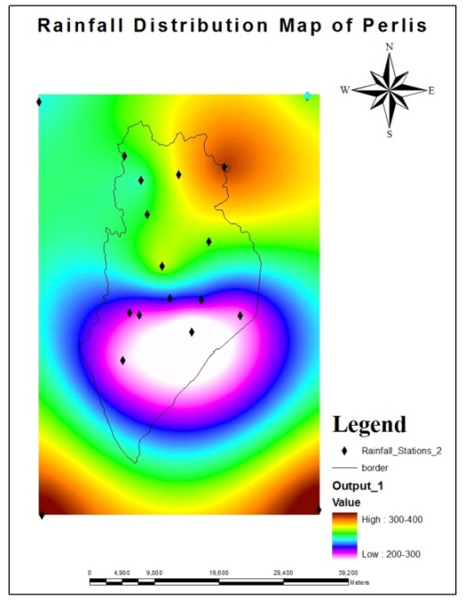

Fig. 2: Mean annual rainfall distribution map produced by Kriging from GIS analysis

*3.2.2 Geology and its influence on flood generation*

A flood coming from rivers and seas occurs across natural landforms that have a characteristic geomorphology and geologic make-up. The related geological deposits can therefore present an important insight in pinpointing exactly where flood has occurred previously and accentuate some other methods of forecasting where flood is likely to take place in the future. For instance, the alluvium deposit is made up of clay sediments (Malaysia, Minerals and Geoscience Department, 2004).

Clay controls the rate of infiltration into the subsurface. The content of clay accounts for the formation of aquitard. Therefore, the more the clay content of an area, the less permeability of that area; and as a result the more susceptible to flood is the area.

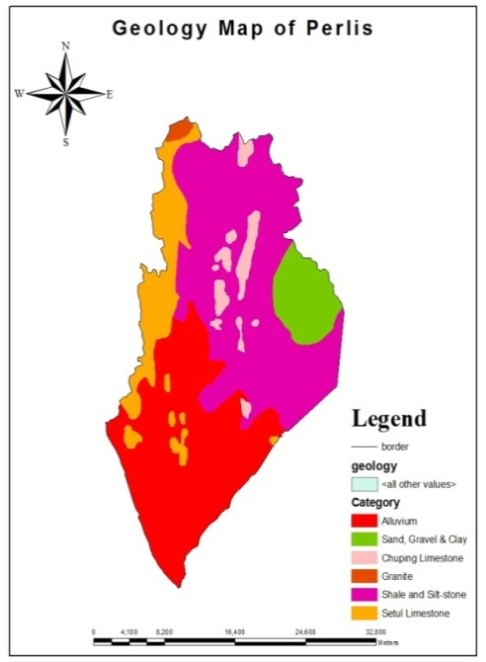

Fig. 3 Geology and mineral distribution map produced from GIS analysis:

*3.2.3 Slope gradient and its influence on flood generation*

Slope determines the velocity with which water flows. Therefore, slope controls the rate of infiltration of groundwater into the subsurface. Usually, when the slope of an area is flat or gentle, the surface runoff is slow allowing more time for rainfall to seep into the ground and consequently, the area will be highly susceptible to flooding. On the other hand, when the slope of an area is steep, it facilitates rapid surface runoff allowing little time for rainfall to infiltrate into the ground thereby causing the area to be less susceptible to flood (Adiat et al., 2012). Therefore, slope gradient is assumed to be an important factor influencing flood generation. The classification used on the slope map was based on Soils and Terrain model (European Commission, 1995).

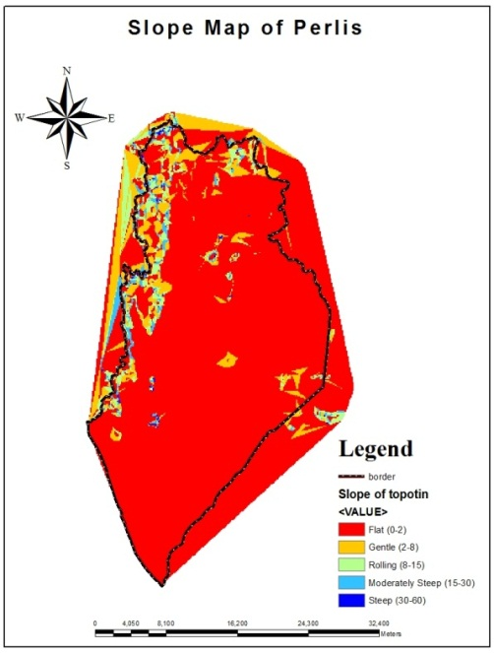

Fig. 4: Slope gradient map produced from GIS analysis

Fig. 5: Land use map produced from GIS analysis

*3.2.4 Land use and its influence on flood generation*

Land use is a human action greatly associated with farming as well as water availability. The types of land use might rely on a number of factors like soil type, rainfall, topography, built-up areas and accessibility. The main changes in land use affecting hydrology and results in flood generation are afforestation, deforestation, intensification of agriculture, drainage systems, roads construction, as well as urbanization.

Hence, the most apparent impact of land use on the water stability associated with catchments is on the evapotranspiration process (Calder et al., 1993). This is because several types of land use possess different evapotranspiration rate; for instance different categories of plants have different vegetation cover, leaf area indices, root depth, and albedo.

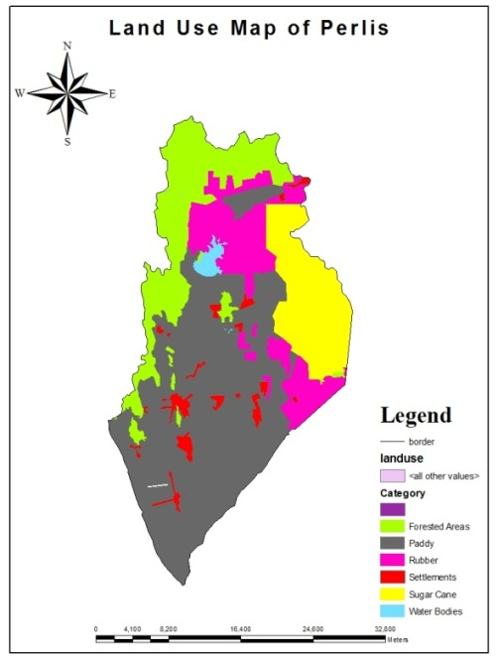

*3.2.5 Soil type and its influence on flood generation*

A sizable majority of soils are made up of inorganic nutrient particles, organic matters, and also rock particles along with water and air. Soils are made as a result of weathering process on rocks that has occurred more than millions of years ago. This particular weathering process is mainly responsible in its physical structure as well as chemical makeup. For example, soils with tiny particles usually consist of clay minerals: thus with attributes of very poor durability, low density, as well as impermeability, which in turn adds up considerably to the degree of runoff responses during the course of intense rainfall events. Clay soil generally displays plasticity; and is readily remolded whenever wet and contains an extremely substantial strength once completely dried up.

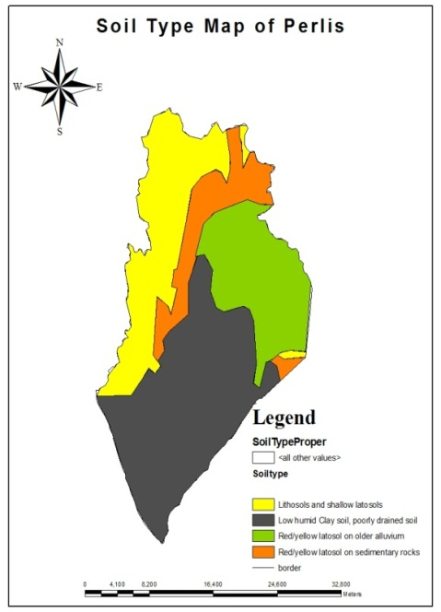

Fig. 6: Soil type map produced from GIS analysis

*3.3 Assigning weights to the flood influencing criteria/factors*.

Based on the method of the Multi-Criteria Decision Making (MCDM), each factor’s weight was computed and assigned to the thematic maps discussed previously. Eastman (1996) and Navalgund (1997) described MCDM as a method that permits each criterion to be weighted with respect to its relative importance/influence. Experts’ judgments were used in assigning the weight of each criterion. The experts used in this study as mentioned earlier are hydrologists and geologists. Hence, in this study the AHP technique developed by (T. L. Saaty, 1980) was used in coming up with the relative weights of each and every flood influencing criterion used herein based on the Saaty’s scale of influence 1 to 9 as shown in Table 1.

Table 1: Interpretation of the Saaty’s scale of measurement

|  |  |  |
| --- | --- | --- |
| **Degree of importance** | **Definition** | **Interpretation** |
| 1 | Equal importance | Two element making equal contribution to the goal |
| 3 | Somewhat more important | Moderate importance of element over the other element |
| 5 | Much more important | Essential or strong importance |
| 7 | Very much important | Very strong importance |
| 9 | Extremely important | Extreme importance |
| Scale, 2.4, 6 and 8 | Intermediate values | These are require when comparison between two adjacent judgment is needed |
| Reciprocals | If v is the judgment value when i is compared to j, then 1/v is the judgment value when j is compared to i. | |

In coming up with the weights, pairwise comparison matrix was used where two factors were compared and scored at a time in accordance with their level of influence in flood generation. Based on the preferences of the two experts; matrixes of pairwise comparisons of the criteria were generated. The pairwise comparisons of all the criteria/factors are considered as the inputs while the relative weights of the criteria are the outputs. The criterions’ final weightings are the normalized values of the eigenvector that is basically associated with the maximum eigenvalues of the ratio (reciprocal) matrix. Therefore, the weights of the factors are generated based on the steps described by Malczewski, 1999.

The experts’ choices were aggregated using a Geometric Mean method as follows: Geometric Means = ((X1)(X2)(X3)....(XN))1/N:

Where X = Individual score and N = Sample size (Number of scores).Therefore, the experts’ preferences helped in carrying out the pairwise comparison matrix.

3.3 Analytic hierarchy process results integration into GIS system

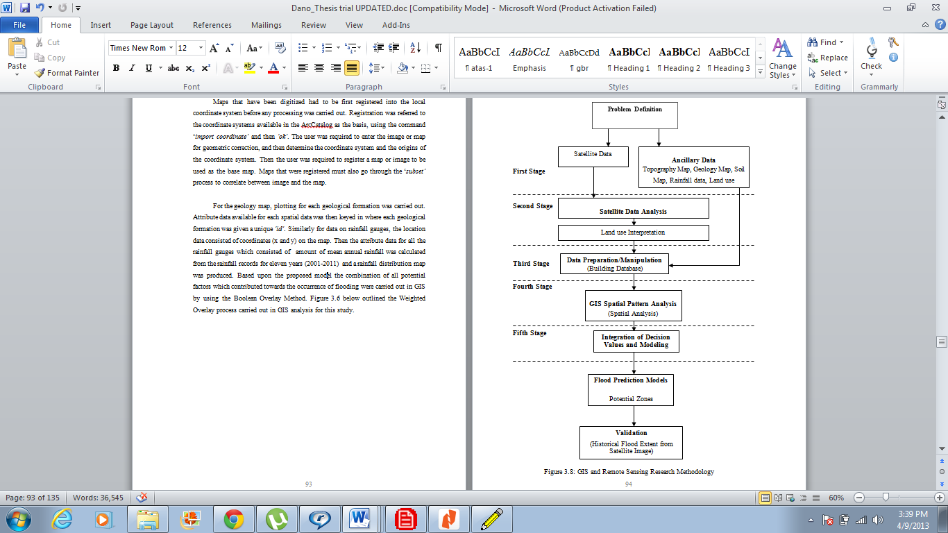In this stage the AHP results were integration into GIS system to simulate the flood vulnerable areas based on the two experts’ preferences. Combining all the thematic layers using the Weighted Linear Combination (WLC) method in accordance with the computed weights was carried out in GIS. The Weighted Linear Combination, or simple additive weighting, relies on the concept of a weighted average where continuous criterions are standardized to a collective numeric range, and then combined by means of a weighted average (Drobne et al., 2009). The overlay of the thematic layers was to obtain the final simulation of the flood forecasted zones. The results of the final analysis managed to indicate the potential flood areas in the study area.

Fig. 7: Flowchart of the study methodology

Figure 7 above shows the steps followed in this study.

**4. Results and Discussion**

4.1 Pairwise comparisons of the factors

It is normally presumed that Multi-Criteria Decision Analysis (MCDA) started at the beginning of 60s. A good number of professionals of MCDA consider that their discipline stems mainly from the early work on goal programming as well as study of Simon in 1977 (Drobne et al., 2009). Simon proposes a framework for analyzing human decision-making processes by differentiating between the intelligence, design, along with choice phases Hence, Multi-Criteria Decision Analysis (MCDA) techniques are numerical algorithms that define suitability of a particular solution on the basis of the input criteria and weight together with some mathematical or logical means of determining trade-offs when conflict arise. Using this technique, a weight value ranges from 1 to 9 was assigned to the data layers by the experts to reflect their relative importance.

Using the Weighted Linear Combination (WLC) method, all the map layers were overlaid in the final GIS spatial analysis for flood susceptible zones simulation. WLC technique can be carried out using any type of GIS system possessing the overlay. This permits the evaluation criterion map layers to be overlaid in order to obtain the composite map layer which is output. Therefore, the output of this WLC method gave a map which simulated the most potential flood susceptible zones of Perlis. Figure 3 shows the flood prediction model.

For comparison, analysis was carried out based on AHP pairwise comparisons. This study had earlier proposed the AHP flood forecasting models based on two categories of experts.

4.1.1 Result based on the geologists’ preferences

Hence, the result of the geologists is computed below:

Where, C1 = Rainfall; C2 = Geology; C3 = Soil type; C4 = Slope gradient; C5 = Land use.

Table 2: A matrix of pair-wise comparisons of five criteria for the AHP process



Table 3: Determining the relative criterion weights



Table 4: Determining consistency ratio (CR)



Table 5: Random inconsistency indices



Table 2 and 3 illustrated the typical pairwise comparisons of the factors as well as the factors weightings.

STEP III:The Consistency Index (CI), which is a measure of departure from consistency, was calculated using the formula:

CI= Equation (3)

Where, n = number of factors (i.e. 5) and  = average value of the consistency vector determined in step ii above.

**=** 5.24 + 5.18 + 5.21 + 5.21 + 5.19 = 26.04/5 = 5.21

Based on equation (3), CI = 5.21-5/5-1 = 0.05

STEP IV: Calculating the Consistency Ratio (CR). The calculation of the CR starts from Table 4. The Consistency Ratio is defined as:

CR= Equation (4)

Where, RI is the random inconsistency index whose value depends on the number (n) of factors being compared; for n = 5, RI = 1.12 as illustrated in Table 5 (T. L. Saaty, 1980).

Using Equation (4),

CR = ** = 0.04

Therefore, since 0.04 < 0.1, it indicates that there is a realistic degree of consistency in the pairwise comparison and as a result, the weights 0.28, 0.13, 0.17, 0.21 and 0.21 (i.e. 28.15%, 13.13%, 16.85%, 21.33% and 20.54% respectively) can be assigned to rainfall, geology, soil type, slope gradient and land use respectively.

4.1.2 Result based on the hydrologists’ preferences

The views of the hydrologists are computed as illustrated below:

Table 6: A matrix of pair-wise comparisons of five criteria for the AHP process



Table 7: Determining the relative criterion weights



Table 8: Determining consistency ratio (CR)



Table 6 and 7 illustrated the typical pairwise comparisons of the factors as well as the factors weightings.

Hence, the result of the hydrologists was also calculated following the same steps as discussed under sub-sub heading 4.1.1 above.

CI= Equation (3)

**=** 5.36 + 5.14 + 5.14 + 5.27 + 5.25 = 26.16/5 = 5.23. Based on equation (3), CI = 5.21-5/5-1 = 0.06

The next step is to calculate the Consistency Ratio (CR). The calculation of the CR starts from Table 8. The Consistency Ratio is defined as:

CR= Equation (4)

Where, RI is the Random Inconsistency index whose value depends on the number (n) of factors being compared; for n = 5, RI = 1.12 as illustrated in Table 4 (T. L. Saaty, 1980).

Using Equation (4),

CR = ** = 0.05

Thus, since 0.05 < 0.1, it indicates that there is a realistic degree of consistency in the pairwise comparison and as a result, the weights 0.44, 0.11, 0.09, 0.17 and 0.19 (i.e. 44.07%, 10.55%, 9.31%, 16.73% and 19.35% respectively) can be assigned to rainfall, geology, soil type, slope gradient and land use respectively.

4.2 Group analytic hierarchy process spatial flood forecasting model

The combination of all parameters was carried out in GIS using the Weighted Linear Combination (WLC) method. This is based on the weights generated from the GAHP. The Weighted Linear Combination (WLC) formula is shown below:

**

Where, *FSZ* is the Flood Susceptible Zones; *w*i is the factors weights which must sum up to 1, and *x*i is the criterion score i. All these relevant data were uploaded into the GIS system before analysis was carried out using a total of five thematic maps: land use, geology, rainfall distribution, soil type and slope gradient. Figure 8 and 9 presents the result of the GIS spatial model for flood susceptible zones. The first model (Figure 8) is based on the views of the geologists whilst the second model is based on the views of the hydrologists.

In Figure 8, the red, lemon green, blue and yellow colors represent the very highly, high, moderate, as well as least susceptible zones likely to be flooded. These are basically based on the ratings of the flood influencing factors by the geologists. Similarly in Figure 9, purple, yellow, red, and dark-blue colors represent very highly, high, moderate, as well as least susceptible zones likely to be flooded.

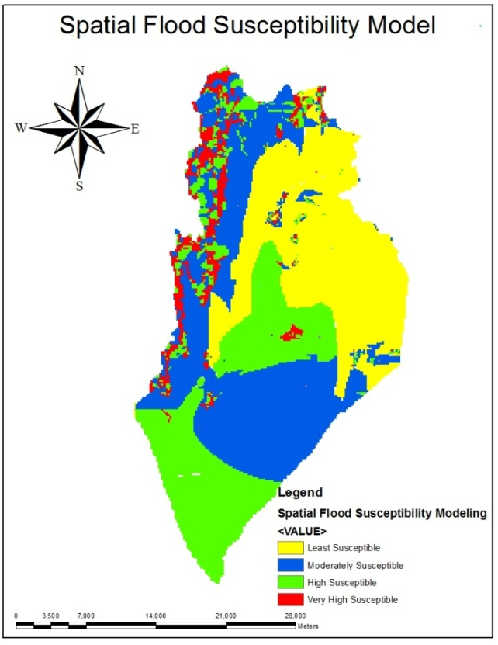

Fig 8: Map of Forecasted Flood Susceptible Zones of Perlis based on the Geologists Point of View

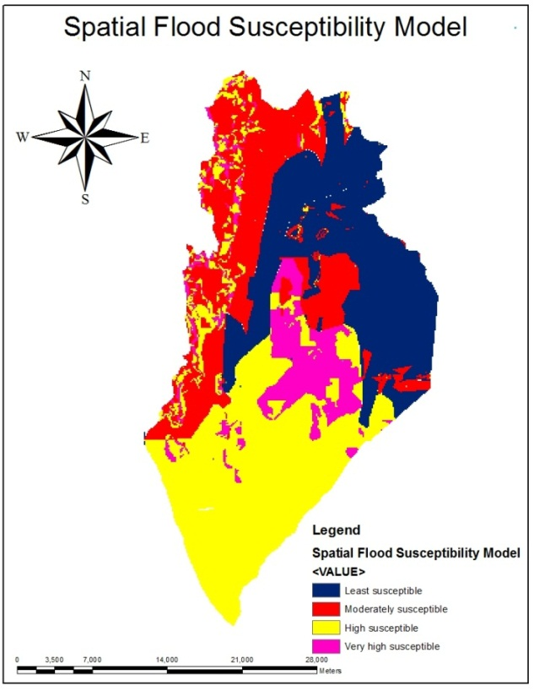

Fig 9: Map of Forecasted Flood Susceptible Zones of Perlis based on the Hydrologists Point of View

4.3 Validation of the GAHP spatial flood forecasting models

In validating the GAHP spatial flood forecasting models, the Flood Extent Extraction Model (Figure 10) developed based on a Minimum Distance Algorithm embedded in ENVI 4.8 software was used. Radar satellite during-flood image dated November, 2010 of Perlis, Malaysia was used. Therefore, to determine the reliability of GAHP spatial flood forecasting models, the models (Figure 8 and 9) were overlaid with the Flood Extent Map of Perlis produced using Minimum Distance Algorithm embedded in ENVI 4.8 software from the RADARSAT during-flood image. Figure 11 and 12 below were obtained by the overlay operation. An analysis of both Figure 11 and 12 revealed that the majority of the flooded areas fell in the areas identified as very high susceptible, high susceptible, and moderately susceptible to flooding. However, the GAHP spatial flood forecasting model deveoled based on the views of the hydrologist shows a more significant match when overlaid with the real life flood extent map (Figure 10) of the study area.

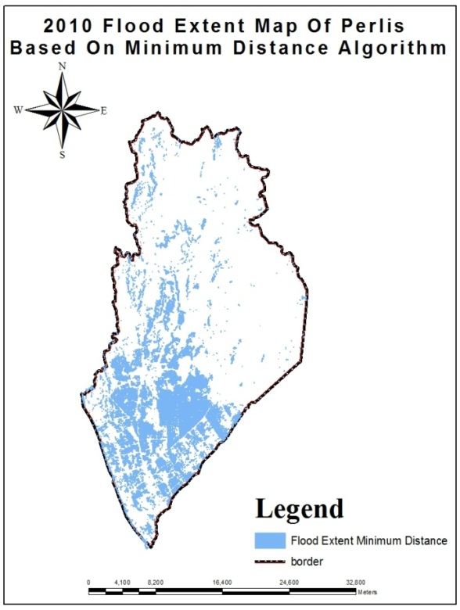

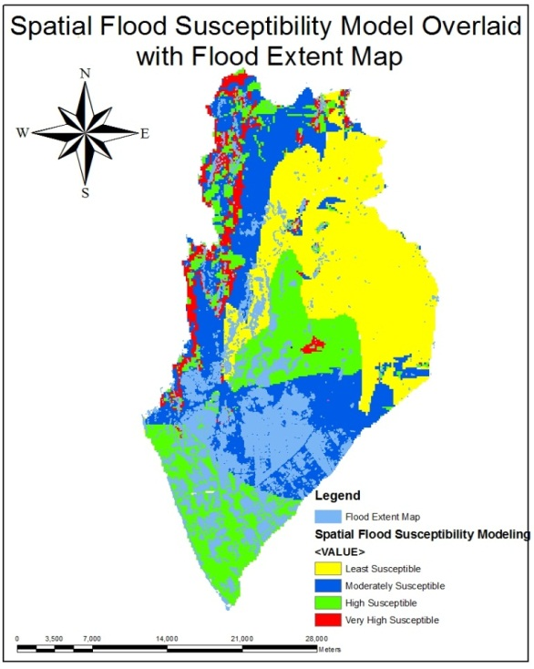Figure 10: Map of flood extent extraction model of Perlis produced from radar-sat during-flood image (Source:MACRES)

Fig 11: Map of Forecasted Flood Susceptible Zones of Perlis based on the Geologists Point of View Overlaid with the Flood Extent Map of Perlis

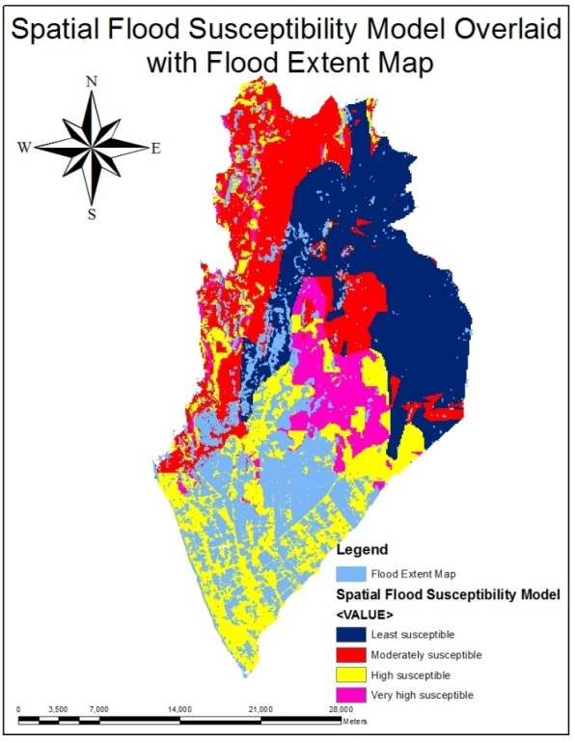

Fig 12: Map of Forecasted Flood Susceptible Zones of Perlis based on the Hydrologists Point of View Overlaid with the Flood Extent Map of Perlis

**5. Conclusion**

The social and economic losses as a result of flood disasters, technologic crises, as well as global epidemics are growing; needing more effective group decision making under uncertainty. A GAHP decision support system for flood forecasting was put forth that used Geographic Information System (GIS) and remote sensing to forecast the flood susceptible zones. GIS and remote sensing tools proved profound potentials in combating flood catastrophes. In this study, the efficiency of GIS-based GAHP and remote sensing as spatial multi-criteria forecasting tools was discovered. Hence, this system will help civil authorities such as planners and emergency agency in taking positive and in-time steps during the pre-disaster situations. It will similarly help them during post-disaster activities to assess damages and losses caused as a result of flood.

**Acknowledgment**

This project was funded by the Universiti Teknologi PETRONAS Short Term Internal Research Fund (STIRF) under the project leadership of Associate Professor Dr. Kamaruzaman Wan Yusof. I would therefore like to acknowledge his support and guidance as well as my supervisors Associate Professor Dr. Abdul-Nasir Matori and Associate Professor Mustafa Ahmad Hashim for their support.

**References**

Adiat, K., Nawawi, M., & Abdullah, K. (2012). Assessing the accuracy of GIS-based elementary multi criteria decision analysis as a spatial prediction tool-A case of predicting potential zones of sustainable groundwater resources. *Journal of Hydrology,*

Ayalew, L., Yamagishi, H., Ugawa, N. (2004). Landslide susceptibility mapping using GIS-based weighted linear combination, the case in tsugawa area of agano river, niigata prefecture, japan. landslides  .*1*, 73-81.

Calder, I. R., Hall, R. L., & Prasanna, K. (1993). Hydrological impact of< i> Eucalyptus</i> plantation in india. *Journal of Hydrology, 150*(2), 635-648.

Chen, D. C., Chen, P. C., Lee, Y. C., You, S. U. and Jao, H. C. (2011). Using an analytic hierarchy process to develop competencies on mould product creativity for vocational college students. *world transactions on engineering and technology education* (WIETE) .*9*(1), 54-59.

Cheng, E. W. L., & Li, H. (2001). Analytic hierarchy process: An approach to determine measures for business performance. *Measuring Business Excellence, 5*(3), 30-37.

Cosgrave, J. (1996). Decision making in emergencies. *Disaster Prevention and Management, 5*(4), 28-35.

Coyle, G. (2004). The analytic hierarchy process, practical strategy. open access material, AHP.

Dai, F.C., Lee, C.F., Zhang, X.H. (2001b). Assessment of landslide susceptibility on the natural terrain of lantau island, hong kong. environmental geology .*61*, 257-271.

Dano U. L., Matori, A. N., & Balogun, A. L. (2011). A geographic information system and multi-criteria decision analysis in proposing new recreational park sites in universiti teknologi malaysia. *Modern Applied Science, 5*(3), p39.

Drobne, S., & Lisec, A. (2009). Multi-attribute decision analysis in GIS: Weighted linear combination and ordered weighted averaging. *Nature, 4*(26), 28.

Eastman, J. R. (1996). Multi-criteria evaluation and geographical information systems eds. longley PA, goodchild MF, magurie DJ and rhind DW, second ed. john wiley and sons, new york.*1*, 493-502.

Emmanouloudis D, Myronidis D, Ioannou K. (2008). Assessment of flood risk in thasos islandwith the combined use of multicriteria analysis ΑHP and geographical information system.innovative applications of informatics in agriculture and environment .*2*, 103-115 ESRI.

European Commission. (1995). Soil terrain database. land management and natural hazards unit. IES and JRC, european commission, brussels. <http:// eusoils.jrc.ec.europa.eu/projects/soter/soter_model.html> (accessed 30.03.11.).

Komac, M. (2006). A landslide susceptibility model using the analytical hierarchy process method and multivariate statistics in perialpine slovenia. geomorphology .*74*(1–4), 17-28.

Laemlaksakul, V., & Bangsarantrip, S. (2008). Analytic hierarchy process for design selection of laminated bamboo chair. *Proceedings of the International MultiConference of Engineers and Computer Scientists, , 2*

Levy, J. K., & Taji, K. (2007). Group decision support for hazards planning and emergency management: A group analytic network process (GANP) approach. *Mathematical and Computer Modelling, 46*(7), 906-917.

Maier, N. R. F. (1963). *Problem-solving discussions and conferences: Leadership methods and skills* McGraw-Hill New York.

Malaysia, Minerals and Geoscience Department. (2004).  Impact of the 26th december 2004 tsunami on groundwater systems and groundwater based water supplies in malaysia.

Malczewski, J.,. (1999).  GIS and multicriteria decision analysis. john wiley and sons, inc. united states of america, ., pp. 177-192.

Meyer V, Scheuer S, Haase D. (2009). A multicriteria approach for flood risk mapping exemplifiedat the mulde river, germany. natural hazards .*48*, 17-39.

Modarres, M., Sadi-Nezhad, S., & Arabi, F. (2010). Fuzzy analytical hierarchy process using preference ratio: A case study for selecting management short course in a business school. *International Journal of Industrial Engineering Computations, 1*(2), 173-184.

Navalgund, R. R. (1997). Revised development plan of ahmedabad urban development authority area – 2011. ahmedabad urban development authority and space applications centre, ahmedabad, india, technical, report 1 SAC/RSAG/TR/12/AUG/1997., 142.

Necsoiu, D. M. (2000). *A data fusion framework for floodplain analysis using GIS and remotely sensed data*

Obled, C., Wendling, J., & Beven, K. (1994). The sensitivity of hydrological models to spatial rainfall patterns: An evaluation using observed data. *Journal of Hydrology, 159*(1), 305-333.

Ogden, F. L., & Julien, P. Y. (1993). Runoff sensitivity to temporal and spatial rainfall variability at runoff plane and small basin scales. *Water Resources Research, 29*(8), 2589-2598.

Saaty, T. L.,. (1980). The analytic hierarchy process: Planning, priority setting, resource allocation. McGraw-hill, new york.

Saaty, T. L. (1994). *Fundamentals of decision making and priority theory with the analytic hierarchy process* RWS publications Pittsburgh.

Saaty, T. L., & Hu, G. (1998). Ranking by eigenvector versus other methods in the analytic hierarchy process. *Applied Mathematics Letters, 11*(4), 121-125.

Simon, H. (1977). The new science of management decisionPrentice-hall. *Englewood Cliffs, NJ,*

Sinha R, Bapalu G, Singh L, Rath B. (2008). Flood risk analysis in the kosi river basin, northBihar using multi-parametric approach of analytical hierarchy process (AHP). journal of IndianSociety of remote sensing.*36*, 335-349.