OZONE IMPACT TO PADDY RICE PRODUCTION: COMPARISON BETWEEN TWO INDUSTRIAL AREAS IN MALAYSIA

Nurul Izma Mohammed, *Nor Azam Ramli, Ahmad Shukri Yahya

Clean Air Research Group, School of Civil Engineering, Engineering Campus,
Universiti Sains Malaysia, 14300 Nibong Tebal, Penang, MALAYSIA.
E-mail: ceazam@usm.edu.my

Abstract
Ozone concentration in the atmosphere could have an adverse impact to the agricultural industry of the nation. It has been identified as one of the factor that could threaten food crop production such as paddy. In Europe, the AOT40 index (accumulated exposure over a threshold of Xppb) is used to study the ozone effects in the reduction of agricultural and vegetation production. However, this type of index is not yet to be found in Malaysia. Hence, this index has been adapted and customized according to Malaysia’s suitability and all the original data has been used in this study. In Malaysia, paddy rice is grown in almost every state even though there are differences in the type of land use. Hence, two industrial area; Perak and Negeri Sembilan have been selected in order to study the reduction in crop yield in Malaysian industrial area. This research has found that industries have significantly reduced paddy rice production in Malaysia. Perak recorded the highest decline with 18.3% while Negeri Sembilan recorded 12.26%. Additionally, this study has also found that the paddy yield is lower during the rainy season as compared to the dry season; as low temperature increases the stomatal conductance and the ozone uptake in paddy’s stoma and adversely affects paddy rice production.
Keywords: AOT, index, ndustrial, monsoon, Negeri Sembilan, Perak

1. Introduction
Paddy rice is one of the most important agricultural crop in Malaysia. On average, each state in Malaysia produces 3-4kg/hectar of rice during the year 2000-2009 (DoA, 2010). However, paddy rice production is still not sufficient to accommodate the growing Malaysian population (MARDI, 2009). Various efforts have been undertaken by MARDI, who are responsible in ensuring the optimal level of paddy rice production in the country. However, air pollutants in the atmosphere have been identified as one of the factors that significantly reduce the world’s paddy rice production (Fuhrer et al., 1997; Keller et al., 2007).
There are many researches that have been conducted which indicate ozone to cause defects in the paddy rice which significantly reduces its production. In Malaysia, paddy rice is grown in almost every state even though there are differences in the type of land use. Malaysia’s Department of Environment (DoE) has classified these Malaysian states based on its economic sector. According to the classification, Ipoh, Perak and Nilai, Negeri Sembilan are two of the rapidly growing industrial area. Hence, these two areas were selected in order to study the reduction in paddy rice crop yield in Malaysian industrial area.
In Europe, the AOT40 index (accumulated exposure over a threshold of Xppb) is used to study the ozone effects in the reduction of agricultural and vegetation production. Since Malaysia does not have a specific index that studies ozone impact to crop yield, this index has been adapted and customized according to Malaysia’s suitability and original data.

2. Materials and Method
2.1 Study Area
The selected area of this study is Ipoh, Perak and Nilai, Negeri Sembilan. Both of these states are industrial areas in Malaysia. (DoE, 2010). The geographical location of the research area is shown in Figure 2.1.

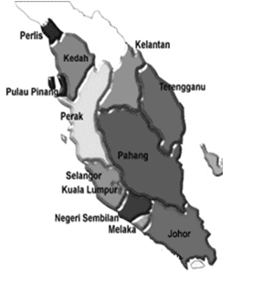
- Ozone concentration and paddy rice production data for this location is for the year 2004 to 2006

- Each of the paddy plantations area is near to the monitoring station.

N
Study area
Figure 2.1: Location of study areas in Malaysia

2.2 Mathematical Model
AOT Index is calculated according to the variance between X ppb and hourly ozone concentrations, in which ozone concentration must exceed X ppb. This index is calculated using Equation 2.1, where the ozone concentrations used are during day time (7 am – 7 pm)

AOTX= (2.1)
Where, is the hourly ozone concentration in ppb, i is the running index, and n is the number of hours with more than X ppb, during the time evaluation (Grunhage et al., 1999
Malaysia has two paddy rice production seasonality which is the main season and off-season. Hence, this analysis which relates the reductions in paddy yield due to ozone were conducted based on the two seasons. The percentage of paddy reduction using the AOT index is shown in Equation 2.2.
AOTX value x Paddy production
∑ Ozone Concentration
Calculated paddy reduction (%) = (2.2)

Where, X is the index of AOT.

AOT index which is used in European countries states that a 5% reduction in crop yield is expected if the cummulative ozone concentration exceeds 3000bsb in 3 months (Ishii et al., 2007; LRTAP Convention, 2004). Equation 2.3 below is used to project the expected reduction in paddy rice crop yield in Malaysia, based on this indicator.

Calculated crops reduction (calculation) (%) x 3000ppb.h
Total AOTX (ppb.h)

Estimated = (2.3)
crops reduction (%)

Where, 3000ppb.h is the European concentration-based critical level for the AOT40 index (UNECE, 1996). Therefore, to investigate the crops reduction for all AOTX indexes, 3000 ppb.h is employed as the guideline consistent with the European critical level. The estimated crops reduction was calculated based on the total ozone exposure for both seasons and the crops production record (2004 to 2009).

3. Results and Discussion

Analysis for the reduction in paddy rice in the research area for the year 2004-2009 based on the two seasons for paddy rice crops in Malaysia which is the main season and off-season. The result of the research is shown in Figure 3.1.
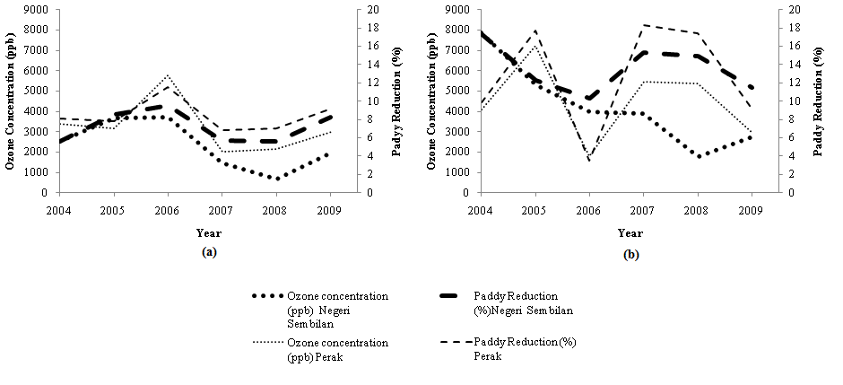
Figure 3.1 (a): Main season, (b): Off season: Paddy reduction between Perak and Negeri Sembilan in Malaysia

Based on Figure 3.1, the reduction in paddy rice production in Perak for both season are higher as compared to Negeri Sembilan. This reduction is consistent with the ozone concentration for both states. When the ozone concentration increases, the percentage of paddy production reduction also increases; vice versa. Ozone concentration in Perak during the main season is 5767bsb and the percentage of paddy production reduction was 11.5%. During off-season, Perak recorded the highest ozone concentration with 5475bsb with a paddy production reduction percentage of 18.3%.
Negeri Sembilan which also has industrial sectors recorded a lower ozone concentration level and percentage of paddy production reduction as compared to Perak. During the main season, the highest ozone concentration recorded was 3708bsb and the reduction in paddy production was 9.56%. During off-season, the highest ozone concentration recorded was 5282bsb and the percentage of paddy production reduction was 12.26%.
Based on Figure 3.1, the percentage of paddy production for off-season was higher as compared to main season for both states even though ozone concentration during primary season is higher. In Malaysia, off-season paddy plantation season is during the northeast monsoon. During this time, the research areas receive more rainfall (Jamaludin et al., 2010). This monsoon season results in a high humidity and low temperature in Malaysia. Even though rainfall has the ability to cleanse the air by removing air pollutants including ozone that is suspended in the atmosphere, it also increases the stomatal conductance in paddy. This significantly reduces paddy rice production (Lal et al., 2000, Wang et al., 2005).

4. Conclusion
The results of the study conducted shows that Malaysian industrial areas significantly reduces paddy rice crop yield. Perak recorded the highest percentage of reduction with 18.3% and Negeri Sembilan recorded 12.26%. This study has also found that the paddy rice crop yield is lower during the monsoon season as compared to the dry season. Even though rain fall has the ability to cleanse the air and lowers the temperature, it also increases the stomatal conductance in paddy which causes a defect in the paddy rice and significantly reduces its production.

5. Acknowledgement
This study was funded by Universiti Sains Malaysia under Grant 304\PAWAM\\6039013304. We owe extreme gratitude to Universiti Sains Malaysia and the USM Fellowship Scheme which provides the financial resources in carrying out this study. Heartiest thanks to the Department of Environment, Malaysia and the Department of Agriculture, Malaysia who also contributed in ensuring the success of this study.

References
Department of Agriculture, Malaysia. (2010). Paddy Production Survey Report Malaysia. ISSN: 1985-2762

Department of Agriculture, Malaysia. (2010). Paddy Statistic of Malaysia. DISSN: 1985-2770

Fuhrer, J., Skarby, L.& Ashmore, M. R., (1997). Critical levels for ozone effects on vegetation in Europe. Environmental Pollution, 97, 91- 106.
Grunhage, L., Jager, H.J., Haenel, H.D., Lopmeier,F.J. & Hanewald,K. (1999). The European critical levels for ozone: improving their usage. Environmental Pollution, 105, 163-173

Ishii, S., Bell, J.N.B., & Marshall,F.M. (2007). Phytotoxic risk assessment of ambient air pollution on agricultural crops in Selangor State, Malaysia, Environmental Pollution, 150, 267-279.

Jamaludin, S., Sayang, M.D., Wan, Z.W.Z. & Abdul A.J. (2010). Trends in peninsular Malaysia rainfall data during the Southwest Monsoon and Northeast Monsoon Seasons: 1975–2004. Sains Malaysiana, 39 (4), 533-542

Keller, F., Bassin, S., Ammann, C. & Fuhrer, J. (2007). High- resolution modelling of AOT40 and stomatal ozone uptake in wheat and grassland: A comparison between 2000 and hot summer of 2003 in Switzerland. Environmental Pollution. 146, 671-677.

Lal, S., Naja, M. & Subbaraya, B.H. (2000). Seasonal variations in surface ozone and its precursors over an urban site in India. Atmospheric Environment. 34, 2713-2724

LRTAP Convention,(2004). Manual on methodologies and criteria for modelling and mapping critical loads and levels and air pollution effects, risks and trends. Convention on Long-range Transboundary Air Pollution. /http://www.icpmapping.org.

MARDI. (2009). Latar Belakang Industri Beras Negara.

UNECE. (1996). Manual on Methodologies and Criteria for Mapping Critical Levels/Loads and geographical areas where they are exceeded. Umweltbundesamt, Berlin, Germany.

Wang, H., Kiang, C.S., Tang, X., Zhou, X. & Chameides, W.L. (2005). Surface ozone: A likely threat to crops in Yangtze delta of China. Atmospheric Environment, 39, 3843-3850.

