EFFECT OF TEMPERATURE ON THE EXTRACTION OF BIO-OIL FROM OIL PALM MESOCARP FIBER USING SUPERCRITICAL CO₂
Main author: Mustakimah Mohamed
Mailing address: Biomass Processing Lab Block P,
Universiti Teknologi PETRONAS,
Bandar Seri Iskandar,
31750 Perak, MALAYSIA.
Email: mustakimah.mohamed@petronas.com.my
Telephone number: +605 368 8216/ 8208
Facsimile number: +605 368 8205

Corresponding author: Suzana Yusup
Mailing address: Chemical Engineering Department,
Universiti Teknologi PETRONAS,
Bandar Seri Iskandar,
31750 Perak, MALAYSIA.
Email: drsuzana_yusuf@petronas.com.my
Telephone number: +605 368 7642/ 8208
Facsimile number: +605 368 8205

Author: Motonobu Goto
Mailing address: Department of Chemical Engineering,
Nagoya University,
Furu-cho, Chikusa-ku
4648603 Nagoya, JAPAN.
Email: mgoto@nuce.nagoya-u.ac.jp
Tel & Fax number: +052 789 3392

Author: Wahyudiono
Mailing address: Department of Chemical Engineering,
Nagoya University,
Furu-cho, Chikusa-ku
4648603 Nagoya, JAPAN.
Email: wahyudiono@b.mbox.nagoya-u.ac.jp
Tel & Fax number: +052 789 3392

Author: Siti Machmudah
Mailing address: Department of Chemical Engineering,
Nagoya University,
Furu-cho, Chikusa-ku
4648603 Nagoya, JAPAN.
Email: machmudah.siti@d.mbox.nagoya-u.ac.jp
Tel & Fax number: +052 789 3392

ABSTRACT
This paper highlights the conversion of oil palm mesocarp fiber into bio-oil via SFE. Effects of extraction temperature which are temperature within 60-90˚C are investigated for two hours of extraction time. The yield is diluted in 10ml dichloromethane (DCM) for analysis of gas chromatography-mass spectrometry (GC-MS). The extracted bio-oil is found to contain fatty acid, esters and other long chain hydrocarbon. The concentration of these compounds is determined based on chromatogram peak area. The analysis indicates that fatty acid such as 6-octadecanoic acid (stearic acid), n-hexadecanoic acid (palmitic acid) and dodecanoic acid, 1,2, 3-propanetryl ester (glycerol trilaurate), are the major compounds of the extracted bio-oil. The extraction yield increased from 16.7% to 19.8% once the temperature was increased from 60 to 90°C. Concentration of stearic acid and glycerol trilaurate increased when temperature was increased from 60 to 70°C yet decreased at 90°C. However, concentration of palmitic acid constantly decreased once temperature increased from 60 to 90°C.

Keyword: Oil palm mesocarp fiber, supercritical CO₂ extraction, bio oil, temperature, stearic acid, palmitic acid and glycerol laurate.

ABSTRAK

Artikel ini mengetengahkan tentang penukaran gentian sabut kelapa sawit kepada minyak bio melalui SFE. Kesan keadaan pengekstrakan iaitu suhu antara 60-90°C, tekanan antara 25-40MPa, dan halaju aliran CO₂ antara 3-6ml/min, telah dikaji untuk dua jam waktu pengesktrakan. Hasil minyak bio telah dilarutkan ke dalam 10ml diklorometana (DCM) untuk analisis kromatografi gas-spektometri jisim (GC-MS). Didapati minyak bio yang terhasil mengandungi asid lemak, ester dan hidrokarbon rantaian panjang yang lain. Kepekatan sebatian ini ditentukan berdasarkan luas puncak kromatografi. Analisa menunjukkan bahawa asid lemak seperti 6-oktadekanoik asid (asid stearik), n-hexadekanoik asid (asid palmitik) dan ester, dodekanoik asid, 1,2, 3-propanetril (gliserol trilaurat), adalah sebatian utama dalam minyak bio yang terhasil. Hasil ekstraksi meningkat dari 16.7% kepada 19.8% apabila suhu dinaikkan dari 60 ke 90°C. Kepekatan asid stearik dan gliserol trilaurat meningkat apabila suhu ditingkatkan dari 60 ke 90°C tetapi menurun pada 90°C. walaubagaimanapun, kepekatan asid palmitik sentiasa menurun apabila suhu meningkat dari 60 ke 90°C.

Kata kunci: gentian sabut kelapa sawit, pengekstrakan bendalir lampau genting CO₂, minyak bio, suhu, tekanan, halaju aliran CO₂.

- INTRODUCTION
As the second largest producer of palm oil in the world, Malaysia generates a substantial amount of oil palm biomass as agricultural wastes in the forms of empty fruit bunches, shell and fiber, fronds, leaves, trunks and other [1]. It was estimated that in the year 2011, the total planted area of oil palm was 4.917 million hectares [1]. This biomass feedstock has long been identified as a sustainable source of renewable energy which could reduce the dependency on fossil fuels as the main source of energy supply and thus leads to reduction of greenhouse gases emission. Therefore, it is vital to carry out extensive researches to find the best technology which could convert this biomass to renewable energy efficiently, effectively and economically.
Supercritical extraction is one of the thermochemical reaction techniques to convert biomass into bio fuel other than combustion, pyrolysis and gasification [2-6]. It is a process to obtain liquid fuels with low molecular weight from biomass by converting the solid compounds under supercritical fluid conditions. The liquid fuels or commonly known as bio oil could be further upgraded to other value added compounds such as gasoline and diesel. Compared to conventional fast pyrolysis method, extraction does not require for material drying, this technique seems favourable and attractive from viewpoint of energy consumption especially for high moisture content feedstock [2]. Since past few decades, the reaction is favour to be conducted under supercritical condition of some fluids such as water, CO₂, alcohol and other fluid.
Molero et al. [7] found that yield of grape seed oil using SC CO₂ is higher compared to the extraction using liquid CO₂. Using the same operating condition, Molero et al. [7] obtain same yield of grape seed oil to those conventional extraction using hexane. Patel et al. [8] extract cashew nut oil using SC CO₂ and managed to obtain 70-90% its aimed compound. Thus, Patel et al. [8] claimed that the quality of the obtained oil using SC CO₂ is better compared to the oil that been obtained using normal thermal route.
Supercritical fluid is defined as fluid formed at conditions above the critical properties for that particular solvent. During supercritical conditions, a fluid is neither liquid nor gas and it has unique properties in between liquid and gas. Due to low viscosity and relatively high diffusivity, the fluid diffuse easily within the extraction matters and results in higher extraction yield [9]. The diffusivity or solubility is closely dependent on the density of the fluid in which extraction parameters such as pressure and temperature are able to alter the conditions [9]. Thus by modifying the extraction condition such as pressure, temperature and CO₂ flow rate, the solubility strength of the fluid can be amended.
Till date, extraction of bio oil from oil palm biomass using SFE SC CO₂ is limited. Therefore, this paper provides an insight of extracting bio oil from oil palm biomass using SC CO₂ under various extraction conditions.

- METHODOLOGY
  - Raw material preparation

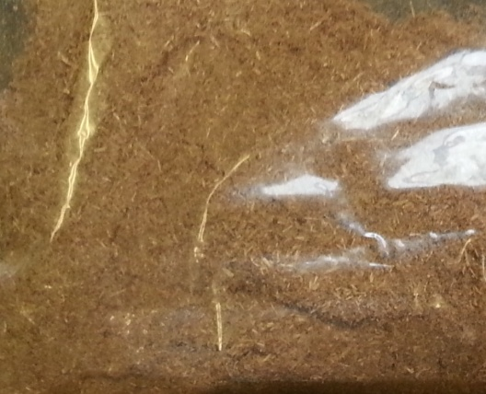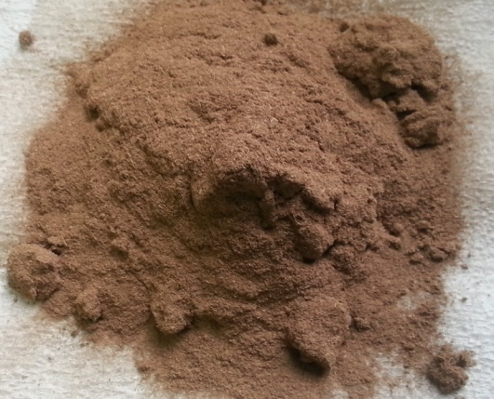
(a)
(b)
Figure 1: Physical appearance of oil palm mesocarp fiber (a) before extraction, and (b) residue

The biomass, oil palm mesocarp fiber (OPMF) is collected from local oil palm plantation near the university. The biomass was cleaned by removing the sand and air dried for one day. It was ground and sieved into the intended particle sizes, which in this case is approximately within range of 0.15 mm. The sample was kept in the refrigerator (6°C) before the extraction was conducted. Figure 1 illustrates the changes of the physical appearance of OPMF due to the extraction using SC CO₂.

  - Extraction process

The extraction of bio oil using Supercritical CO₂ (SC-CO₂) was conducted using the extraction system as illustrated in Figure 2. The 25ml extraction vessel (TharDesigns) is placed in the oven (EYELA WFO-400). The liquid CO₂ is supplied from the gas cylinder with purity of 99% and the flow rate was adjusted using CO₂ delivery pump (Jasco). Before the extraction vessel was connected into the system, the lines were purged with CO₂.

Figure 2: Set-up of SFE system in GOTO Laboratory, Nagoya University, Japan.
10g of ground mesocarp fiber were filled into the vessel. The chiller was turn on to achieve temperature drop within 0 to -2 °C. To start the experiment, CO₂ gas was flown from the gas tank and passed through the chiller to liquefy the stream. At the same time, the oven was heated to the desired temperature. Back pressure regulator was used to manually regulate the pressure of the reaction. The extraction took place for 120 minutes and the samples were collected in the sample bottle. The CO₂ wet gas which was released from the extractor was measured using the wet gas meter before being exhausted. The extraction conditions used in this study is described in Table 1.
The extracted bio oil was weighted before being diluted in 10 ml of DCM. As precaution step, the samples were first centrifuged and filtered before being filled into the vials. Figure 3 demonstrates the extracted bio oil obtained during the extraction and after being diluted into the solvent. The obtained bio oil was in waxy state once it was produced during the extraction and due to the analysis using GC-MS, it was diluted into the solvent.
Table 1: Reaction conditions of the manipulation reaction parameters
Temperature (°C) | Pressure (MPa) | CO₂ flowrate (ml/min)
60 | 40 | 5
70
90
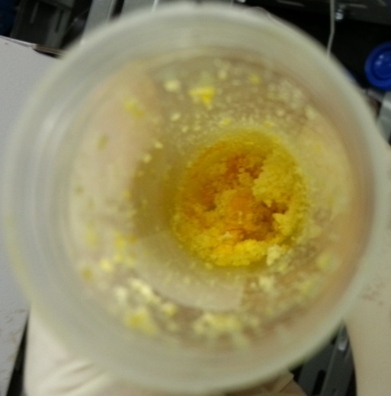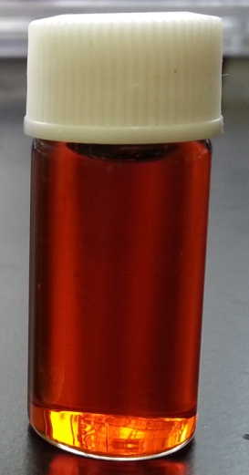
(a)
(b)
Figure 3: Physical appearance of (a) waxy bio oil (b) diluted bio oil in DCM

  - Gas Chromatography Mass Spectrometer (GCMS) Analysis
Gas Chromatography (Agilent) is used to analyze the extracted bio oil that was diluted in 10ml Dichloromethane (DCM). Helium with flow rate of 3 ml/min was the carrier gas and the split less column HP-5MS is used to analyze the components in the sample using NIST Library. The column temperature was kept constant at 150°C for 3 minutes then ramp to 320°C for 10 minutes with heating rate of 5°C/min.
- RESULTS AND DISCUSSION
  - Analysis of chemical composition

Table 2 indicates the amount of main component in OPMF. Cellulose, hemicellulose and lignin are the major component that made up the biomass. Lignin has the highest composition compared to cellulose and hemicellulose. Cellulose and hemicellulose are the compounds which are mainly involved and converted into bio oil during the extraction compared to lignin. Therefore high composition of these components reflects that OPMF is a good source to obtain the bio oil.

Table 2: Composition of three main components in biomass
Component | Composition (%)
Hemicellulose  Alpha-cellulose  Lignin | 22.2  23.1  30.6

  - Yield of bio oil

Figure 4 illustrates the extraction yield of bio oil from OPMF with respect to different extraction temperature as explained in Table 1. The extraction yield is expressed as the yield of crude extracts with respects to the biomass used as quoted in Eq. 1.

(1)

= mass of the crude extract (g); = mass of the biomass (g)

“It is known that the yield of extract depends on the change in solubility and volatility of supercritical fluid. With increase in temperature, the density of supercritical fluid (SCF) decreases while volatility increases“ [8]. Extraction temperature is one of the parameter that can affect the solubility and extraction capability of the fluid. According to Bimakr et al.,[10], fluid density is highly sensitive to temperature during its near critical state because a slight increment in temperature can lead to a large decrease in fluid density hence reducing solubility. High temperature is able to increase the vapor pressure of the extractable compounds which will enhance extraction efficiency. Besides, high temperature also can accelerate mass transfer which improves the extraction yield [10].
According to Machmudah et al., [11], higher temperature contributed to the decomposition of cell walls, and as a results oil extraction increased. Leo et al., [13] also claimed that high temperature enhance the oil solubility in the CO₂ fluid due to lower solvent strength since the fluid density tends to decrease. Therefore, as shown in Figure 4(a), at constant pressure and CO₂ flow rate, the extraction yield increased from 16.7% to 19.8% once the temperature was increased from 60 to 90°C. Rahman et al., [12] and Leo et al., [13] also observed similar behavior as shown in Figure 4 (b) and (c) in which at constant CO₂ flow rate and pressure, the yield keep increasing with respect to temperature increment.
(a)
(c))
(b)
Figure 4: Extraction yield at different temperature obtained (a) this study (b)Rahman et al., [12] and (b) Leo et al., [13]

  - Compounds in extracted bio oil

Table 3: Concentration of respective compounds in the extracted bio oil at different conditions
Component | Temperature (°C)
 | 60 | 70 | 90
6-Octadecenoic acid | 33.87 | 32.45 | 33.6
n-Hexadecanoic acid | 24.59 | 23.46 | 22.26
Dodecanoic acid, 1,2,3-propanetriyl ester | 8.82 | 15.3 | 11.24
Dodecanoic acid | 10.4 | 10.15 | 11.94
Tetradecanoic acid | 4.35 | 4.46 | 4.71
4-Dibenzofuranamine | 3.66 | - | 3.5
Vitamin E | 1.29 | 0.91 | 1.4
Squalene | 0.79 | 0.76 | 0.91
.beta.-Sitosterol | 0.48 | 0.44 | 0.62

Table 3 indicates concentration for some of the major compounds presence in the bio oil with respect to different temperature. Overall, the extracted bio oil is mostly made up of fatty acid and esters such as stearic acid (6-octadecanoic acid), palmitic acid (n-hexadecanoic acid), glycerol trilaurate (dodecanoic acid, 1,2,3-propanetriyl ester) and lauric acid (dodecanoic acid). The composition of the presence compounds were influenced by the changes of the extraction conditions. Composition of palmitic acid decreased constantly from 24.6 to 22.3% when temperature was decreased. Increased in temperature from 60 to 70°C reduced the composition of stearic acid and lauric acid which later increased at 90°C. Inversely, concentration of glycerol trylaurate increased when temperature increased from 60 to 70°C yet decreased at 90°C. Based on this behavior, varying extraction temperature could be implemented into the system to extract the desired compound.

- CONCLUSION
Overall, bio oil that contains fatty acid has been successfully extracted from oil palm mesocarp fiber using supercritical CO₂ under different reaction condition. Extraction efficiency and yield of bio oil is dependent on solubility of the fluid are modified using the extraction temperature. The study shows that the highest yield of bio oil is 19.8% which was obtained at temperature of 90 °C, 40 MPa and CO₂ flow rate of 5ml/min. Extracted bio oil from OPMF is mainly made up of 6-octadecenoic acid (stearic acid), n-hexadecanoic acid (palmitic acid), dodecanoic acid, 1,2,3-propanetriyl ester (glycerol trilaurate) and dodecanoic acid (lauric acid). The composition of each compounds changes with respect to different extraction condition. The outcome of this analysis provides an insight on the potential of the extracted bio oil to be converted in to bio fuel.

ACKNOWLEDGMENT
This research study is financially supported by Yayasan Universiti Teknologi PETRONAS-Fundamental Research Grant.

REFERENCES
- Malaysia Palm Oil Industry, PalmOilWorld.org, 2011, http://www.palmoilworld.org/about_malaysian-industry.html, accessed on 18th May 2013.
- Qian, Y., C. Zuo, J. Tan, J. He. 2007. Structural Analysis of Bio Oils from Sub and Supercritical Water Liquefaction of Woody Biomass. Energy. 32: 196-202.
- Demirbas, A. 2000. Mechanism of Liquefaction and Pyrolysis Reactions of Biomass. Energy Conservation and Management. 41: 633-646.
- Xu, Y., X. Hu, W. Li, Y. Shi. 2011. Preparation and Characterization of Bio Oil from Biomass. Progress in Biomass and Bioenergy Production, Dr Shahid Shaukat (Ed.), ISBN: 978-953-307-491-7, InTech.
- Naik S., Goud V. V., Rout P. K., Jacobson K., Dalai A. K., 2010, Characterization of Canadian biomass for alternative renewable biofuel, Renewable Energy, 35, pp. 1624-1631
- Minowa T., Kondo T., Sudirjo S. T., 1998, Thermochemical liquefaction of Indonesian biomass residues, Biomass and Bioenergy, 14, pp. 517-524.
- Molero, A., C. Pereyra, E. Martinez. 1996. Recovery of Grape Seed Oil by Liquid and Supercritical Carbon Dioxide Extraction: A Comparison with Conventional Solvent Extraction. The Chemical Engineering Journal. 61: 227-231.
- Patel, R. N., S. Bandyopadhyay, A. Ganesh. 2006. Extraction of Cashew (Anarcadium Occidentale) Nut Shell Liquid using Supercritical Carbon Dioxide. Bioresource Technology. 97: 847-853.
- Herrero, M., A. Cifuentes, E. Ibanez. 2006. Sub and Supercritical Fluid Extraction of Functional Ingredients from Different Natural Sources: Plants, Food-By-Products, Algae and Microalgae: A Review. Food Chemistry. 98: 136-148.
- Bimakr, M., R. A. Rahman, F. S. Taip, L. T. Chuan, A. Ganjloo, J. Selamat, A. Hamid. 2009. Supercritical Carbon Dioxide (SC-CO₂) Extraction of Bioactive Flavonoid Compounds from Spearmint (Mentha Spicata L.) Leaves. European Journal of Scientific Research. 33: 679-690.
- Machmudah, S., Y. Kawahito, M. Sasaki, M. Goto. 2007. Supercritical CO₂ Extraction of Rosehip Seed Oil: Fatty Acids Composition and Process Optimization. The Journal of Supercritical Fluids. 41: 421-428.
- Rahman, N. N. A., S. S. Al-Rawi, A. H. Ibrahim, M. M. B. Nama, M. O. A. Kadir. 2012. Supercritical Carbon Dioxide Extraction of The Residual Oil from Palm Kernel Cake. Journal of Food Engineering. 108: 166-170.
- Leo, L., L. Rescio, L. Ciurlia, G. Zacheo. 2005. Supercritical Carbon Dioxide Extraction of Oil and Alpha-Tacopherol from Almond Seeds. Journal of the Science of Food and Agriculture. 85: 2167-2174.

