Mapping the Kinta Valley karst system, Peninsular Malaysia: Implications for Better Insight of Subsurface Karst Features
Solomon Kassa, Bernard J. Pierson, Chow Weng Sum and Jasmi B. Ab. Talib
Universiti Teknologi PETRONAS, Bandar Seri Iskandar, 31750, Tronoh, Perak. E-mail- solkas4@gmail.com

Abstract
The Kinta Valley karst system is characterized by residual limestone hills which are immensely fractured and honeycombed with karst caves, whose passage morphologies appear rectilinear, convoluted and circular. It is not uncommon to observe similar karst morphologies being interpreted from seismic data. The uncertainties about the true nature of the subsurface karst features highlight the importance of studying subaerial karst system, as comprehending the origin and nature of the latter is the key to envisage and interpret the former. Lineament analyses, using Spot image, and cave surveying were conducted to understand the relation between geologic structures and karst features. Similar orientation of fractures and karstic caves channels were obtained, and the continuity of fracture traces was inferred, which enables us to envisage the occurrence of the same trend of fractures in the subsurface karst.
Key words: Cave passage, Fracture, Karst, Kinta Valley
Introduction
The Kinta Valley is characterized by remnant limestone hills, which are part of the expansive bedrock that once covered the whole valley. These hills are honeycombed with karst caves and shattered by tectonic structures.The development of karst in carbonate rocks by meteoric water, during subaerial exposure, is believed to be an important geologic phenomenon that can lead to the formation of petroleum reservoirs (Wang and Al-Aasm, 2002 and references therein). To define reservoir geometry, scale, pore networks, and spatial complexities for purposes of exploration and development, near-surface histories of karst features and their later burial modifications must be understood (Loucks, 1999). The existence of paleokarst channels, collapsed caves and sinkholes, commonly indicated by analyzing the seismic reflection characteristics of these features and from well logs (Vahrenkamp, 2004; Shen et al., 2007; Zheng et al., 2011).

According to Van Golf-Racht (1982), a carbonate reservoir is defined as being "fractured" only if a continuous network of various degrees of fracturing is distributed throughout the reservoir. In general, the most intense karst occurs along linear fault and fracture-controlled karst channels, and such faults and fractures have an important impact on reservoir connectivity (Shen et al., 2007). In spite of that, it can be difficult to interpret continuity of fracturing in matured subsurface karst system, but comprehending subaerial karst features can be a way forward to unearthing the most likely trend of the subsurface structures. And may help to fill gaps in the knowledge base that still exist, concerning particularly connectivity (how individual fractures link to form coherent networks) and scaling (how small features are related to large ones) (Odling, 1999).
This study is initiated by the curiosity of (1) identifying the peculiar nature of the Kinta Valley karst landform and to illustrate how it can be a good analogue for subsurface karst, (2) identifying the role of faults and joints, and whether it is possible to infer their continuity considering the location of the isolated hills scattered in the valley. And it is hypothesized that, having a good knowledge of subaerial karst system, including distribution, dimensions, and factors responsible for their formation, among others, is key to comprehend and interpret subsurface karst features, which are commonly inferred from indirect evidences.
Methods
In order to identify the prominent factors controlling the development of karst, cave surveying and lineament analysis were conducted. To map the various karstic caves, standard method of cave mapping using clinometers, compass and laser distance measuring instruments were employed. And the survey data were analysed using COMPASS software.
Spot image, with a resolution of 2.5 m, was used for the extraction of lineaments. Two methods of lineament extraction techniques were adapted: manual (visual interpretation) and automatic; for this study we used the former, as it is easier to manually identify geological elements from non geological ones. In order to enhance the interpretability of the image, the commonly used image enhancement techniques, i.e. directional filtering and color composite, were employed. And to enhance linear features in specific directions, directional filtering was conducted, and color composite was used to achieve maximum contrast by combining different bands (RGB), for the ease of identifying linear patterns of geological elements.
Image enhancement has been undertaken using PCI Geomatics software, and Arc GIS 9.3 software used to digitize the lineaments and make the final map, and GOrient software was employed to indicate the lineaments’ orientations using rose diagrams.

Result and Discussion
After a number of caves were surveyed and their passage orientations analyzed, the main cave passages trend appeared to be in the NNW-SSE. Lineaments extracted from the vestige hills also indicated similar prominent orientation. The overall trend of the cave passages (fig.1a) and the lineaments (fig.1b) appeared to be almost the same, and it leads to deduce that the karst development, most likely, attributes to the pre-existence of tectonic structures oriented in the NNW-SSE. Furthermore, this similarity has also enabled to infer the continuity of fracture traces, albeit continuous fault system that traverses the whole valley was not evident. The multi-fracturing phenomenon clearly observed on the hills appears to have been imprinted on the caves passage morphology, as rectilinear, circular and convoluted conduits typifies the pattern of karstic caves passage of the area. For instance, figure 2b-d exemplifies this phenomenon.
Although direct comparison is not always possible, the Kinta Valley karst system is a good analogue to envisage the possible continuity of fracture traces in carbonate reservoirs, which might have undergone intensive subaerial karstification process. As a matter of fact, because of the intensive subaerial kartsification process, positive paleokarst features may not appear in seismic section, and it can be difficult to infer the continuity of associated negative karst features and fracture traces. Nonetheless, such a problem can be alleviated by comprhe-

(c)

Fig.1 (a) indicates the prominent NNW-SSE trend of conduits analyzed for twelve caves, and (b) inset rose diagram depicting the general orientation of lineaments extracted from the vestige hills, and (c) illustrates fracture sets observed on the wall of a precipitous hill.
nding the relation between structures and associated karst features in a matured karst system, such as the one in the Kinta Valley.
Despite the fact that a carbonate terrain is immensely shattered by fracturing, multiple channel development via the fractures may not occur, if one considers the Kinta Valley karst system as analogue. This is because, whenever fracture traces are interconnected, channels in the form of sinuous (fig.2b and c) or loop (fig.2d) will take place, following the ease of solute attacks along the fractures. It has to be noted that, as the Kinta Valley karst features indicate, the convoluted and curvilinear passage morphologies may not necessarily suggest the prime influence of fracturing. At times, similar conduit pattern can be controlled by bedding-plane partings or predominance of intergranular pores (Palmer, 1991) than being merely a consequence of the pre-existence of structures; hence, it may be difficult to infer as to what controlled the development of similar pattern of subsurface karst features. However, according to Palmer (1991), solutionally enlarged joints and high-angle faults tend to produce fissure-like passages with lenticular cross sections and angular intersections. But bedding-plane partings lead to the formation of branchwork or anastomotic pattern. Thus, we can deduce that, good know-how of the origin and patterns of modern karst system may help to improve the interpretation and structural understanding of 3D seismic data.
The karstic caves conduits dimension in the study area do not exceed 10 m and in many caves it is about 1.5-2.5 meters. Though most of the channels appear collapsed, forming various scales of chambers, there are also conduits that survived the collapse. The multi layered Kandu cave (fig.2d) is a prime example that illustrates collapsed and extant conduits. Coalesced collapsed paleocave reservoirs that may extend for hundreds of kilometres are believed to have formed from later burial and compaction process (Loucks, 1999); nonetheless, considering the fact that commonly the average conduits diameter is within the range of 2-3 meters and the distance between the channels is in the order of 10 m, the possibility of coalescence of channels, after burial, might be doubtful. At times, the possibility of occurrence of spongework patterns of solutional caves, in poorly lithified carbonates, and its resemblance with coalesced collapsed paleocave systems, needs to be taken in to consideration, so as to be able to alleviate the erroneous interpretation of these karst features.
Identifying the relation between karst channels and fractures is indispensable to understand complexity of subsurface karst. In the Kinta Valley, the complex structures that characterize the carbonate rock are also visible at the micro fracture scale (fig.1c). Fractures are also quite visible on the ceiling of cave chambers. This fracturing phenomenon will be more aggravated when the subaerial karst features are subjected to burial, further enhancing the interconnection between fracture traces, which may lead to the formation of good fracture reservoir. It is obvious that fractures are below seismic resolution, but the resulting fracture porosity can potentially be extracted from seismic data (Eberli et al., 2004); therefore, understanding the complex fracturing phenomenon and the associated occurrence of karst features is an intrinsic part of acquiring information that can be crucial in the modeling of karst reservoirs.

Conclusion
The integrated approach of lineament analysis and cave surveying clearly indicated that the Kinta Valley karst morphology is controlled by tectonic structures. The possible continuity of fracture traces has also been inferred. As subsurface karst features are the result of subaerial karstification process and later burial, understanding the geometry of modern karst enables to visualize the possible geometry and scale of paleokarst features, which in turn strengthen the interpretations to be made from indirect evidences. Although subsurface karst features consistent with the scale and dimensions of modern karst can be inferred, a direct correlation or comparison is not always possible. In spite of that, the Kinta Valley karst system is considered as good analogue to envisage the continuity of fracture traces in carbonate reservoirs, which might have undergone intensive subaerial karstification process.

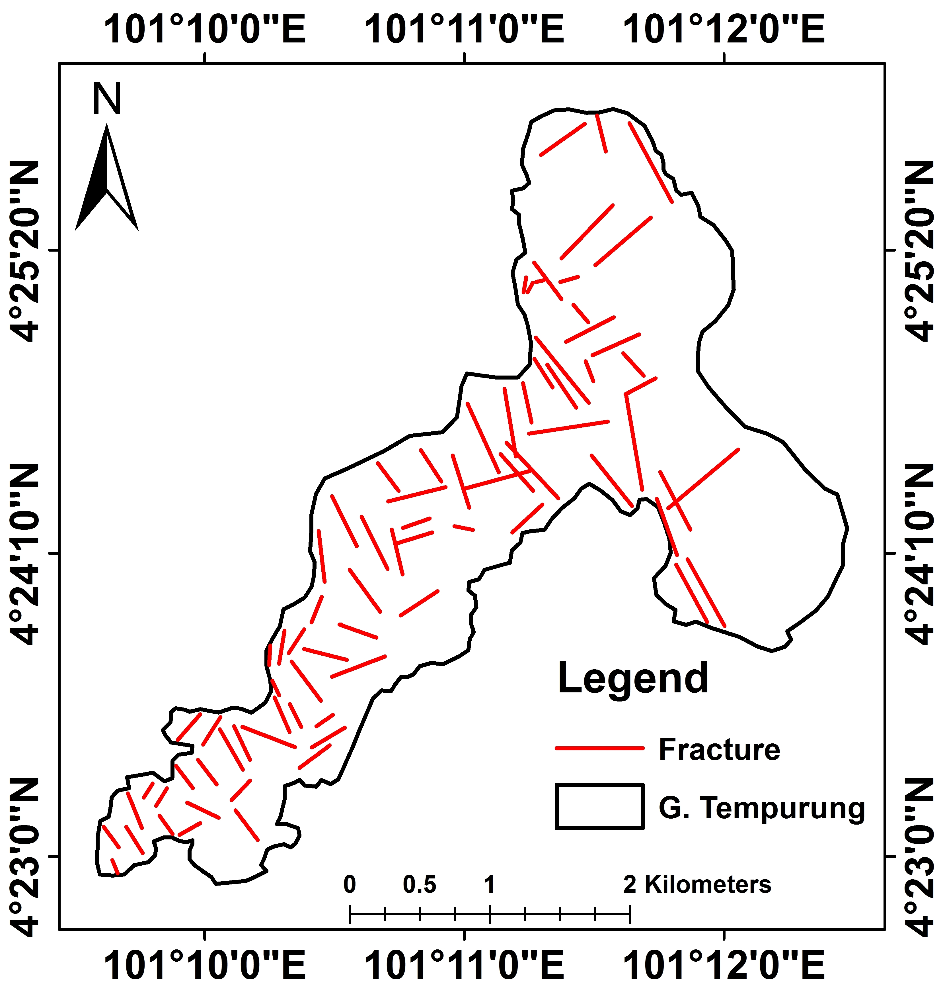

(d)
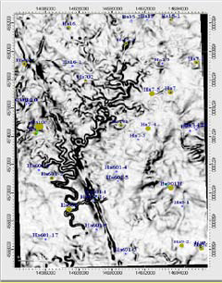

(a)

(e)

Fig.2 Indicates Tempurung hill which is shattered by fractures (a), and the two sinuous passage caves, Anak Tempurung (b) and Tempurung (c) located close to each other in this hill. The red lines, in the caves passage, indicate the possible trend of fractures along which conduit development might have taken place, (d) 3-D map of the multi-layered and circular passage Kandu cave, and (e) paleokarst channels observed with seismic discontinuity and dip attributes (Zheng et al., 2011).

References
Eberli, G.P., Masaferro, J.L. and Sarg, J.F. [2004] Seismic Imaging of Carbonate Reservoirs and Systems. AAPG Memoir, 81, 1-9.
Loucks, RG. [1999] Paleocave Carbonate Reservoirs: Origins, Burial-Depth Modifications, Spatial Complexity, and Reservoir Implications. AAPG Bulletin, 83, 1795-1834.
Odling, N. E., Gillespie, P., Bourgine, B., Castaing, C., Chile, J-P., Christensen, N. P., Fillion, E. , Genter, A., Olsen, C., Thrane, L., Trice, R., Aarseth, E., Walsh, J. J. and Watterson, J. [1999] Variations in fracture system geometry and their implications for fluid flow in fractured hydrocarbon reservoirs. Petroleum Geoscience, 5, 373–384.
Palmer, A.N. [1991] Origin and morphology of limestone caves. Geological Society of American Bulletin, 103, 1-21.
Shen, F. [2007]. Characterization and preservation of karst networks in the carbonate reservoir modeling. Society of Petroleum Engineers, 1-8.
van Golf-Racht, T. D., 1982, Fundamentals of fractured reservoir engineering: Elsevier Scientific Publ. Co., Inc. pp.710.
Wang, B. and Al-Aasm, I.S. [2002] Karst-controlled diagenesis and reservoir development: Example from the Ordovician main reservoir carbonate rocks on the eastern margin of the Ordos basin, China. AAPG Bulletin, 86(9), 1639-1658.
Zheng, D., Zhang, L. and Shen, F. [2011] Characterization and Modeling Study of Karst Networks in the Ordovician Carbonate Reservoirs, Tarim Basin. AAPG Annual Convention and Exhibition, Texas, USA, Poster presentation #40795.
Vahrenkamp, V.C., David, F., Duijndam, P., Newal, M., Crevello, P. [2004] Growth Architecture, Faulting, and Karestification of a middle Miocene carbonate platform, Luconia Province, offshore Sarawak, Malaysia. In Eberli, P., Masaferro, J.I. and Sarg, J.F. (Eds.) Seismic imaging of carbonate reservoirs and systems. AAPG Memoir, 81, 329-350.

