Ontology Design for Process Safety Management

Dr. T. J. Low, K. H. Yew, X. C. Tan

Computer and Information Sciences Department, Universiti Teknologi PETRONAS

*Abstract –* This project investigates the OSHA Process Safety Management (PSM) that eventually leads to the development of an appropriate ontology to represent and integrates the taxonomy of PSM elements as a knowledge base for safety process analysis. The main objective is to overcome the tedious manual PSM safety audit processes commonly practice in the industry. The proposed PSM ontology provides the fundamental set of knowledge representation for the PSM elements. This PSM ontology semantically integrates the PSM elements and their relationships thus forming a computer readable knowledge base as the platform for artificial intelligent machines to process and automate PSM audit processes. The proposed ontology shall become a framework for further development in PSM domain. Protégé is used as the main development tool in this project The outcomes of the project were evaluated and validated quantitatively and qualitatively using OntoQA metric, OSHA PSM compliance checklist, and by PSM domain researchers.

*Index Terms –* ontology, process safety management, PSM elements, process hazard analysis

1. Introduction

M

ajor devastating disasters that associate with highly hazardous chemicals such as Ajka alumina plant accident in Hungary in 2010, AZF fertilizer factory explosion in Toulouse, France that killed 29 people in 2001, the largest industry disaster of Bhopal Gas Tragedy in India that resulted in a death toll of more than 2,000 in the year 1984, and etc. have triggered serious global attention. To ensure safety and to reduce the occurrence of such catastrophes in the refining and petrochemical plants, relevant authorities have developed various safety regulations.

The obligation in the management of hazards associated with processes using highly hazardous chemicals and the assurance of the health and safety in the workplace have been proposed and is known as “Process Safety Management of Highly Hazardous Chemicals” standard (29 CFR 1910.119), in the Occupational Safety and Health Administration on July 17, 1990. This standard provides a guideline that aims to reduce the consequences of toxic, fire or explosion hazards due to the disastrous discharge of toxic, reactive, flammable, and explosive chemicals. [1, 2].

PSM standard is essentially applicable to manufacturing industries that deal with highly hazardous chemicals, such as pyrotechnics and explosives manufacturers. [1]. Hazard is an inherent physical or chemical characteristic that has the potential for causing harm to people, the environment, or property. It is intrinsic to a material or its conditions of use, e.g. hydrogen sulfide is hazardous and can be toxic by inhalation, gasoline is flammable, and etc. [3]. PSM ultimately aims to prevent unwanted release of hazardous chemicals. Nevertheless, PSM can be tedious for the industries to implement because it involves the evaluation of the whole chemical process, which will be affected by the interrelated 14 elements in the PSM.

To resolve the challenges of managing process safety faced by the industry of chemical plants, refineries, gas plants, and etc., PSM needs to be simplified by representing and integrating the 14 foundations of PSM in ontology as a stepping stone towards the automation of non-complex and more manageable safety audit procedure.

From human factors perspective, the lacking of fundamental human factors standard that could be adopted across the PSM elements to minimize human errors is known to be caused ineffectiveness in PSM. The catastrophic accident at the British Petroleum Texas City Refinery in year 2005, as cited in the United States Chemical Safety Board (CDB), was found to be mainly caused by the human factor deficiencies. Our proposed PSM ontology is focusing on human factors related PSM elements which include process hazard analysis (PHA), element 3, operating procedure (OP), and element 4, all of which have been given scant attention by the industries [4].

The philosophical definition of ontology is that it is a systematic way of explaining “being” – essence of a thing. [5]. In the perspective of ontology engineering it is a formal conceptualization of a domain. It is suitable to be used to represent the elements of PSM because ontology embraces a thing (an individual), classes of things (individuals), and properties of things (the relationships between the individuals). [6]. Besides, ontology can be the possible solution to the complexity of PSM because ontology allows structured communication of knowledge and it guarantees mutual (consensual) understanding between the concepts. [5].

Ontology development methodology - METHONTOLOGY is used as the development life cycle guide for PSM ontology. METHONTOLOGY strategy relies on the available resources of the studied area of PSM to start the development of the domain ontology using the core ontology. PSM has relevant information of its domain elements to begin the development of domain ontology [7] [5].

The evaluation and validation of our PSM ontology were conducted in two phases i.e. the quantitative metric based evaluation, and the qualitative validation with the PSM domain knowledge researchers. The OntoQA metric based evaluation was used because it is able to indicate the richness, width, depth, and inheritance of an ontology design [8]. The correctness of the knowledge domain is verified with the PSM domain researchers, supported by the recommended OSHA PSM Standard Compliance Checklist in validating the entities and relationships of PSM elements.

1. Problem statement

Despite the fact that PSM standard has successfully reduced the fatal or catastrophic incidents related to the highly hazardous chemicals since its inception, there are challenges faced by the petroleum refinery industry in the implementation of PSM. Many refining and petrochemical plants are still somewhat struggling with process safety due to the complexity of the interrelated 14 elements.

The complicatedly associated nature of PSM elements can cause the same information for the safety audit process to be circulated in multiple versions. PSM elements are overlapped with each other and the current manual implementation always compound the problem due to information redundancy that often being recreated and revalidated by different departments.

The PSM safety audit process is vital to be abided in the industry as it may result in termination of an operation or in the worst case, and costly losses as a consequence of catastrophic incidents. Unfortunately, manually executed PSM safety audit is always vulnerable to human errors and human recklessness.

1. literature review
2. Process Safety Management (PSM)

PSM is also known as Process Safety Management for Highly Hazardous Chemicals by OSHA (29 CFR 1910.119), which establishes a comprehensive management program to ensure process safeness. This standard is applicable to the manufacturing industries that associate with the release of highly hazardous chemicals.

OSHA’s term “process” in PSM refers to activities that deal with highly hazardous chemical, including using, storming, manufacturing, handling, moving, or the combination of these activities at the operation site. To clarify the ambiguity of the term “process”, it is considered a single process whenever a group of vessels that are interconnected, or when separated vessels are located in a way that could involve the potential release of a highly hazardous chemical. [1] [2].

To relate to the OSHA’s context, “safety” is referring to the technical safeness, occupational safeness, and process safeness. Technical safety covers the engineering and design decisions which usually involves at the initial stage. Occupational safety is commonly known intuition of safeness at the site, i.e. being in a state of protected from possible consequences of accidents, harms, or undesirable events whenever they are at work. Process safety focuses on the combination of several sequential small events that leads to different consequences.

Whereas the term “management” in PSM signifies the coordination of the activities, i.e. ensuring effectiveness of safety process by being proactively identify, evaluate, and mitigate of chemical releases that could take place due to failure of processes, procedure, or equipment. [2].

Element 3, the PHA based on [4] [1] is our focus in this project. It is a key component of PSM that mandates the initial hazard evaluation or analysis of all highly hazardous chemical associated processes covered by PSM standard to be done. PHA completely and analytically identifies, evaluates, and controls the hazards of processes associated with highly hazardous chemicals, via appropriate methodology(s) that fit the complexity of the processes. Employers need to fulfill the requirement of the process hazard analysis as follows:

* Determine and document the priority order for conducting process hazard analyses with consideration of the extent of the process hazards, the number of potentially affected employees, the age of the process, and the operating history of the process.
* Conduct all initial process hazard analyses as soon as possible with a minimum completion of 25 percent at first year and increment of minimum 25 percent on each consecutive year, to 100 percent completion in the fourth year. If the workplace has only one process, the analysis should be completed in the first year.
* Update and revalidate all the process hazard analyses at least every 5 years base on the completion date to ensure that the hazard analysis is consistent with the current process.
* Use one or more appropriate methods to analyze, determine and evaluate the hazards of the process, i.e. what-if, checklist, what-if/checklist. Hazard and operability study (HAZOP), failure mode and effects analysis (FMEA), fault tree analysis, or any appropriate equivalent methodology.
* Address the following items for whichever method(s) that is used in the process hazard analysis:
* Conduct the process hazard analysis in a team with expertise in engineering and process operations, i.e. include at least one employee who is experienced and knowledgeable in the process that will be evaluated, and a team member who is knowledgeable in the specific analysis methods that will be used.
* Establish a system to address the team’s findings and recommendations.
* Resolve recommendations timely and document the resolutions which written what actions are to be taken.
* Develop a schedule for action completion and communicate the actions (resolutions to recommendations) to operating, maintenance, and other employees whose work assignments are in the process who may be affected.
* Keep file and make available of the updated and revalidated process hazard analyses, and the resolution of recommendations document for OSHA whenever requested for the entire life of the process.

1. Ontology and Its Purpose

From the philosophy branch of metaphysics, ontology is philosophically concerning the nature of being and existence, and is defined as “a systematic explanation of being” [5]. This term has evolved throughout the years and researchers have eventually modified and improvised the definitions to explain “ontology”.

Gruber’s simple definition of an ontology is “an explicit specification of a conceptualization”, i.e. *a description (like a formal specification of a program) of the concepts and relationship that can exist for an agent or a community of agents; this is a definition that is consistent with the usage of ontology as set-of-concept-definitions.* [9].

Gruber further illustrates that the essence of an ontology is what it is *for*, which he explains the purpose is for knowledge sharing and reuse through ontologies designs. Gruber’s view of reusability is somewhat matching the idea of Gómez-Pérez and Fernández-López who proposed that ontologies aim to capture c*onsensual* knowledge in a generic way for the reuse and sharing purpose across software applications. [5].

Uschold and Jasper [10] also agreed on the benefit of reusability of the formal representation of important entities, particularly in engineering software systems. They proposed that ontology contributes in communications between human agents, to achieve inter-operability among computer systems via the process of translating, using ontology as an interchange format.

In fact the reuse and sharing purpose of ontology has been broadly adopted in various field such as the application of Semantic Web, intelligent integration, knowledge management, e-commerce, natural language processing, and etc. Uschold and Jasper s’ definition of ontology covers wider fields of explanations as such:

“*An ontology may take a variety of forms, but necessarily it will include a vocabulary of terms, and some specification of their meaning. This includes definitions and an indication of how concepts are inter-related which collectively impose a structure on the domain and constrain the possible interpretations of terms.*” [10].

In this research project, Process Safety Management (PSM) is the particular context in which an ontology is suitable to be applied in order to achieve the purpose mentioned above as well as other more specific benefits, i.e. maintenance, reliability, and specification. Uschold and Jasper discussed about the benefit of using ontologies which is the improvement of maintenance because systems which are built using explicit ontologies will advance documentation of the software, and thus reduce maintenance cost. Besides, ontology helps the process of identifying requirements and defining a specification for a knowledge-based system. In terms of reliability, ontology has a formal representation that makes the automation of consistency checking possible. [10].

1. methodology

METHONTOLOGY proposed by a group of ontology researchers at Universidad Politécnica de Madrid has been used as the development life cycle of PSM ontology. METHONTOLOGY will support the ontology design tool, i.e. Protégé, an open source application maintained by Stanford University.



Figure 1: METHONTOLOGY’s ontology development life cycle. [7].

The first step is to specify the purpose of the ontology being built, i.e. the objectives, scope and the intended uses of the ontology. Some background study is conducted to identify the problem statement, and then further narrow down the issues in order to counter the problems with specific objectives and scope of study.

The second step is to conceptualize ontologies. This phase involves collecting the needed knowledge, organize and converts the informally collected source to a semi-formal format by using a set of terms known as intermediate representation (IRs) as defined according to Fernández-López and Gómez-Pérez,. The output of this phase is ontology conceptual model that is more explicitly representing the concepts with IRs for better understanding of the ontology development stage.

The third step involves the transformation of the conceptual model into a formal model, in preparation for implementation. The fourth step is the implementation of the ontology using the chosen ontology language and tool. The outcome of implementation phase is the codified representation of ontology in a formal language. The final step is the maintenance which involves corrections and updates of the ontology model.

The maintenance activities (which include scheduling, controlling, and quality assurance) and support activities (which include knowledge acquisition, integration, evaluation, documentation, and configuration management) are to be carried out concurrently throughout the development phases.

1. result

The following results demonstrate the outcome of conceptualized ontology design experiment for selected PSM element, i.e. element 3, process hazard analysis (PHA). PHA has been chosen because it is one of the elements in the ontology design that addresses the human factors influential elements as proposed by [4]. The conceptualized PSM ontology design has been built through Protégé ontology design tool. The diagrams in the following sections illustrate the relationships of the elements (classes) supported by the Protégé’s ontology browser plugin tools namely, OWL Viz and OntoGraf.

OWLViz enables class hierarchies in the OWL ontology to be viewed and incrementally navigated for comparison. Due to page limitation the thorough OWL Viz diagram is not able to be shown in this paper.

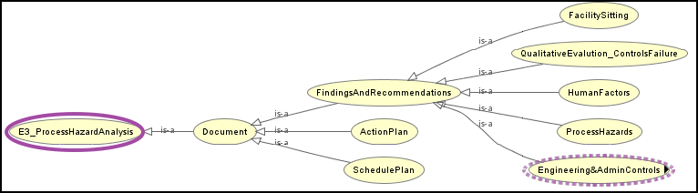

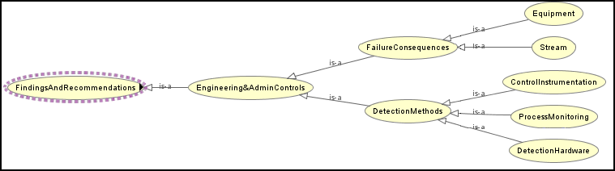

Figure 2: OWL Viz for PHA

Figure 2 displays the hierarchy for process hazard analysis in the OWLViz form. Figure 3 shows six levels of “is-a” relationship, the class hierarchy is as shown below:

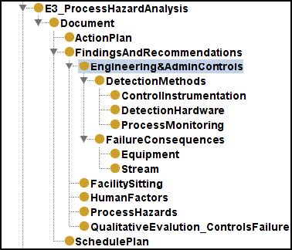

Figure 3: Class Hierarchy for PHA

|  |  |  |
| --- | --- | --- |
| **Level** | **Superclass** | **Subclass** |
| 1 | PHA | Document |
| 2 | Document | Findings and Recommendations,  Action Plan, and Schedule Plan |
| 3 | Findings and Recommendations | Facility Sitting, Qualitative Evaluation Controls Failure, Human Factors, Process Hazards, and Engineering and Admin Controls |
| 4 | Engineering and Admin Controls | Failure Consequences, and  Detection Methods |
| 5 | Failure Consequences | Equipment, and Stream |
| 6 | Detection Methods | Control Instrumentation, Process Monitoring, and Detection Hardware |

Table 1: PHA “Is-a” relationship table

Referring to Table 1, the subclasses will inherit the property of superclass entity, i.e. the superclass will not have properties that the subclass has. For instance in level 1, PHA “is a” document, and document are made up of findings and recommendations, action plan, and schedule plan. Findings and recommendations, action plan, and schedule plan will inherit the properties of document, whereas document only inherits the properties of PHA.

OntoGraf enables interactive navigation of relationships of the OWL ontologies, e.g. subclass, individual, object properties, and etc.

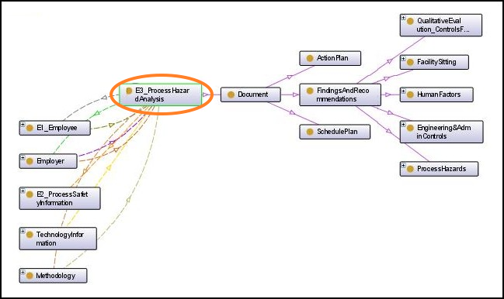

Figure 4: OntoGraf for PHA (extend to Figure 5)

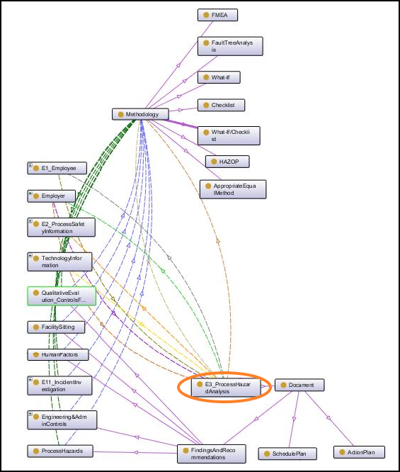

Figure 5: OntoGraf for PHA

Figure 5 displays the concept of PHA in PSM context which associated with other entities. Figure 4 is the extension to Figure 5 that shows the hidden subclass entities of document in Figure 5.

|  |  |  |  |
| --- | --- | --- | --- |
| **Line** | **Domain** | **Relationship/ Property (s)** | **Range** |
| Sol-id Line | E3_PHA | “is-a” | Document |
|  | Document | “is-a” | * Findings and Recommendations * Action Plan * Schedule Plan |
|  | Findings and Recommendations | “is-a” | * Facility Sitting * Qualitative Evaluation Controls Failure * Human Factors * Process Hazards * Engineering and Admin Controls |
|  | Methodo-logy | “is-a” | * FMEA * Fault Tree Analysis * What-If * Checklist * What-If/Checklist * HAZOP * Appropriate Equivalent Method |
| Dot-ed Line | Methodo-logy | “has addressed”  “is addressed by” | * E11_Incident Investigation * Engineering & Admin Controls * Facility Sitting * Human Factors * Process Hazards * Qualitative Evaluation for Controls Failure |
|  | Methodo-logy | “is used method by” | * E3_PHA |
|  | E1_Employee | “has access to trade secret”  “is access by trade secret” | * E3_PHA |
|  | E3_PHA | “compliance with” | * E2_PSI |
|  | Employer | “has implemented” | * E3_PHA |
|  | Employer | “is communicate to”  “has communication from” | * E3_PHA |
|  | Technology Information | “is developed in conjunction with” | * E3_PHA |

Table 2: PHA relationships / properties table

Table 2 lists and describe every association that graphically displayed in Figure 3 and 4.

1. discussion
2. Quantitative Evaluation:

Ontology evaluation may not produce a problem-free ontology design because there is no single best method for evaluation, but it will make ontology more reliable. [5]. This section presents the quantitative metric-based evaluation approach to evaluate the content of PSM ontology.

Inheritance richness (IR) schema metric has been used to evaluate the ontology as follows:

|  |  |
| --- | --- |
| **Indication** | The distribution of information across different levels of the ontology’s inheritance tree or the fan-out of parent classes. I.e. High IR would be a shallow (or horizontal) ontology, which indicates that the ontology represents a wide range of general knowledge with a low level of detail; low IR would be a deep (or vertical) ontology, which indicates that the ontology covers a specific domain in a detailed manner. |
| **Definition** | The average number of subclasses per class. |
| **Formula** | |H(c)|: Number of subclasses of Class C  |C|: Number of classes |
| **Result** | The average number of subclass is 4.59 per class. |

Table 3: IR schema metric evaluation

Table 4 is a summary of several ontologies presented by Tartir et al. in comparison with the inheritance richness result of PSM ontology. SWETO is an ontology that describes the domain for publications, affiliation, geography and terrorism; TAP is a domain that describes publications, sports, and geography; and GlycO is an ontology that prepare for efficient acquisition, description, analysis, sharing and dissemination of data for Glycan Expression. [11].

|  |  |  |  |
| --- | --- | --- | --- |
| Ontology | Classes | Instances | Inheritance Richness |
| SWETO | 44 | 813,271 | 4.00 |
| TAP | 3,229 | 70,850 | 5.36 |
| GlycO | 352 | 2,034 | 1.56 |
| PSM | 95 | 78 | 4.59 |

Table 4: Summary of IR for SWETO, TAP, GlycO, and PSM

Based on the above table, TAP has the largest inheritance richness while GlycO has the smallest inheritance richness which indicates that it is domain specific as the ontology has smaller number of subclasses per class and a large number of instances. SWETO and PSM have the inheritance richness that is between the highest and the lowest inheritance richness. Thus, SWETO and PSM are considered as moderately general purpose ontology.

Class connectivity knowledgebase metric has been used to evaluate the ontology as follows:

|  |  |
| --- | --- |
| **Indication** | To understand the nature of the ontology by indicating which classes play a central role compare to other classes. |
| **Definition** | The total number of relationships instances of the classes that have with instances of other classes. |
| **Formula** | NIREL|: Total number of relationships instances of the class have with instances of other classes |
| **Result**  Table 5: Class connectivity knowledgebase metric evaluation | Class of Process Hazard Analysis (element 3):  = 7  Class of Process Safety Information (element2):  = 11  Class of Operating Procedure (element 4):  = 13 |

Class connectivity describes the nature of ontology by indicating which classes play a more central role than the other classes. The average class connectivity to entity process safety information (PSI), process hazard analysis (PHA), and operating procedure (OP) is about 10.6, and the class with best domain information is OP since it has the highest number of class connectivity. This means that, OP possess the central role of the ontology design with the most information about the domain compared to PSI and PHA with lesser domain information than that of OP.

1. Qualitative Evaluation:

The qualitative evaluation was conducted to evaluate the correctness of the generated PSM ontology entities via a formal discussion and verification with domain researchers’ work in process safety domain for Chemical Engineering department of Universiti Teknologi PETRONAS. Element 3, process hazard analysis (PHA) ontology is being investigated thoroughly by the researchers through ontology relationships breakdown demonstration and explanation using Protégé ontology design tool. The PSM ontology rationalize procedure is guided with PHA compliance checklist, i.e. checklist is compared with the PSM ontology implementation.

Despite that the ontology design has its limitations; the discussion result has sufficiently indicated that the PSM ontology design is able to reasonably representing the PSM domain knowledge.

1. Findings

The lesson learned is that ontology has its limitation of capturing non-static data. The reason being ontology is essentially representing the concepts and relationships, rather than storing the data that gives no definitions and associations.

Our PSM ontology is a pioneer design in the PSM domain. We are yet to find a suitable and unambiguous ontology benchmark to be used for conducting meaningful comparison and evaluation on our design.

The setback of the schema quality is that it could be difficult to measure due to subjectivity and inconsistent domain expert acceptance. The standard of the evaluation metric can be inconsistent as the metric formula given is vulnerable different interpretation by different researchers from different perspective.

The metric-based evaluation may not be completely accurate. This is because ontologies evolved from time to time due to changes in the domain, changes in conceptualization, and changes in the explicit specification [8]. Thus, the input from domain knowledge researcher is valuable to justify the correctness of the entities and relations representation of PSM in ontology.

The experiment of conceptualizing PSM elements displays the challenge of generating a definite design. This is due to some extents of the safety guidelines that have the characteristics of vagueness and uncertainness, and therefore guidelines are varied depending on implementer. Besides, perceptions and interpretation of the domain knowledge are diverse according to cultural background, language, education, ideology, and etc.

1. conclusion and future direction

Petrochemical plants and refinery industry that deal with highly hazardous chemicals have been doing researches on integrating the overlapping and complicatedly associated PSM elements in order to overcome the shortcomings of current manual execution of the safety auditing procedure.

The proposed PSM ontology has been developed using Protégé ontology development tool. The PSM ontology has been evaluated quantitatively using OntoQA metric measure, and validated qualitatively with knowledge base researcher guided with industry PSM element’s compliance checklist.

The proposed PSM ontology may provide base to guide future ontology designs, and ontology evaluation benchmark for process safety standards since there has not been any formal conceptualization effort accomplished in the area of PSM.

PSM ontology will provide a framework and useful information for future research in the area of automating the PSM procedures through artificial intelligent systems and other software, as PSM ontology provides a common knowledge representation of the PSM elements that is machine-readable, reusable, and achieve interoperability among computer systems.

The future enhancement for the PSM ontology would be an ontology design that can be more effectively capture the non-static and qualitative safety requirements in the PSM standard. Besides, artificial intelligent software in the area of PSM has positive prospect as it can counter the current vagueness of ontology evaluation methods because the software-generated outcome will support the credibility and reliability of the PSM ontology.

Acknowledgment

Author would like to gratefully acknowledge the help and advice from Dr. Low Tang Jung and Mr. Yew Kwang Hooi from Computer and Information Systems department of Universiti Teknologi PETRONAS for their constructive advice, technical and non-technical support. To Ms. Hanida Aziz from Chemical Engineering department of Universiti Teknologi PETRONAS, who gave up her precious time to provide valuable evaluation opinion glosses the project.

References

[1] A. M. Herman and C. N. Jeffress, "Process Safety Management," U. S. D. o. Labor, Ed., ed, 2000.

[2] O. S. a. H. A. OSHA, "Regulation Process Safety Management of Highly Hazardous Chemicals," in *Occupational Safety and Health Standards* vol. 1910.119, ed, 1992.

[3] H. J. Toups, "Hazards, Accidents, Process Safety Management & Process Hazard Analysis," ed. SACHE 2003 Workshop LSU Department of Chemical Engineering 2003.

[4] W. Bridges and R. Tew, "Human Factors Elements Missing from Process Safety Management (PSM)," presented at the 6th Global Congress on Process Safety, Texas, USA, 2010.

[5] A. Gómez-Pérez*, et al.* (2004). *Ontological Engineering*.

[6] M. Horridge. (2011, October 22, 2011 ). *A Practical Guide To Building OWL Ontologies Using Protégé 4 and CO-ODE Tools (1.3 ed.)*.

[7] O. Corcho*, et al.*, "Building Legal Ontologies with METHONTOLOGY and WebODE," *Law and the Semantic Web,* pp. 142-157, 2005.

[8] S. Tartir*, et al.*, "Ontological evaluation and validation," *Theory and Applications of Ontology: Computer Applications,* pp. 115-130, 2010.

[9] T. R. Gruber, "Toward Principles for the Design of Ontologies Used for Knowledge Sharing," *International Journal Human-Computer Studies,* vol. 43, pp. 907-928, 1993.

[10] M. Uschold and R. Jasper, "A Framework for Understanding and Classifying Ontology Applications," in *IJCAI-99 Workshop on Ontologies and Problem-Solving Methods: Lessons Learned and Future Trends*, Stockholm, Sweden, 1999.

[11] S. Tartir*, et al.*, "OntoQA: Metric-based ontology quality analysis," 2005.