South Korea and Malaysia Relations in O&G: Mutual Cooperation in Offshore Initiatives
Author: M.S. Liew and Noor Amila W.A.Zawawi
The contemporary development of the global oil and gas (O&G) economy outlook for 2013 has been reported by OPEC 2012 to potentially fall short of world oil demand growth forecasts. The cited reasons were Europe’s troubled economy and the risk of weakness in faster growing regions such as China and India. However for Malaysia, the outlook for O&G industry remains fiscally positive, supported by National Key Economic Area (NKEA) which acts as a major boost. Twelve (12) targets were set in NKEA to address the Oil, Gas and Energy (OGE) Sector, encompassing implementation of enhanced oil recovery (EOR) techniques, regasification terminals, new well discoveries and marginal oil fields to name a few. In keeping with growth in the global economy, the government of Malaysia through NKEA puts forth a vision to transform the nation into South East Asia main hub for O&G by the year 2017. Malaysia targets to attract major international companies in the Oil Field Services and Equipment (OFSE) industry to bring their business operations to Malaysia. This will position Malaysia as a cost-competitive base for engineering, procurement and construction as well as a strategic base for installation activities in the Asia-Pacific region.
Locally and internationally, the O&G sector in Malaysia has always been viewed as an important investment sector. The current climate is that PETRONAS, the national oil company, is expecting a slowdown in crude oil demand due to uncertain global economic weather, thus will lower PETRONAS’ earnings. Despite a number of major projects in the pipeline, there are huge challenges that needed to be overcome. A key thrust would be to intensify exploration and enhance production from domestic reserves. Malaysia will also develop a strong regional OFSE hub and a stronger presence in the regional midstream logistics and downstream markets. O&G activities are expected to pick up with PETRONAS featuring two (2) prominent themes namely the gas sector and an array of projects addressing the upstream and downstream activities. For the gas sector, the recent Pengerang Integrated Petroleum Complex (PIPC) in Johor and commercialization of LNG regasification facilities project in 2012 will lift domestic gas supply by 22% and single-handedly address the nation’s supply constraint currently affecting the power and industrial sectors. For project awards, with strong capital expenditure plan ahead, it is expected that O&G service providers will continue to enjoy a sustained growth as demands for equipment and services increase in light of rising activities in the sector. Various major billion (MYR) fabrication jobs are or will be up for grabs such as the Malikai TLP, PETRONAS Carigali’s major central processing platform projects and Shell’s fabrication projects, just to name a few. Another example is in floating solutions where demand for floaters in the domestic market is picking up. With the MYR15b North Malay basin field fast-tracked for production by 2013, we see a continuous flow of pipe-coating projects.

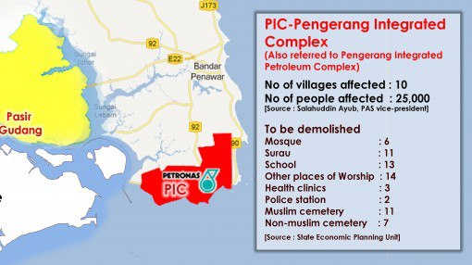
Pengerang Integrated Complex, Johor
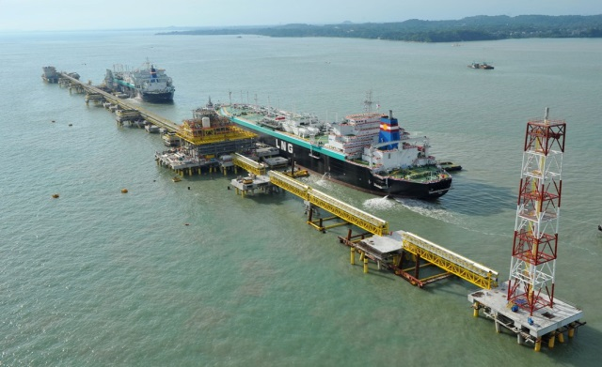
LEKAS, regasification facilities in Malacca

Summing all of this up, it is anticipated that in the next 5 years, PETRONAS would be engaging itself and its stakeholders in the fabrication and commissioning of nearly 70 new platforms. This sort of momentum can only bode well for the local industry. However, the question remains, “Is the local industry capable to take on this challenge?”. The current setting shows that the local industry players are struggling to fulfill the rising demands, and are in dire need for fast-track input from quarters with existing capabilities. Perhaps it is time we consider the strength of our long-time allies and identify ways on how our relations can be further enhanced in line with the growing economy.
South Korea has been Malaysia’s long-time ally since 1960. It has been 53 years since Malaysia-South Korea governments embarked on bilateral relations through Malaysia’s Look East policy. Since then, both parties have been working together to establish a mutually beneficial and future-oriented strategic partnership. The bilateral relations between the two governments seem to be booming at government as well as business level. Of course, for Malaysians in general, the members of the public are better acquainted with the South Koreans through the Korean cars of Hyundai, Kia and Ssangyong, the lifestyle products such as Samsung and LG, and the entertainment industry through Korean drama Winter Sonata and the K-pop culture of Big Bang and Rain, and Korean food kim-chi and all.
From the government-to-government perspective, the cooperation focuses on research and development (R&D) and the industries such as plants, electronics, vehicles and trade and investment systems. The formula has worked well for five decades, but perhaps with changing time and global economies, it is timely for new sectors such as O&G to come in.
South Korea is in a great position as a potential investor; it is currently the world’s 14th largest economy with decades of impressive economic growth. It is a world leader in electronics, communications, automobile production and shipbuilding. South Korea now is the largest shipbuilding nation in the world, winning the title over from Japan in 1990s due to advantages of much cheaper wages, strong government backing and a cheaper currency. Historically, Japan won the title over from Europe in 1960s in similar ways. In O&G industry, the overseas exploration and production (E&P) plays a more essential role in Korea. South Korea’s national oil company, KNOC only produces a negligible portion of its more than 2 million bbl/d total petroleum consumption, of which nearly all are imported. Private E&P overseas receive strong support by the Korean government through taxation benefits and the extension for credit lines to International Oil Companies (IOC), as well as providing diplomatic aid in overseas negotiations. KNOC has currently invested in over 200 projects overseas. In the downstream sector, South Korea has the sixth largest refining capacity in the world, with crude oil producing capacity of 2.8 million bbl/d. The Korean refineries are well-known for producing more light clean products and increasing capacity utilization, thus expected to remain a leading refiner is Asia, with significant exports to China, Singapore and Indonesia. South Korea is also a major producer of petrochemicals with more than 7 million ton/year of ethylene capacity.
On the other hand, Malaysia is a resource-rich country, wealthy with mineral resources and fertile soils. The structural transformation of Malaysia’s economy has been spectacular over the last 40 years. The nation is however lacking in comparison to South Korea in terms of economic robustness, technology and tenacity. South Korea investments in Malaysia depend heavily on the price stability of electricity, and in particular of gas. The price of electricity is more expensive in Malaysia, but investment from South Korea is attracted by the lower price of gas. Apart from these, Malaysia has great potential as an investment destination due to advanced infrastructure, access to raw materials, active government support, social stability and rule of law.
In view of the targets set out in NKEA, Malaysia has positioned herself as an attractive investment hub for O&G sector, across the upstream, mid-stream and downstream sectors. The business directions of both nations seem to be inline and mutually exclusive, with South Korea set out to venture into more E&P overseas, offering the latest technology; and Malaysia to attract the multi-national companies (MNC) to optimize the wealthy resources in our lands. In the bid to increase investment potentials, the government of Malaysia leverages on the key strength through provision of political stability and government supports, infrastructure improvement and better accessibility to, and stability of supply for, raw materials.
Undeniably the O&G industry is contending with a dynamic global marketplace and an increasingly resolute group of stakeholders, with the available reserves getting increasingly difficult and expensive to produce. Market analysts globally have consistently identified four (4) trends that could potentially result in hindrances to the growth of an O&G company; Malaysia being no exception to this rule as well. The trends include the need for sustainable solutions, the need to recruit and retain a skilled workforce, the need for high performance data management and technology advancement and lastly, the need for safety and regulatory compliance tools. This means that there are opportunities abound for any interested MNC to come in and fill up the gaps.
Another good news, PETRONAS has cited that majority of its capital expenditure (Capex) will include aggressive exploration, development of marginal fields and establishment of regasification terminals in Melaka, Pengerang and Lahad Datu. Aggressive exploration means PETRONAS is moving to deeper waters. Future deepwater projects are in motion up till 2015 with one of the largest fields containing 2701m boe reserve, thus requiring large scale commissioning services. The marginal fields have also been tendered out at RM3billion. The opportunities for fabricators are abound as the steel industry is facing challenging times ahead due to influx of cheaper imports, with price dumping from main competitors such as China and lack of import duty which is affecting support for local growth. At the moment Malaysian is at 22% higher than ASP, and the local market is experiencing a slowdown in overall steel demand, followed by the fact that procurement is not full-fledged in Malaysia as very few companies are willing to provide the supply of a single fabrication work.
The sustained Capex is likely to be followed by huge demand for O&G expertise over the next few years. This great momentum would also demand herculean efforts from Malaysian local players in terms of throughput and as a result, the presence of regional powerhouses gracing our midst should be taken advantage of to the fullest. Being the more technologically and economically advanced nation, South Korea is more than welcome to work with us. After all, Malaysians are already fond of the Korean lifestyle products and are no stranger to K-pop culture.
Hwan young hamnida (Selamat datang)!

