Spatial Simulation for Flood Disaster Forecasting: A Geospatial Technology-based Group Analytic Hierarchy Process Approach

Dano Umar Lawal, Abdul-Nasir Matori, Khamaruzaman Wan Yusof , Ahmad Mustafa Hashim , Mansir Aminu5, Soheil Sabri 6, Abdul-Lateef Balogun7, Imtiaz Ahmed Chandio8, Munirah Radin Mohd Mokhtar9

1, 2, 3, 4, 5, 7, 8, 9 Civil Engineering Department, Universiti Teknologi PETRONAS

6 Urban and Regional Planning Department, Universiti Teknologi Malaysia

**Abstract: Group Analytic Hierarchy Process (GAHP) is integrated with Geographic Information System (GIS) and remote sensing to help in simulating the flood likely areas based on a total number of five set of criteria/factors believed to be triggering flood generation in the study area. Two categories of experts namely hydrologists and geologists were considered. Saaty’s 1-9 scale of preference was employed in rating each factor’s influence in flood generation and the ratings from the experts were aggregated using a Geometric Mean method. Having done with the aggregation, priory weights of the factors were calculated; weights were further normalized through the Analytic Hierarchy Process (AHP). The result was further integrated into GIS system for spatial simulation of the likely flood areas. In validating the robustness of the result, known Flood Extent Extraction Model developed based on a Neural Network Algorithm embedded in ENVI 4.8 software was used. The result of the overlay carried out in ArcGIS 9.3 software displayed a significant match with what is on ground.**

**Keywords: Geospatial Technology-based Group Analytic Hierarchy Process, Spatial flood simulation**

1. INTRODUCTION

Floods are the most shocking natural catastrophes in the world. Historically, floods have been part and parcel of the human lives. They are regular phenomena that made a basic and persistent feature of all river basin and lowland coastal systems [1]. In the most developed nations, severe floods can be seen as the most frequent and costliest natural catastrophes in terms of human and economic damages. Likewise they are the key cause of hazard-related deaths in the less developed nations. Since ancient times, the natural disasters troubled human development with distressing consequences. Therefore, a group decision making can be an efficient means of minimizing the flood disastrous effects. A group decision making is a vital part of the modern emergency planning and management [2]. The view of one expert may vary from others, but this will often be to the advantage of the planning authorities since it offers a useful medium for all expectations to be questioned and reﬁned. The end result is therefore more realistic. [3] described how the civil defense and emergency management group decisions shared numerous exclusive characteristics. First of all, the group must frequently make several sophisticated and multi-faceted decisions in a short period, thereby contributing to a great “decision load”. Secondly, these decisions may have possibly serious significances. [4] uses the terminology “decision quality” in describing the point to which a wrong decision could lead to disastrous outcomes. Thirdly, the group decision must frequently be prepared with incomplete information (equally in terms of quality and quantity), mainly in the initial phases of a disaster because of emergency management problems.

The Group Analytic Hierarchy Process (GAHP) [5-7] has great potential for use in the group emergency decision making. The Analytic Hierarchy Process (AHP) is a mathematical modeling technique for multi-criteria decision making [5] ; [8][9, 9] ;[10][10]; and [11]. It was developed by Saaty, a mathematician in early 70s. The AHP method helps to specify numerical weights representing the relative importance of factors, elements, criteria for flood susceptibility models (see also [12];[13, 13]; [14]; [11]. AHP allows both qualitative and quantitative approaches to solve complex decision problems. Therefore, vast majority of the work and literature available on the application of AHP in geo-engineering are dedicated to the generation of relative weights of influential factors based on a group decision making and integration of the weights into GIS environment for spatial modeling. Hence, AHP’s comprehensive literature collections could be found in http://www.expertchoice.com. For instance, [15] generated relative weights of influential factors affecting urban (Lanzhou city, China) geo-environment using AHP, where the suitability potentials of urban land use were evaluated using GIS.

In this study, the principles of Multi-Criteria Decision Making (MCDM) in the context of group analytic hierarchy process (GAHP) have been integrated with GIS and remote sensing to simulate and forecast the flood susceptible zones. The objectives are to develop a flood susceptibility map based on the views of two category of experts (hydrologists and geologists) using some hydrogeological indexes. The data preparation and integration were carried out in GIS environment.

II. DESCRIPTION OF THE STUDY AREA

*A. Location of the study area*

The State of Perlis is bounded by Thailand in the north, Kedah in the south, while its western coastline borders the Straits of Malacca as illustrated in Fig. 1. It is bounded by longitudes 100 º 07’ 02”E/ 100 º 22’ 33”E and latitudes 6 º 43’ 19”N/6 º 15’ 13”N respectively.

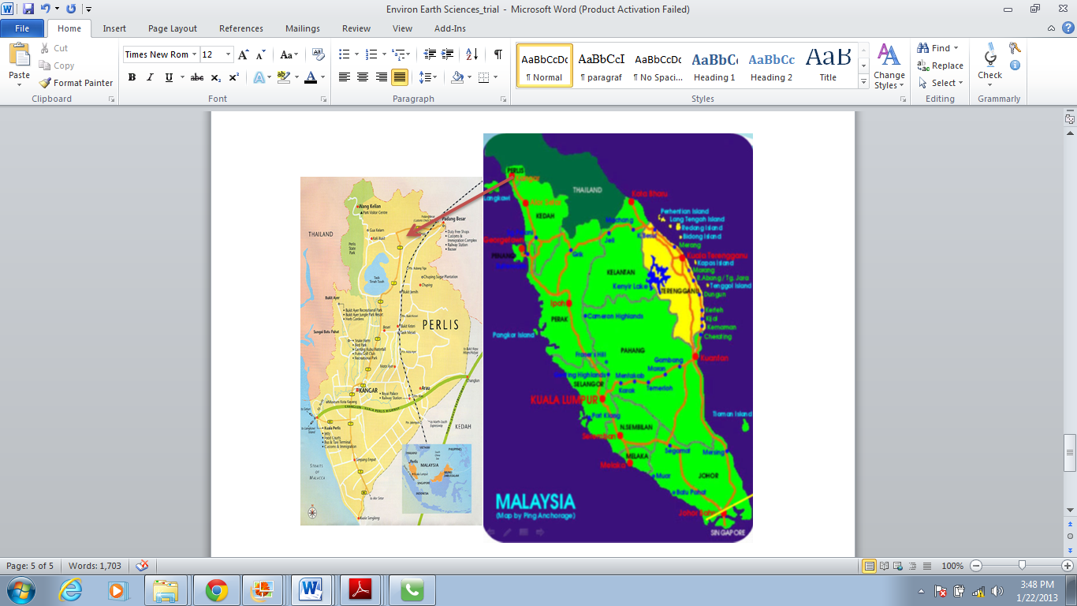

TABLE 1: INTERPRETATION OF THE SAATY’S SCALE OF MEASUREMENT

Fig. 1: Map of Peninsular Malaysia showing the study area

Source: http://www.royalpcg.com/sites

III. STUDY METHODOLOGY

*A. Selecting the flood influencing criteria/factors in the study area*

Certain natural flood influencing factors were considered in this study in order to forecast the flood susceptible zones in the study area. The factors considered herein are: rainfall, geology, slope gradient, land use, and the soil type. [16] and [17] used the same factors in their flood studies. Therefore, these factors are believed to be influencing flood generation in the area.

*B. Assignment of weights to the flood influencing criteria/factors*

Based on the method of the Multi-Criteria Decision Making (MCDM), each factor’s weight was computed and assigned to the factors discussed previously in GIS environment. [18] and [19] described MCDM as a method that permits each criterion to be weighted with respect to its relative importance/influence. Experts’ judgments were used in assigning the weight of each criterion. The experts’ ratings were aggregated using a Geometric Mean method as follows: Geometric Means = ((X1)(X2)(X3)....(XN))1/N; where X = Individual score and N = Sample size (Number of scores).Therefore, the experts’ preferences helped in carrying out the pairwise comparison matrix. As mentioned earlier, AHP technique developed by [5] was used in coming up with the relative weights based on the Saaty’s scale of influence 1 to 9 as shown in Table 1. The weights of the factors were generated based on the steps described by [20]

|  |  |  |
| --- | --- | --- |
| **Degree of importance** | **Definition** | **Interpretation** |
| 1 | Equal importance | Two element making equal contribution to the goal |
| 3 | Somewhat more important | Moderate importance of element over the other element |
| 5 | Much more important | Essential or strong importance |
| 7 | Very much important | Very strong importance |
| 9 | Extremely important | Extreme importance |
| Scale, 2.4, 6 and 8 | Intermediate values | These are require when comparison between two adjacent judgment is needed |
| Reciprocals | If v is the judgment value when i is compared to j, then 1/v is the judgment value when j is compared to i. | |

*C. Group analytic hierarchy process results integration into GIS system*

In this stage, the GAHP results were integration into GIS system to simulate the flood vulnerable areas. Combining all the thematic layers (the factors) using the Weighted Linear Combination (WLC) method in accordance with the computed weights was carried out in GIS. The Weighted Linear Combination, or simple additive weighting, relies on the concept of a weighted average where continuous criterions are standardized to a collective numeric range, and then combined by means of a weighted average [21][21]. The overlay of the thematic layers was to obtain the final simulation of the flood forecasted zones. The results of the final analysis managed to indicate the potential flood areas in the study area.

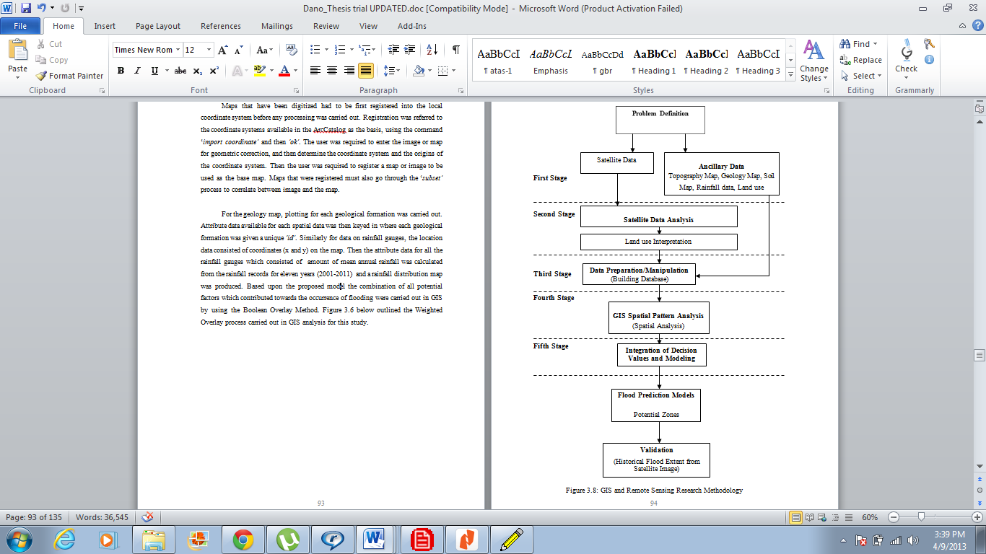



TABLE 2: A MATRIX OF PAIR-WISE COMPARISONS OF FIVE CRITERIA FOR THE AHP PROCESS

Fig. 2: Flowchart of the study methodology

IV. GAHP RESULTS AND SIMULATIONS

*A. Pairwise comparisons of the factors*

It is normally presumed that Multi-Criteria Decision Analysis (MCDA) started at the beginning of 60s. A good number of experts of MCDA consider that their discipline stems mainly from the early work on goal programming as well as study of [22] [21][21]. Simon proposes a framework for analyzing human decision-making processes by differentiating between the intelligence, design, along with choice phases Hence, Multi-Criteria Decision Analysis (MCDA) techniques are numerical algorithms that define suitability of a particular solution on the basis of the input criteria and weight together with some mathematical or logical means of determining trade-offs when conflict arise. By this technique, a weight value ranges from 1 to 9 was assigned to each factor by the experts to reflect their relative significance. Using the Weighted Linear Combination (WLC) method, all the map layers (the factors) were overlaid in the final GIS spatial analysis for flood susceptible zones simulation.

WLC technique can be carried out using any type of GIS system possessing the overlay. This permits the evaluation criterion map layers to be overlaid in order to obtain the composite map layer which is output. Therefore, the output of this WLC method gave a map which simulated the most potential flood susceptible zones of Perlis. Figure 3 shows the flood prediction model. The result of the experts is computed below:

Where, C1 = Rainfall; C2 = Geology; C3 = Soil type; C4 = Slope gradient; C5 = Land use.

TABLE 5: RANDOM INCONSISTENCY INDICES



TABLE 3: DETERMINING THE RELATIVE CRITERION WEIGHTS



TABLE 4: DETERMINING CONSISTENCY RATIO (CR)



STEP III:The Consistency Index (CI), which is a measure of departure from consistency, was calculated using the formula:

CI= (3)

Where, n = number of factors (i.e. 5) and  = average value of the consistency vector determined in step ii above.

**=** 5.24 + 5.18 + 5.21 + 5.21 + 5.19 = 26.04/5 = 5.21

Based on equation (3), CI = 5.21-5/5-1 = 0.05

STEP IV: Calculating the Consistency Ratio (CR). The Consistency Ratio is defined as:

CR=** (4)

Where, RI is the random inconsistency index whose value depends on the number (n) of factors being compared; for n = 5, RI = 1.12 as illustrated in Table 4 [5].

Using Equation (4),

CR = ** = 0.04

Therefore, since 0.04 < 0.1, it indicates that there is a realistic degree of consistency in the pairwise comparison and as a result, the weights 0.28, 0.13, 0.17, 0.21 and 0.21 (i.e. 28.15%, 13.13%, 16.85%, 21.33% and 20.54% respectively) can be assigned to rainfall, geology, soil type, slope gradient and land use respectively.

*B. Group analytic hierarchy process spatial flood forecasting model*

The combination of all parameters was carried out in GIS using the Weighted Linear Combination (WLC) method. This is based on the weights generated from the GAHP. The Weighted Linear Combination (WLC) formula is shown below:

** (5)

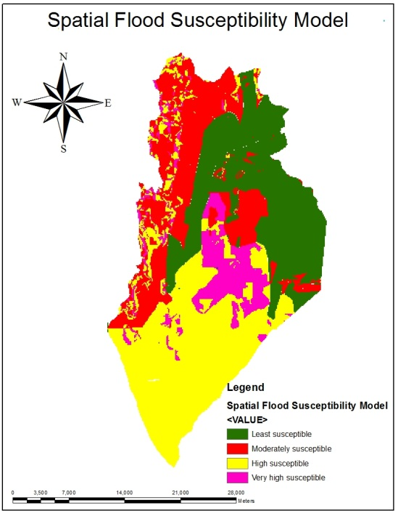where, *FSZ* is the Flood Susceptible Zones; *w*i is the factors weights which must sum up to 1, and *x*i is the criterion score i. All these relevant data were uploaded into the GIS system before analysis was carried out using a total of five thematic maps: land use, geology, rainfall distribution, soil type and slope gradient. Figure 3 presents the result of the GIS spatial simulation model for flood susceptible zones. In Figure 3, the purple, yellow, red, and dark-blue colors represent very highly, high, moderate, as well as least susceptible zones likely to be flooded. These are basically based on the ratings of the flood influencing factors by the experts.

Fig 3: Map of Forecasted Flood Susceptible Zones of Perlis

*C. Validation of the GAHP spatial flood forecasting models*

In validating the GAHP spatial flood forecasting models, the Flood Extent Extraction Model (Figure 4) developed based on a Neural Network Algorithm embedded in ENVI 4.8 software was used. Radar satellite during-flood image dated November, 2010 of Perlis, Malaysia was used. In determining the reliability of GAHP spatial flood forecasting model, the model (Figure 3) was overlaid with the Flood Extent Map of Perlis produced using Neural Network Algorithm embedded in ENVI 4.8 software from the RADARSAT during-flood image. Figure 4 below was obtained by the overlay operation. An analysis of both Figure 3 and 4 revealed that the majority of the flooded areas fell in the areas identified as very high susceptible, high susceptible, and moderately susceptible to flooding.

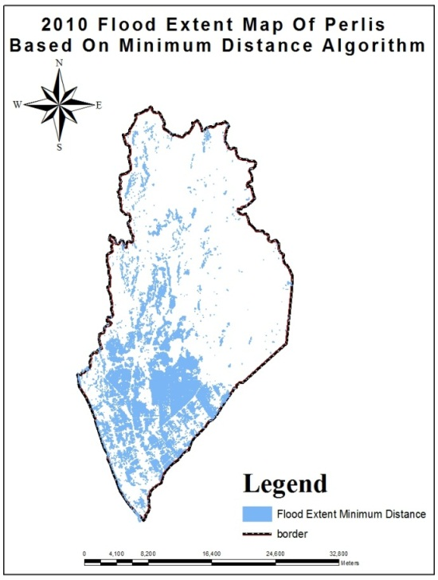

Figure 4: Map of flood extent extraction model of Perlis produced from radar-sat during-flood image (Source:MACRES)

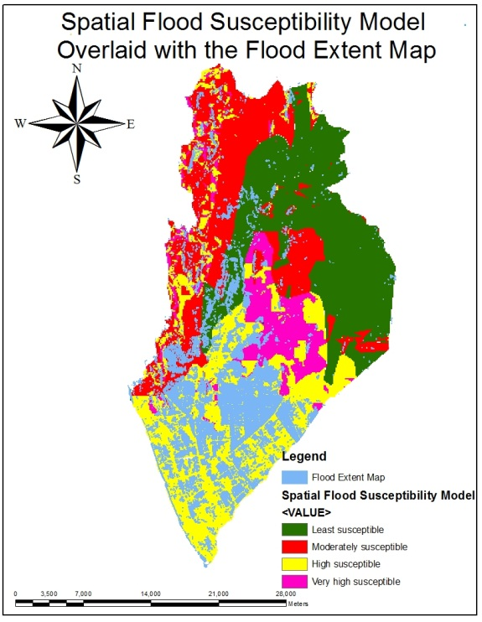

Fig 5: Map of Forecasted Flood Susceptible Zones of Perlis Overlaid with the Flood Extent Map of Perlis

V. CONCLUSION

In this study, remote sensing and GIS-based group analytic hierarchy process were successfully applied in simulating the flood susceptible zones for Perlis State. In recent years, GIS and remote sensing tools proved profound potentials in combating flood catastrophes. The social and economic losses as a result of flood disasters, technologic crises, as well as global epidemics are growing; needing more effective group decision making under uncertainty. In this study, the efficiency of GIS-based GAHP and remote sensing as spatial multi-criteria forecasting tools was discovered. Hence, this system will help civil authorities such as planners and emergency agency in taking positive and in-time steps during the pre-disaster situations. It will similarly help them during post-disaster activities to assess damages and losses caused as a result of flood.

ACKNOWLEDGMENT

This project was funded by the Universiti Teknologi PETRONAS Short Term Internal Research Fund (STIRF) under the project leadership of Associate Professor Dr. Kamaruzaman Wan Yusof. I would therefore like to acknowledge his support and guidance as well as my supervisors Associate Professor Dr. Abdul-Nasir Matori and Associate Professor Mustafa Ahmad Hashim for their support.

REFERENCES

[1] D. M. Necsoiu, *A Data Fusion Framework for Floodplain Analysis using GIS and Remotely Sensed Data.* 2000.

[2] J. Cosgrave, "Decision making in emergencies," *Disaster Prev. Manage.,* vol. 5, pp. 28-35, 1996.

[3] J. K. Levy and K. Taji, "Group decision support for hazards planning and emergency management: A Group Analytic Network Process (GANP) approach," *Math. Comput. Model.,* vol. 46, pp. 906-917, 2007.

[4] N. R. F. Maier, *Problem-Solving Discussions and Conferences: Leadership Methods and Skills.* McGraw-Hill New York, 1963.

[5] T. L. Saaty , "The Analytic Hierarchy Process: Planning, Priority Setting, Resource Allocation. McGraw-Hill, New York." 1980.

[6] T. L. Saaty, *Fundamentals of Decision Making and Priority Theory with the Analytic Hierarchy Process.* RWS publications Pittsburgh, 1994.

[7] T. L. Saaty and G. Hu, "Ranking by eigenvector versus other methods in the analytic hierarchy process," *Applied Mathematics Letters,* vol. 11, pp. 121-125, 1998.

[8] E. W. L. Cheng and H. Li, "Analytic hierarchy process: an approach to determine measures for business performance," *Measuring Business Excellence,* vol. 5, pp. 30-37, 2001.

[9] G. Coyle, "The Analytic Hierarchy Process, Practical Strategy. Open Access Material, AHP," 2004.

[10] M. Modarres, S. Sadi-Nezhad and F. Arabi, "Fuzzy analytical hierarchy process using preference ratio: A case study for selecting management short course in a business school," *International Journal of Industrial Engineering Computations,* vol. 1, pp. 173-184, 2010.

[11] Chen, D. C., Chen, P. C., Lee, Y. C., You, S. U. and Jao, H. C., "Using an analytic hierarchy process to develop competencies on mould product creativity for vocational college students. *World Transactions on Engineering and Technology Education* (WIETE) ," vol. 9, pp. 54-59, 2011.

[12] Emmanouloudis D, Myronidis D, Ioannou K, "Assessment of flood risk in Thasos Islandwith the combined use of multicriteria analysis ΑHP and Geographical Information System.Innovative Applications of Informatics in Agriculture and Environment ," vol. 2, pp. 103-115 ESRI, 2008.

[13] Sinha R, Bapalu G, Singh L, Rath B, "Flood risk analysis in the Kosi river basin, northBihar using multi-parametric approach of analytical hierarchy process (AHP). Journal of IndianSociety of Remote Sensing," vol. 36, pp. 335-349, 2008.

[14] Meyer V, Scheuer S, Haase D, "A multicriteria approach for flood risk mapping exemplifiedat the Mulde river, Germany. Natural Hazards ," vol. 48, pp. 17-39, 2009.

[15] Dai, F.C., Lee, C.F., Zhang, X.H., "Assessment of landslide susceptibility on the natural terrain of Lantau Island, Hong Kong. Environmental Geology ," vol. 61, pp. 257-271, 2001b.

[16] B. Pradhan, "Flood susceptible mapping and risk area delineation using logistic regression, GIS and remote sensing," *Journal of Spatial Hydrology,* vol. 9, 2010.

[17] S. Yahaya, N. Ahmad and R. Abdalla, "Multicriteria analysis for flood vulnerable areas in Hadejia-Jama'are River basin, Nigeria," *European Journal of Scientific Research,* vol. 42, pp. 71-83, 2010.

[18] J. R. Eastman, "Multi-criteria Evaluation and Geographical Information Systems Eds. Longley PA, Goodchild MF, Magurie DJ and Rhind DW, Second ed. John Wiley and sons, New York," vol. 1, pp. 493-502., 1996.

[19] R. R. Navalgund, "Revised Development plan of Ahmedabad Urban Development Authority Area – 2011. Ahmedabad Urban Development Authority and Space applications Centre, Ahmedabad, India, Technical, Report 1 SAC/RSAG/TR/12/AUG/1997," pp. 142, 1997.

[20] J. Malczewski , " GIS and Multicriteria decision analysis. John Wiley and Sons, Inc. United States of America, ," pp. pp. 177-192., 1999.

[21] S. Drobne and A. Lisec, "Multi-attribute decision analysis in GIS: weighted linear combination and ordered weighted averaging," *Nature,* vol. 4, pp. 28, 2009.

[22] H. Simon, "The new science of management decisionPrentice-Hall," *Englewood Cliffs, NJ,* 1977.