CROPS RESPONSE TOWARDS AOTX INDICES IN NEGERI SEMBILAN
Nurul Izma Mohammed, Nor Azam Ramli, Ahmad Shukri Yahya
Clean Air Research Group, School of Civil Engineering, Engineering Campus, Universiti Sains Malaysia, 14300 Nibong Tebal, Penang, MALAYSIA.

ABSTRACT
Increasing of ozone concentration in the atmosphere can threaten the food security due to its effects towards crops production. Ozone is believed to be the most damaging air pollutant to crops since 1980’s. Accumulated exposure over a threshold of 40 ppb (AOT40) plays an important role in evaluating the ozone impacts on the vegetation in the European countries. In Malaysia, there is no index to protect the crops from the exposure of the fluctuation of ozone. Thus, this research is carried out in order to determine the crops response towards the ozone concentration by using nine different AOTX indices, which were AOT0, AOT5, AOT10, AOT15, AOT20, AOT25, AOT30, AOT40, and AOT50 in Negeri Sembilan for year 2004. The results from this study showed that AOT50 index is the most critical AOTX index, as compared to the others and the formation of the ozone is highly related to the NO₂, UVB, temperature, wind speed, and humidity. However, the relationship between AOT50 index and ozone concentration need to be completed in order to achieve the most precise explanations.
Keywords: AOT40, AOT50, NO₂, ozone, vegetation

1. INTRODUCTION
Growing of ozone concentration in the atmosphere is due to the increasing of ozone precursor’s emissions such as nitrogen oxides and volatile organic compounds. Since the second half of the last century, many countries in the world have rapidly growth their economic sectors and this leads to the increasing of the surface ozone concentration at an annual rate of 0.5 to 2 % (Vingarzan, 2004). Numerous studies have shown that the elevated of ozone concentration may cause negative impacts to the plants growth (Feng and Kobayashi, 2009). Ozone is not only reduced the photosynthesis rate and the whole-plants growth but it is also capable to decrease the stomatal conductance and altering the antioxidant system in the plants (Ashmore, 2005, Morgan et al., 2003). According to Holland et al., (2006), almost 6.7 billion pound sterling has lost in Europe due to the reduction of 23 horticultural and agricultural crops in 2000. In Malaysia, Ishii et al. (2007) estimated that a 1.6-5.0% yield losses (by weight) would occur for major agricultural crops such as lettuce, French bean, lady’s finger, sweet potato, maize and rice in 2000.
As one of the agricultural countries in Asia, threat to crops security and the economic losses due to the crops reduction has become an issue of concern now a day. Van Dingenen et al., (2009) reported that parts of Asia will experience further significant increase in ozone concentration by 2030. In Asia, the monthly mean of ozone concentration in the suburban and rural areas commonly exceed 50 ppb during the important agricultural growing season (EANET, 2006). In European countries, an accumulated exposure over a threshold of 40 ppb (AOT40) plays an important role in evaluating the ozone impacts on the vegetation but in Malaysia, there is no any index to protect the crops from the exposure of the fluctuation of ozone. Thus, this research is carried out in order to determine the crops response towards ozone concentration by using nine different AOTX indices, which were AOT0, AOT5, AOT10, AOT15, AOT20, AOT25, AOT30, AOT40, and AOT50. However, it is more focusing on the AOT50 index due to the data report by EANET (2006).

2. METHOD
The studies to test the response of crops production towards the nine different AOTX indices, which were AOT0, AOT5, AOT10, AOT15, AOT20, AOT25, AOT30, AOT40, and AOT50, were based on the monitoring data of hourly ozone concentration and meteorological parameters like wind speed, humidity, nitrogen dioxides (NO₂), UVB, and temperature in Nilai, Negeri Sembilan. These data was obtained from the Department of Environment (DoE), Malaysia.
The estimation of the percentage of crops response towards the AOTX indices due to the ozone exposure for 2004 is using the equation below:
Percentage of crops response (%) = $\frac{{AOTX}_{\left(Y\right)}}{Σ{Ozone concentration }_{\left(y\right)} } ×Crops production$
Where, X is the index of AOT and y is the year of the collected data.
The response of crops towards the AOTX indices was conducted by using Microsoft Office Excel 2007. Data were then analyzed by using SPSS (Statistical Package for the Social Science) software Version 11.5.

3. RESULTS AND DISCUSSION
The relationship between the nine AOT indices, AOT0, AOT5, AOT10, AOT15, AOT20, AOT25, AOT30, AOT40, and AOT50 and the response of crops towards the ozone concentration in Negeri Sembilan, Malaysia for 2004 was shown in Figure 3.1(a), (b), (c), (d) .

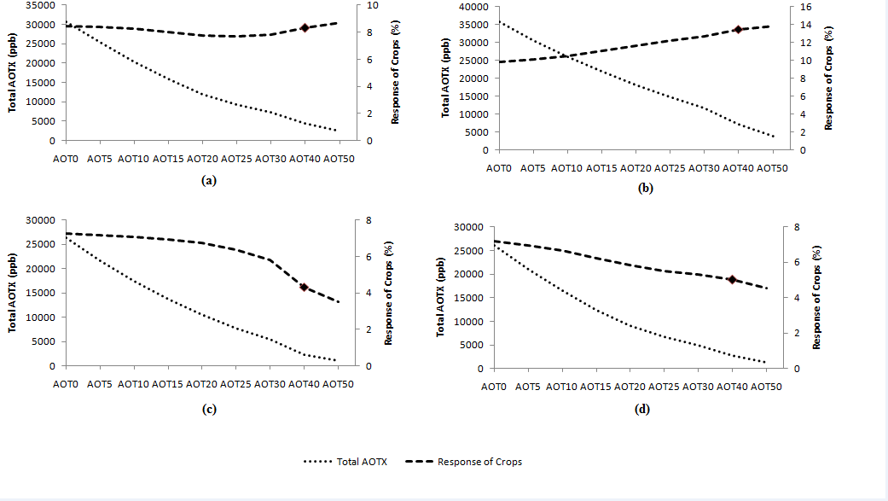
* AOT40 is the AOTX index which was recommended for crops in Europe
Figure 3.1(a): January to March, (b): April to June, (c): July to September, (d): October to December: Relationship between AOTX and crops response Negeri Sembilan in 2004
From Figure 3.1(a), the highest percentage of the crops response towards the ozone exposure was the best with AOT50 index with 8.70 % in January to March, 2004. This percentage was followed by AOT0 with 8.46 % while AOT25 gave the least percentage with 7.66 %. AOT40 index, which was recommended for the crops in Europe, showed the percentage of response of 8.33%.
In Figure 3.1 (b), AOT50 recorded the highest percentage of the crops response towards the ozone exposure with 13.80 % from April to June 2004, followed by AOT40 with 13.48 %. AOT0 (control index) which produced the second highest percentage from January to March, 2004 however showed the smallest percentage of crops response towards the ozone exposure during these months with 10.68%. In contrast, this value is considered high as compared to the previous three-month period.
The percentage of the crops response towards the ozone exposure was highest with AOT0 index, followed by AOT5 by 0.12 % from July to September 2004 [Figure 3.1 (c)]. AOT50 was the least index in response to the crops with 3.54%.
AOT0 (control index) recorded the utmost percentage in the crops response towards the ozone exposure with 7.18% in Figure 3.1 (d). However, this value is considered small as compared to the April-June period in 2004. AOT40 which was recommended by the European countries as the critical index for the crops gave the second least percentage of the crops response towards ozone with 5.03% followed by AOT50 index with only 4.55 %.
Results from Figure 3.1 demonstrate that AOT0 and AOT50 gave the highest crops response towards daylight ozone concentration throughout 2004. In this study, AOT0 was considered to be the control index as many studies have reported that ozone has a lot of potential to give adverse impacts on plants (Pleijal et al., 1998). Therefore, AOT50 can be considered as the most critical AOTX index in Negeri Sembilan.
Table 3.1 shows the model summary between the daylight (7 am to 7 pm) ozone concentration and its precursor such as NO₂, UVB, temperature, wind speed, and humidity for four different three-month period in 2004 while Table 3.2 shows the model summary between AOT50 index and ozone concentration at the same time period.
Table 3.1: Model summary of ozone for Nilai, Negeri Sembilan (2004)
Model | R | R Square | Adjusted R Square
January to March | 0.757 | 0.573 | 0.571
April to June | 0.782 | 0.612 | 0.610
July to September | 0.816 | 0.666 | 0.664
October to December | 0.712 | 0.507 | 0.503
*Predictors: (Constant), Wind Speed, Humidity, NO₂, UVB, Temperature

Table 3.2: Model summary of AOT50 for Nilai, Negeri Sembilan (2004)
Model | R | R Square | Adjusted R Square
January to March | 0.819 | 0.671 | 0.638
April to June | 0.672 | 0.452 | 0.397
July to September | 0.687 | 0.472 | 0.420
October to December | 0.748 | 0.559 | 0.515
*Predictors: (Constant), Ozone (ppb)
Values for R square and adjusted R square in Table 3.1 are between 0.5 and 0.7 while values for R square and adjusted R square in Table 3.2 are between 0.4 and 0.65. According to Cohen et al. (2007), adjusted R square value which is higher than 0.5 indicates the strong fit model. Moderate fit model is indicated by the adjusted R square value between 0.31 and 0.50. Results from Table 3.1 shows that the wind speed, humidity, NO₂, UVB, and temperature are highly contributed in the formation of ozone. The outcome from Table 3.2 shows that the three-month period from April to September in 2004 gave the moderate fit result between the ozone concentration and AOT50 index in the study area. This result may due to the effects of South-West monsoon that usually occur from April to September every year. In spite of this, further study ought to be completed in order to attain the most accurate explanations.

4. CONCLUSION
The results from this study can be concluded that AOT50 index is the most critical AOTX index, as compared to AOT0, AOT5, AOT10, AOT15, AOT20, AOT25, AOT30, and AOT40 in Negeri Sembilan. Adjusted R square value from the model summary of ozone shows that the wind speed, humidity, NO₂, UVB, and temperature are highly contributed in the formation of ozone. However, the relationship between AOT50 index and ozone concentration needs to be completed in order to achieve the most precise explanations.

5. ACKNOWLEDGEMENT
This study was funded by Universiti Sains Malaysia under Grant 304\PAWAM\\6039013304. Thank you to Universiti Sains Malaysia and Fellowship Scheme for providing financial support to carry out this study and also thanks to the Department of Environment Malaysia for their support.

6. REFERENCES
Ashmore, M.R., 2005. Assessing the future global impacts of ozone on vegetation. Plant, Cell and Environment 28, 949–964.

EANET, 2006. Data report on the acid Deposition in the East Asian Region 2005. Network Centre of EANET, Japan. http://www.eanet.cc/.

Feng, Z. & Kobayashi, K., 2009. Assessing the impacts of current and future concentrations of surface ozone on crop yield with meta-analysis. Atmospheric Environment 43, 1510–1519.
Fuhrer, J., Skarby, L.& Ashmore, M. R., 1997. Critical levels for ozone effects on vegetation in Europe. Environmental Pollution 97, 91- 106.

Holland, M., Kinghorn, S., Emberson, L., Cinderby, S., Ashmore, M., Mills, G. & Harmens, H., 2006. Development of a framework for probabilistic assessment of the economic losses caused by ozone damage to crops in Europe. CEH Project No. C02309NEW. Report to U.K. Department of Environment, Food and Rural affairs under contract 1/2/170 1/3/205.

Ishii, S., Bell, J. N. B. & Marshall, F. M. 2007. Phytotoxic risk assessment of ambient air pollution on agricultural crops in Selangor State, Malaysia. Environmental Pollution 150, 267-279.

Keller, F., Bassin, S., Ammann, C. & Fuhrer, J. 2007. High- resolution modelling of AOT40 and stomatal ozone uptake in wheat and grassland: A comparison between 2000 and hot summer of 2003 in Switzerland. Environmental Pollution 146, 671-677

Morgan, P.B., Ainsworth, E.A. & Long, S.P. 2003. How does elevated ozone impact soybean? A meta-analysis of photosynthesis, growth and yield. Plant, Cell and Environment 26, 1317–1328.

Pleijel, H., Danielsson, H., Gelang, J., Sild, E. & Selldén, G. 1998. Growth stage dependence of the grain yield response to ozone in spring wheat (Triticum eastivum L.). Agricultural Ecosystem Environment 70, 61–68.

Van Dingenen, R., Dentener, F.J., Raes, F., Krol, M.C., Emberson, L. & Cofala, J., 2009. The global impact of ozone on agricultural crop yields under current and future air quality legislation. Atmospheric Environment 43, 604-618.

Vingarzan, R., 2004. A review of surface ozone background levels and trends. Atmospheric Environment 38, 3431–3442.

